Circulation Scope: Customer
Revision Date: October 13th, 2022
Pebble POS Back of House User Manual

Table of Contents
Introduction 5
How to Access and Sign-in to WebConfig 7
How to Sign-in to WebConfig 7
How to Recover Your Password for WebConfig 7
How to Use WebConfig 10
Navigate 10
Save and Back 11
Delete 11
Edit 12
Logout 12
Enterprise Programming 13
How to Edit Enterprise Settings 13
How to Create a Property 14
How to Create Enterprise Level Users 16
Create an Access Level 16
Access Levels Descriptions 17
Create a User 22
Create a User Role 23
House Accounts 25
How to Create a House Account Group 25
How to Create a House Account 27
Tags 30
Property Level Configuration 32
How to Create a Profit Center 32
Local and Remote Printers 35
How to Create a Printer in WebConfig 35
How to Create a Printer Group 36
How to Create Peripherals 38
Check Trailers 40
Create a Custom Check Trailer 40
Property Level Users 41
Payment Configuration 42
Tenders 42
How to Create Tenders 42
How to Create an Electronic Payment 44
Create BINs for Mapping Interfaces 46
Price Levels 47
How to Create a Price Level 47
Discounts 50
How to Create Discounts 50
Comps 52
How to Create Comps 52
Void Reasons 54
How to Create Void Reasons 54
Service Charges 56
How to Create a Service Charge 56
How to Create a Service Charge Group 57
Automatic Gratuities 61
How to Create an Auto Grat 61
Profit Center Level Configuration 63
POS Terminals 63
How to Create a Terminal 63
Advanced Tab 66
Cache Lifetime 67
Taxes 67
How to Configure Taxes 67
How to Create a Tax Group 68
Price Intervals 71
How to Create Price Intervals 71
Day Parts 73
How to Create Day Parts 73
Refunds 74
How to Create Refund Reasons 74
Paid In / Paid Out Reasons 75
How to Create Paid In / Out Reasons 75
Profit Center Level Users 76
Product Configuration 77
Revenue Types 77
How to Create Revenue Types 77
Menus 79
How to Create Menu Groups 79
How to Create Menus 80
Forced Modifiers 82
How to Create Forced Modifiers 82
How to Create a Forced Modifier Group 84
Exception Modifiers 86
How to Create Exception Modifiers 86
How to Create an Exception Modifier Group 87
Inclusive Tips 89
How to Create Inclusive Tips 89
Product Groups 90
How to Create Product Groups 90
Products 93
How to Create Products 93
Map Order Buttons 95
How to Create Map Order Buttons 95
How to Remove Map Order Buttons 97
Pebble Tools 98
How to Use Profit Center Replication Tool 98
How to Use Product Replication Tool 100
Electronic Journal 101
How to Run an Electronic Journal Query 101
Select a Date Range 102
How to Save a Journal 104
SkyWire SQL 105
Executing SkyWire SQL queries 105
Saving SkyWire SQL queries 106
Viewing and editing SkyWire SQL Queries 107
Filtering SkyWire SQL Query Results 108
Back Office Reporting 110
How to Run WebConfig Reports 110
Destinations for Scheduled Reports 112
How to Create Destinations 112
Destination for Email 112
Destination for FTP 113
Scheduling Reports, Imports and Exports 113
How to Schedule Actions 113
Create Public Reports 116
Schedule Public Reports 118
Available Reports 119
Audit 119
Sales 120
Employee 121
House Account Reports 121

Introduction

Pebble Point of Sale (POS) is designed to manage businesses of any size, from small stand-alone locations to large multi-site organizations which run reports from multiple profit centers per day and require true enterprise-wide centralization.

Regardless of your size or type of business, Pebble POS delivers an efficient, flexible, and yet easy to use system, providing all our customers with a fully integrated, scalable restaurant POS, back-office, and enterprise system which include the following standard components.

The POS configuration structure is as follows. Components configured at the enterprise level will be accessible for all properties in that enterprise. Components configured at the property level will be accessible to all profit centers in that property. Profit center level configuration will be accessible to the profit center it is configured in only.
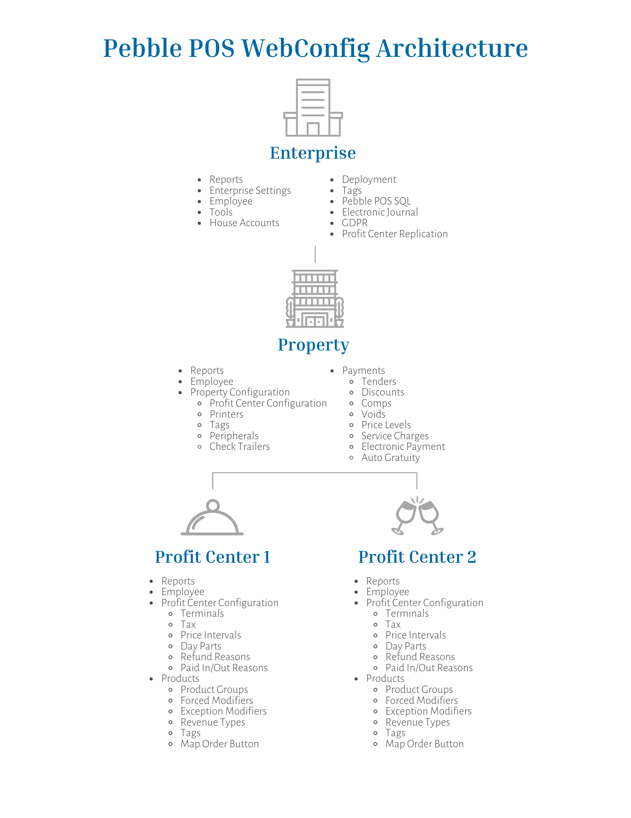

How to Access and Sign-in to WebConfig

WebConfig is the back-office application for Pebble POS. This is the website you will go to for all configuration. Once your enterprise has been created, you will receive a URL and credentials to access WebConfig.

How to Sign-in to WebConfig

- Enter the WebConfig URL.
- Enter your user credentials and company.
- Select "Login.”

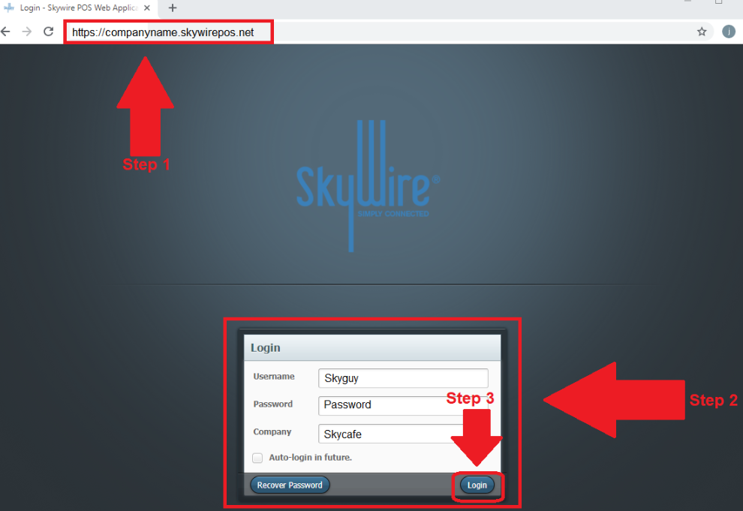

How to Recover Your Password for WebConfig

- Select "Recover Password.”

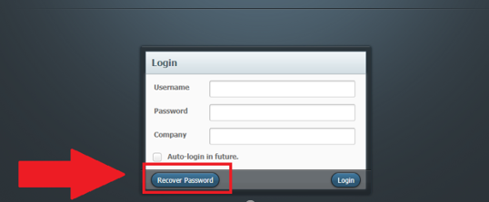
- Enter your email address and company.
- Select "Reset.”

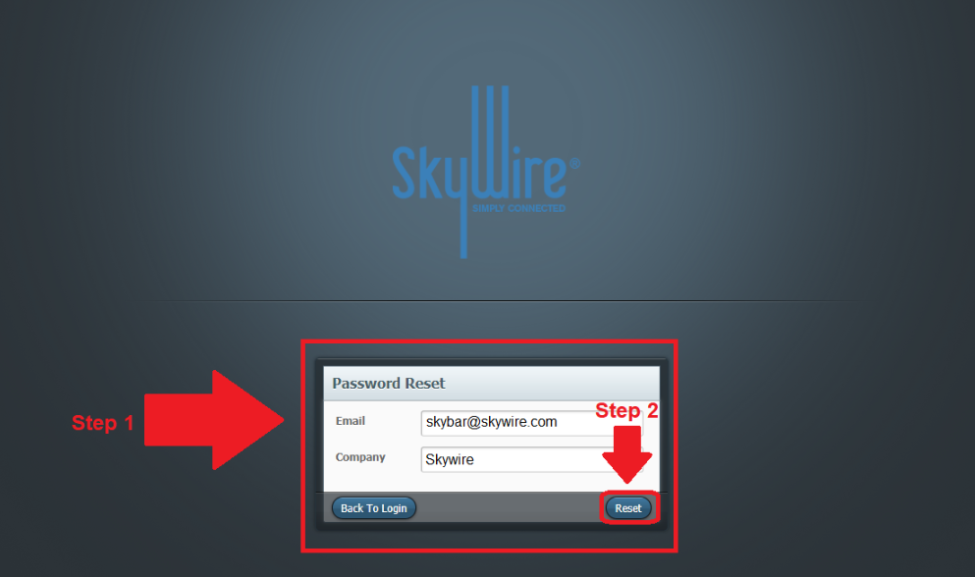

- A new password will be sent via email.

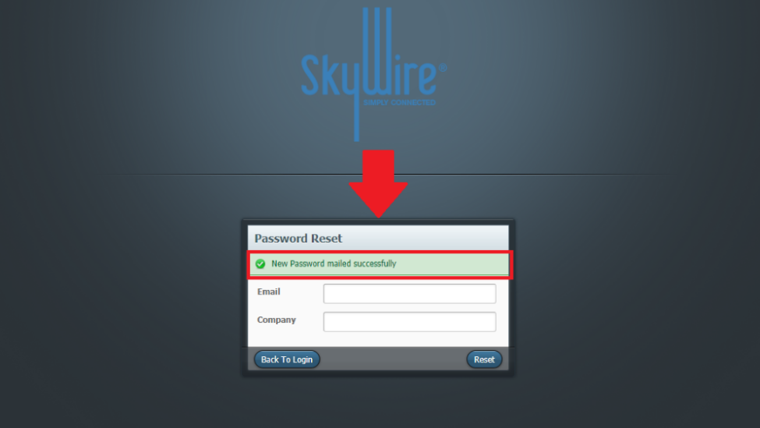

- You will receive an email with your new password.

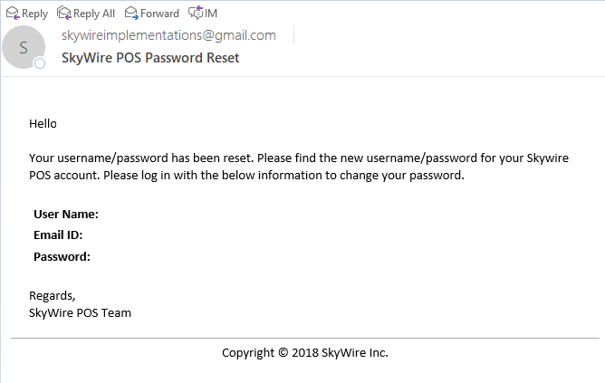

- Use the new password sent to your email to sign-in to WebConfig.
- You will then be prompted to change your password.
  - Password Requirements are as follows:
    - 8 characters
    - 1 upper case
    - 1 special character

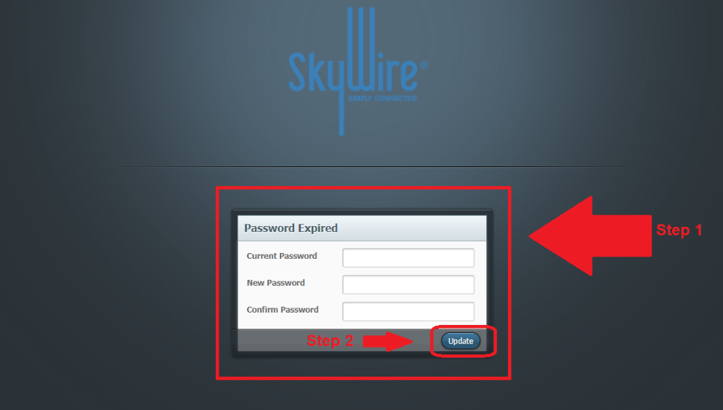

How to Use WebConfig

Navigate

- To access Enterprise configuration tabs, select "Settings.”

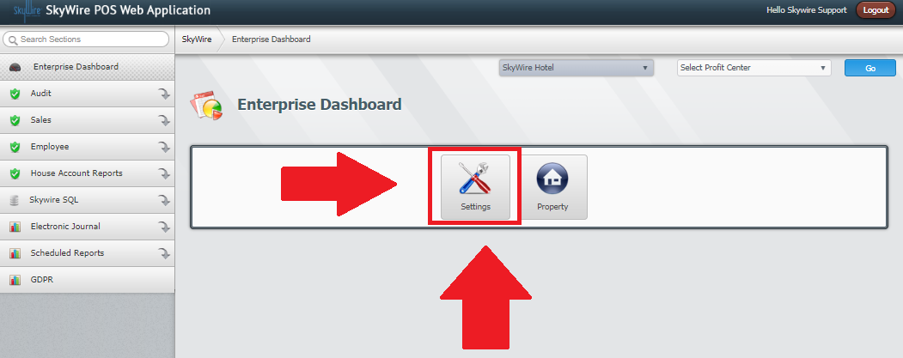

- After properties and profit centers have been created; they can always be accessed by selecting them.
  - Select the desired property to access property level configuration tabs.
  - Select the desired property and profit center to access profit center level configuration tabs.
- Select "Go.”

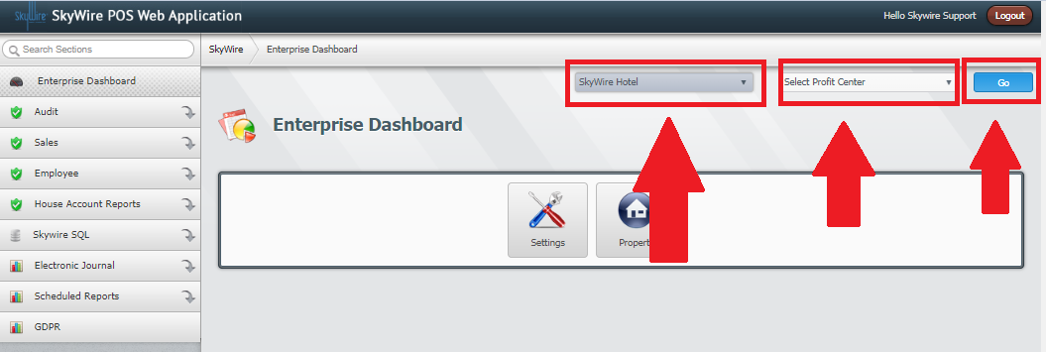

Save and Back

- Configuration settings can be saved by selecting "Save.”
- Selecting "Back" will not save any changes and will take you to the previous screen.

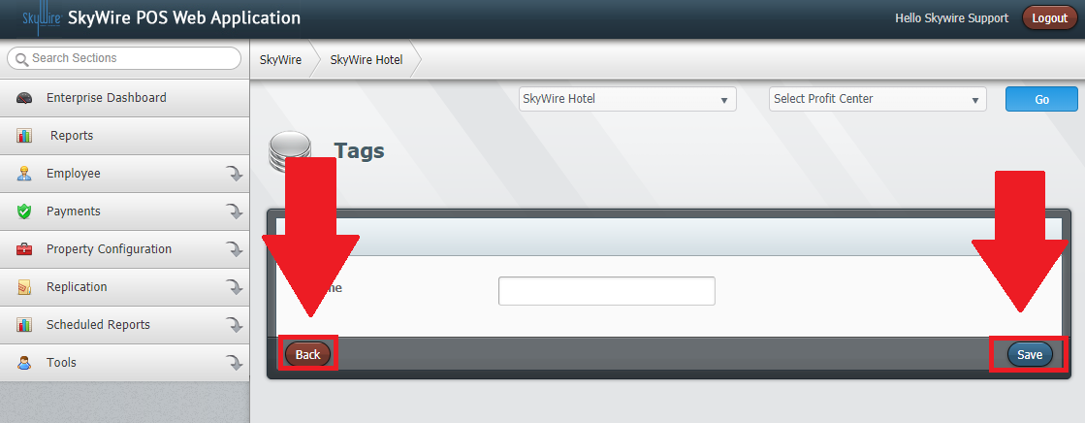

Delete

- Select "Delete" to erase or remove undesired configuration.

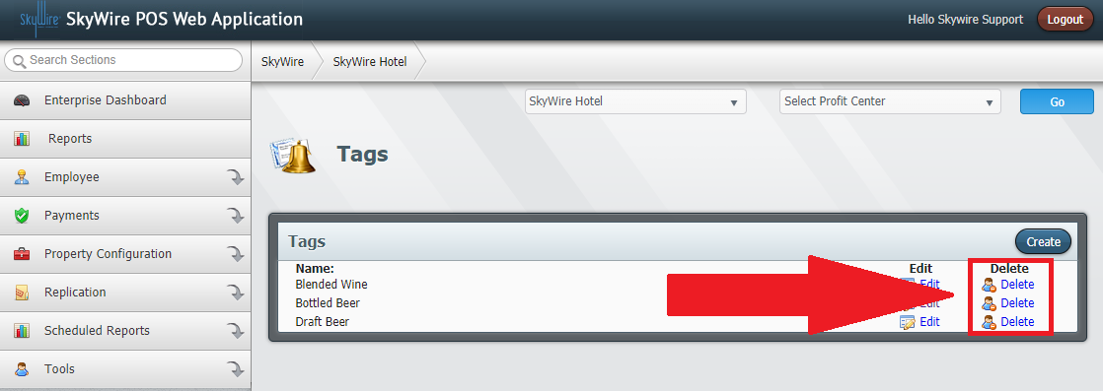

Edit

- Configurations can be modified after components have been created.
- Select "Edit.”

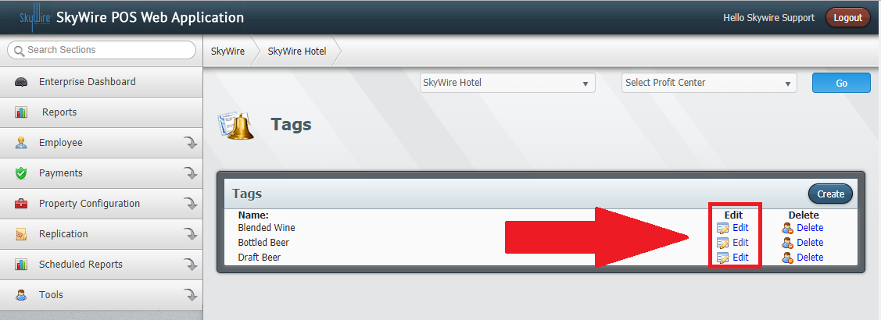

Logout

- Select "Logout" to exit WebConfig.

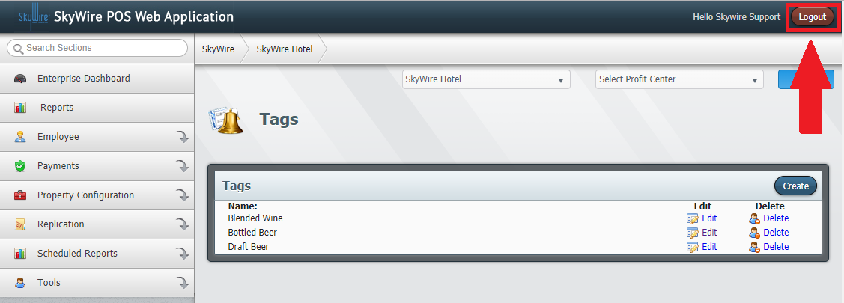

Enterprise Programming

The Enterprise is created by the Pebble team. The settings are configured using best practices but can be changed at any time.

How to Edit Enterprise Settings
- Select "Settings.”
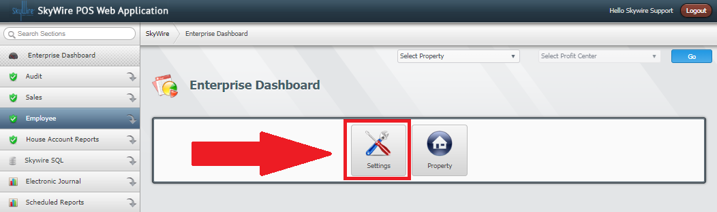
- Edit desired changes.
- Select "Save.”
See detailed description below.
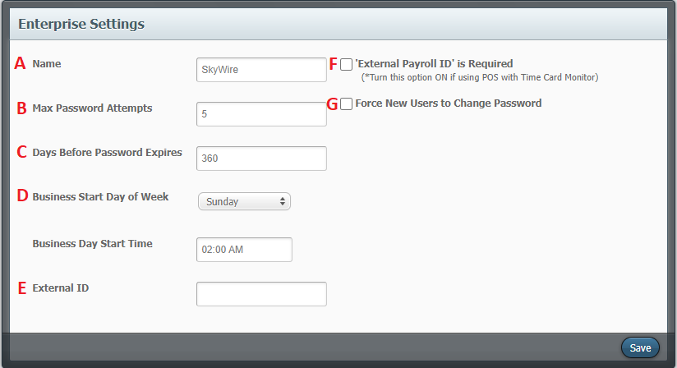
- Name: Enter or edit enterprise name.
- Max Password Attempts: Enter the maximum number of attempts before the account is locked.
- Days Before Password Expires: Enter the number of days a password can be valid for.
- Business Start Day of Week and Start Time: Enter the business start day and time. This will be the time period used for enterprise level reporting.
- External ID: External IDs may populate automatically; they can be changed. External IDs are used for POS integrations.
- External Payroll ID is Required: Select this option if using Timecard Monitoring interface.
- Force New Users to Change Password: Select this option to require new users to create a new password after signing into WebConfig for the first time.

How to Create a Property

Components configured at the Property level will be accessible to all profit centers in that Property.
- Select “Property.”

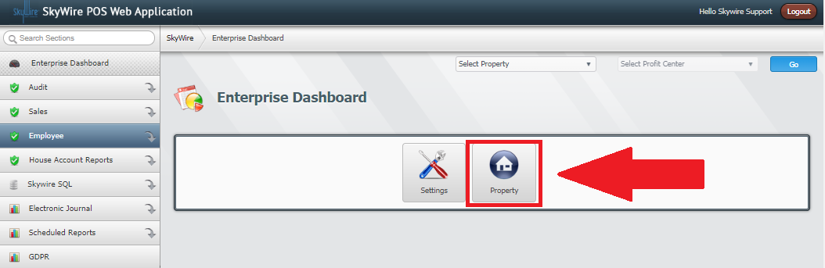

- Select “Create.”

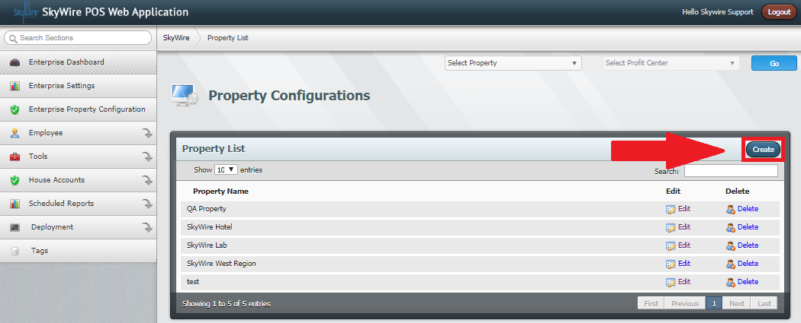
Detailed explanation below.

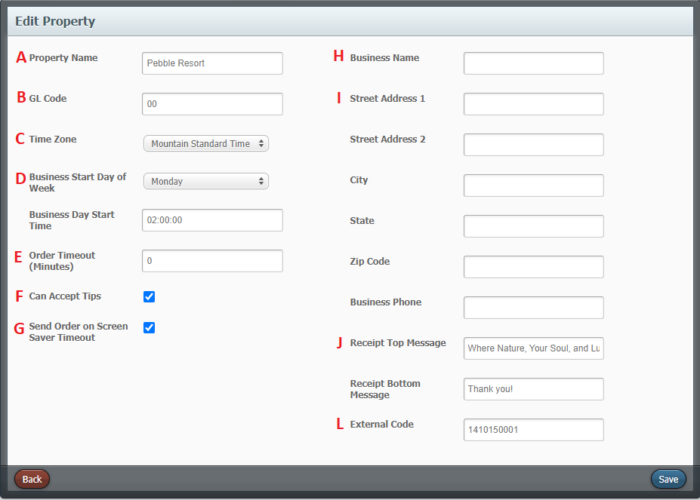

- Property Name: Enter the name of the property.
- GL Code: Enter the GL Code, if applicable. General Ledger Codes are used for accounting.
- Time Zone: Enter the time zone of the property.
- Business Start Day of Week and Time: Select the business start day and start time. This will be the time period used for reporting at the property level.
- Order Timeout: Enter the minutes to automatically sign a user off if the POS terminal if it is left idle.
- Can Accept Tips: Select this option if the property can accept tips.
- Send Order on Screen Saver Timeout: Select this option to save and send items to remote printers when order times out.
- Business Name: Add desired name for receipt header. This can be overridden in the profit center.
- Street Address and Business Phone: Enter the address and phone number for receipt text. This can be overridden in the Profit Center.
- Receipt Top and Bottom Message: Enter desired receipt text. This can be overridden in the profit center.
- External code: This field is for mapping interfaces.
- Select “Save.”

How to Create Enterprise Level Users

Users can be created at the enterprise level, property level and profit center level. Enterprise Level Users will have access to all properties and profit centers.

Create an Access Level

- Select "Settings.”

- Select "Employee.”
- Select "Access Levels.”
- Select "Create.”

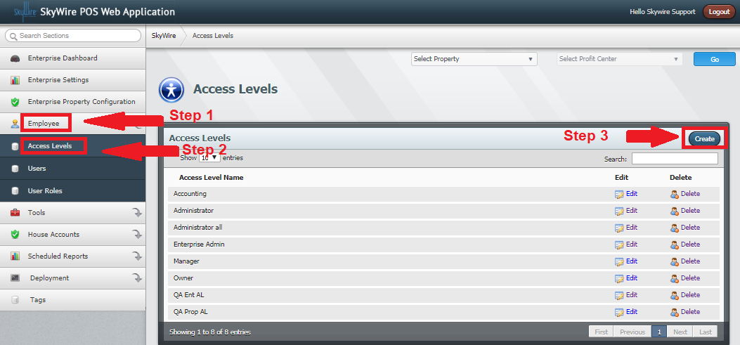

- Enter the name of the Access Level.
- Select the functions that the role created can use. Use “Select All,” to enable all the access levels in the category. Uncheck access levels to disable them for the access level.
- Select "Save.”

See detailed Access Level descriptions below.

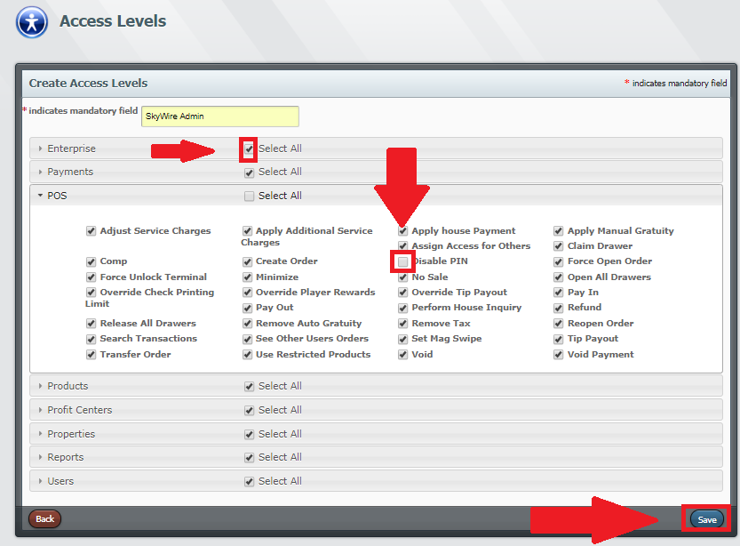

Access Levels Descriptions
Access Check Box | Function
Access Order History/Transaction History | Able to Access Order History/Transaction History
Access POS Tools | Able to Access POS Tools within Setup
Access System Config | Able to Access System Config
Adjust Service Charges | Able to Adjust Service Charges
Adjust Guest Count | Able to Adjust Guest Count
Apply Additional Service Charges | Able to Apply Additional Service Charges
Apply House Adjustment | Able to Apply House Adjustment
Apply House Payment | Able to Apply House Payment
Apply Manual Gratuity | Able to Apply Manual Gratuity
Assign Access for Others | Able to Assign Access for Others
Batch Payments | Able to Batch Payments
Capture Electronic Payment | Able to Capture Electronic Payment
Check Trailers | Able to Create and Edit Check Trailers
Checkout Summary Report | Able to View Checkout Summary Report
Claim Drawer | Able to Claim Cash Drawers
Clocked In Report | Able to View Clocked In Report
Close House | Able to Close House
Closed Check Report | Able to View Closed Check Report
Comp | Able to Comp Checks and Items
Create Order | Able to Create an Order
Create Public Reports | Able to Create Public Reports
Create Public Report in EJ | Able to Create Public Report in EJ
Create Report in EJ | Able to Create Report in EJ
Disable PIN | Able to Disable Using FOH Password at Terminal
Discount | Able to Discount Checks and Items
Discounts/Voids/Comps | Able to Apply Discounts/Voids/Comps
Discount By Report | Able to View Discount By Report
Discount Report | Able to View Discount Report
Edit Access Levels | Able to Edit Access Levels
Edit Auto Gratuity | Able to Edit Auto Gratuity
Edit Day Parts | Able to Edit Day Parts
Edit Discounts | Able to Edit Discounts
Edit Electronic Payments | Able to Edit Electronic Payments and Bins
Edit Exception Modifiers | Able to Edit Exception Modifiers
Edit Force Modifiers | Able to Edit Force Modifiers
Edit Job Codes | Able to Edit Job Codes
Edit Map Order Buttons | Able to Edit Map Order Buttons
Edit Menu Configuration | Able to Edit Menu Configuration
Edit Pay Grades | Able to Edit Pay Grades
Edit Payment Reasons | Able to Edit Payment Reasons
Edit Peripherals | Able to Edit Peripherals
Edit Price Intervals | Able to Edit Price Intervals
Edit Price Levels | Able to Edit Price Levels
Edit Printers | Able to Edit Printers
Edit Products | Able to Edit Products
Edit Profit Center Config | Able to Edit Profit Center Config
Edit Profit Center Dashboard | Able to Edit Profit Center Dashboard
Edit Property Parameters | Able to Edit Property Parameters
Edit Property Tools | Able to Edit Property Tools
Edit Public Reports | Able to Edit Public Reports
Edit Revenue Types | Able to Edit Revenue Types
Edit Service Charges | Able to Edit Service Charges
Edit SMS Coupons | Able to Edit SMS Coupons
Edit Tags | Able to Edit Tags
Edit Taxes | Able to Edit Taxes
Edit Tenders | Able to Edit Tenders
Edit Terminal Gratuity Map | Able to Edit Terminal Gratuity Map
Edit Terminals | Able to Edit Terminals
Edit Users | Able to Edit Users
Edit User Roles | Able to Edit User Roles
Employee Access Report | Able to View Employee Access Report
Employee Report | Able to View Employee Report
Enterprise Settings | Able to View Enterprise Settings
Force Open Order | Able to Force Open Orders
Force Unlock Terminal | Able to Force Unlock a Terminal
GDPR | Able to GDPR Search and Purge
House Account Detail Report | Able to View House Account Detail Report
House Account Summary Report | Able to View House Account Summary Report
House Status Report | Able to View House Status Report
Is Admin in EJ | Is Admin in EJ
Log into EJ | Able to Log into EJ
Make Payments | Able to Make Payments
Master Report | Able to View Master Report
Minimize | Able to Minimize Application
No Sale | Able to No Sale
One Touch Report | Able to View One Touch Report
Open All Drawers | Able to Open All Drawers
Open Check Report | Able to View Open Check Report
Override Check Printing Limit | Able to Override Check Printing Limit
Override Player Rewards | Able to Override Player Rewards
Override Tip Payout | Able to Override Calculated Tip Payout
Pay In | Able to Pay In
Pay Out | Able to Pay Out
Paid In/Out Reasons | Able to Edit Pay In/Out Reasons
Payroll Report | Able to View Payroll Report
Perform House Inquiry | Able to Perform House Inquiry
Perform House Account Payment | Able to Perform House Account Payment  NOTE: Having this enabled will still prompt User for a manager override when applying payment  NOTE2: If User does not require any House Account access, do not enable this Access Level as well as “Restricted House Account Group Payment Authorization”
Print Shift Report | Able to Print Shift Report
Profit Center Master Report | Able to View Profit Center Master Report
Profit Center Replication | Able to Use Profit Center Replication Tool
Profit Tax Report | Able to View Profit Center Tax Report
Property Master Report | Able to View Property Master Report
Property Tax Report | Able to View Property Tax Report
Refresh Terminal | Able to Refresh Terminal
Refund | Able to Create Refund Orders
Refund Reasons | Able to Edit Refund Reasons
Release Drawers for Others | Able to Release All Drawers
Remove Auto Gratuity | Able to Remove Auto Gratuity
Remove Tax | Able to Remove Tax
Reopen Order | Able to Reopen Orders
Restricted House Account Group Payment Authorization | Able to Assign House Accounts to House Account Tenders  NOTE: Having this enabled + “Perform House Account Payment “will not prompt for manager override  NOTE2: If User does not require any House Account access, do not enable this Access Level as well as “Perform House Account Payment”
Run Public Reports | Able to Run Public Reports
Sale Detail Report | Able to View Sale Detail Report
Sales By Report | Able to View Sales By Report
Sales Mix Report | Able to View Sales Mix Report
Search Transactions | Able to Search Transactions
See Other Users Orders | Able to See Other Users Orders
Set Mag Swipe | Able to Set Mag Swipe
SkyWire SQL | Able to Sql Query View
Tax Report | Able to View Tax Report
Tender Report | Able to View Tender Report
Tip Payout | Able to Perform Tip Payouts
Tip Report | Able to View Tip Report
Tip Transfer | Able to Transfer Tips
Transfer Order | Able to Transfer Orders
Use Import Utility | Able to Use Import Utility
Use Restricted Products | Able to Use Restricted Products
View System Logs | Able to View System Logs
View Property Dashboard | Able to View Property Dashboard
View Reports | Able to View Reports
View Tax | Able to View Tax
Void | Able to Void Checks and Items
Void Payment | Able to Void a Payment

Create a User

- Select “Employee.”
- Select "Users."
- Select "Create."

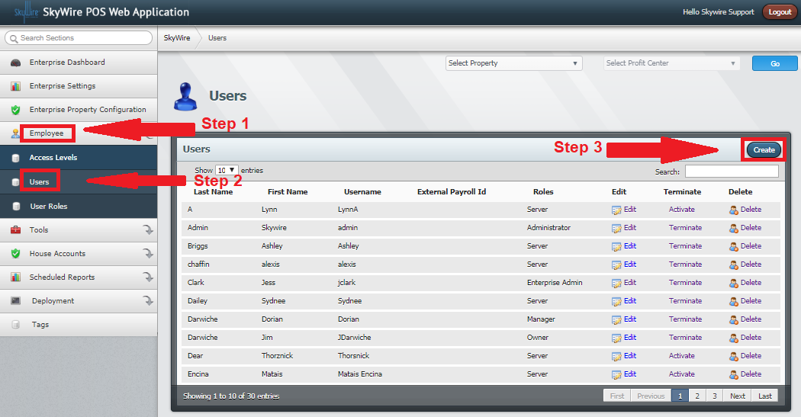

Detailed explanation below.

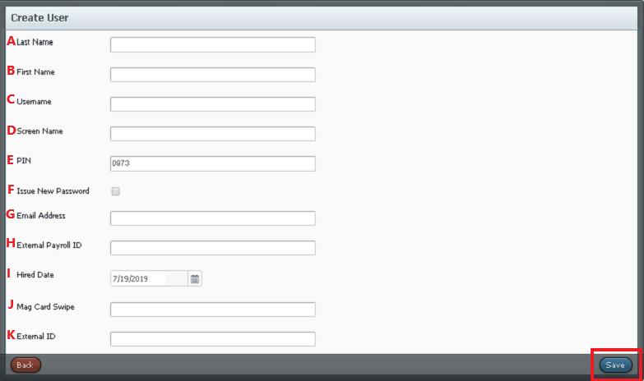

- Last Name: Enter the user’s last name.
- First Name: Enter the user’s first name.
- Username: This is the name that is used to login to WebConfig, if allowed access.
- Screen Name: This is the name that will display on the POS terminal when signed in.
- PIN: This will be the number used to sign-in to the POS terminal. A password will automatically populate when a user is created but can be changed. Two users cannot have the same Front of House Password.
- Issue New Password: Select this option when creating a WebConfig user. This will email a password and the user will be able to create a new password after signing in for the first time. Once the user is created, this option will change to reset password. Toggle this option and select "save" to issue a new password at any time.
- Email Address: Enter an Email Address for WebConfig users only. This email address will be where the password is sent to.
- External Payroll ID: This is used to track user by payroll number (Optional).
- Hire Date: Enter the user’s start date.
- Mag Card Swipe: This is the number of the swipe card used for sign-in (Optional).
- External id: This is used to track the user by ID number (Optional).

Create a User Role

NOTE: User will not be visible on employee list until a Role had been created.

- Select "User Roles.”
- Select "Create.”

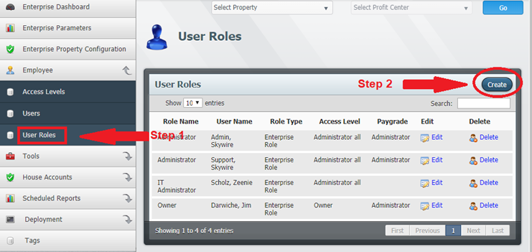

See detailed explanation below.

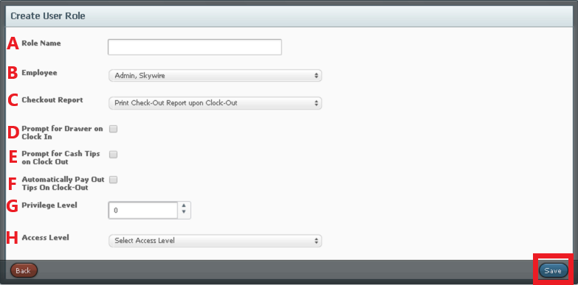

- Role Name: This is the name that will display on the terminal when clocking in. Note: Two roles cannot exist with same name and employee. The employee’s name needs to be added before adding the role.
- Employee: Select the user created.
- Checkout Report: Select which report to print when ending shift.
- Prompt to Claim Drawer on Clock-In: This will prompt the user to select an available cash drawer. A cash drawer must be claimed to open for tenders configured to do so.
- Prompt for Cash Tips on Clock-out: Toggle this option to give the user the opportunity to claim cash tips.
- Automatically Pay Out Tips on Clock-Out: Toggle this option to have tips automatically paid out at the end of shift.
- Privilege Level: Select a number from 0-10, 0 being the highest and 10 being the lowest level of privilege. Privilege levels dictate which users can apply tenders created. The privilege level is also configured in "Tenders.” Confirm the privilege level correlates with the users who need the ability to apply the tender.
- Access Level: Select the access level created.
- Select "Save.”

House Accounts

House Accounts are general accounts that allow for internal charging and tracking. House Accounts are assigned a group. House Account Groups dictate charging privileges and functionality options. To apply a payment using a House Account, a correlating tender must be created. A House Account tender is created in "Tenders" and then assigned to terminal (s).

How to Create a House Account Group

- Select "Settings.”

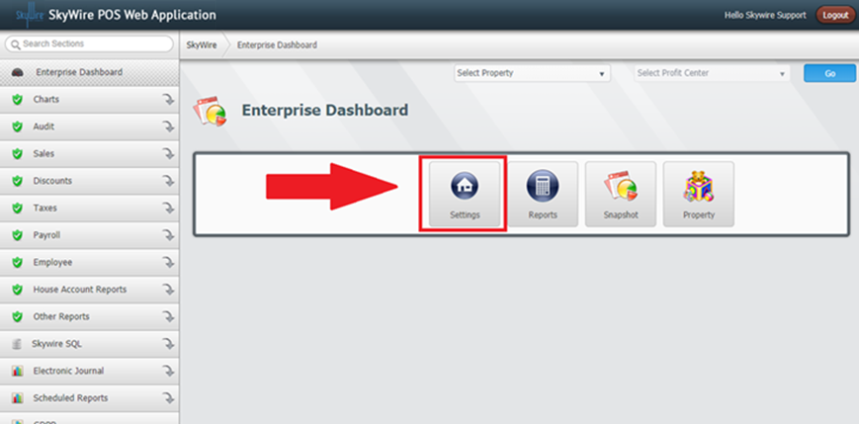

- Select "House Accounts.”
- Select "House Account Setup.”
- Select "House Account Groups.”

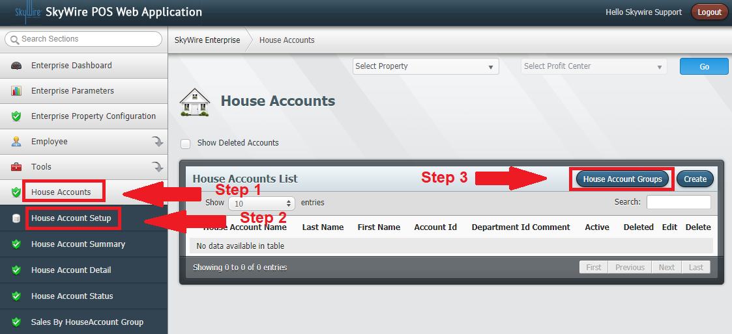
Detailed explanation below.

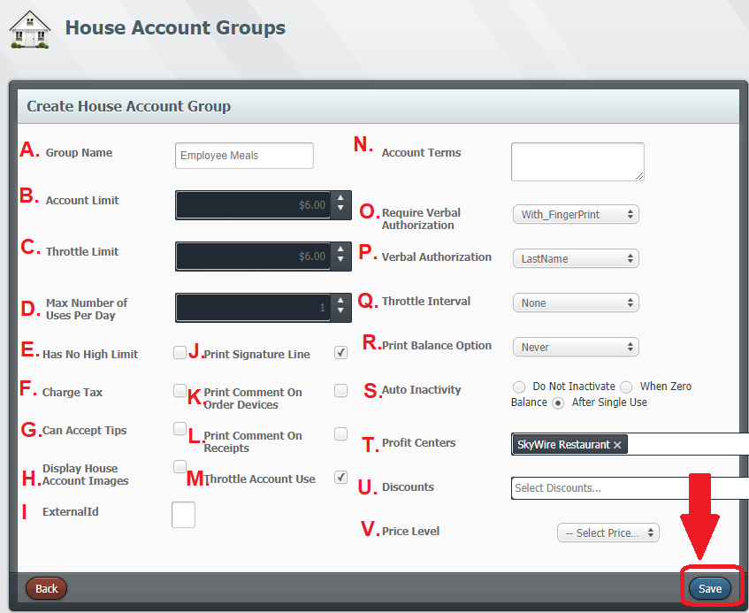

- Group Name: Enter the group name.
- Account Limit: Enter the amount that the user or users’ groups can spend.
- Throttle Limit: What a user or users’ group can spend per time period. Throttle limits can be reset daily, weekly, bi-weekly, monthly or yearly.
- Max Number of Users Per Day: How many times this account can be used per day.
- Has No High Limit: This overrides the account limit and the user will have an unlimited amount to charge to their account.
- Charge Tax: Allow tax to be applied.
- Can Accept Tips: Allow the user or users group to add a tip.
- Display House Account Images: Select this option to display account images. (Optional)
- External ID: Used for mapping interfaces. (Optional)
- Print Signature Line: Print with a signature line.
- Print Comments on Order Devices: Print any special comments to the remote printer (s).
- Print Comments on Receipt: Print any special comments to the local printer.
- Throttle Account Use: Override account limit to use throttle limit.
- Account Terms: Special information notes for each specific account.
- Require Verbal Authorization: Select the required authorization type. Options include verbal ID, fingerprint or photo ID.
- Verbal authorization: Select the data the user will be required to ask for verification.
- Throttle Intervals: How often the throttle needs to be applied. Throttle limits can be reset daily, weekly, bi-weekly, monthly or yearly.
- Print Balance: Print the account balance on the customer receipt
- Auto Inactivity: Select an option when to automatically inactivate user.
- Profit Center: Select which profit center (s) can use this account group.
- Discount: Select which discounts to apply when applying this account group, if applicable.
- Price Level: Select which a price level to use when this applying this account group, if applicable.
- Select "Save.”

How to Create a House Account

- Select "House Account.”

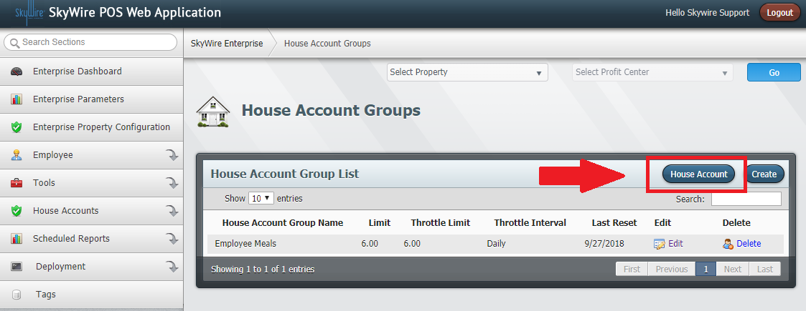

- Select "Create.”

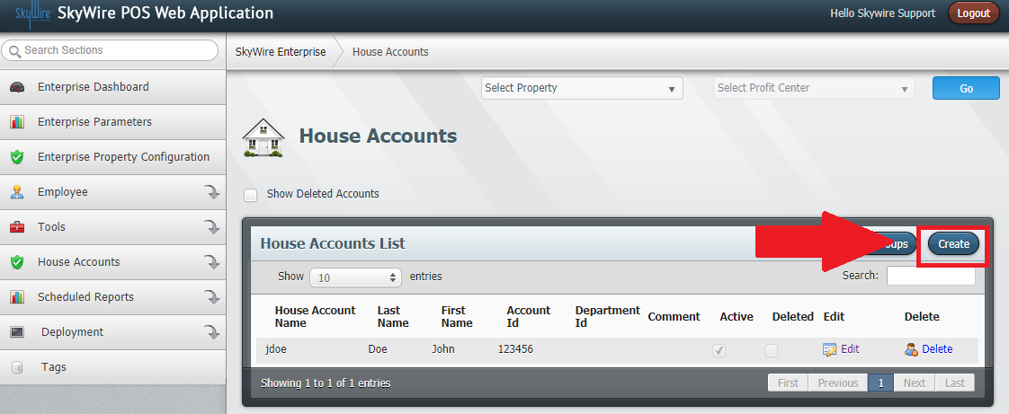
Detailed explanation below.

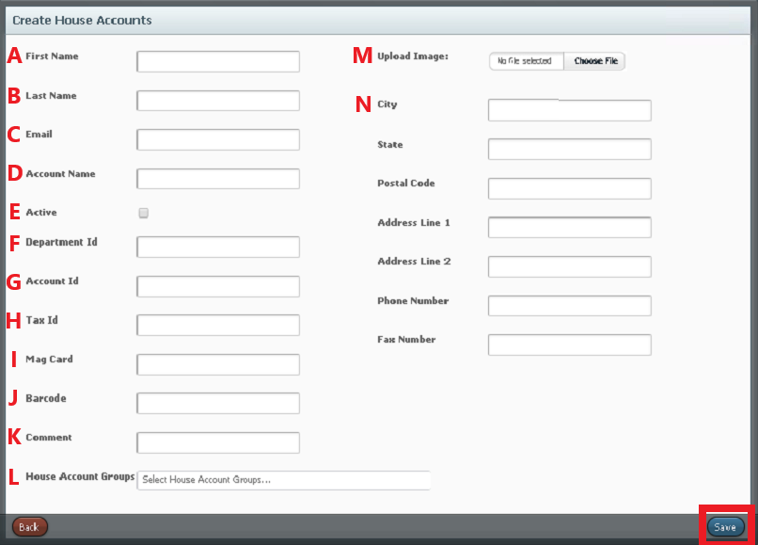

- First Name: Enter the first name of the account user.
- Last Name: Enter the last name of the account user.
- Email: Enter the Email address of the account user.
- Account Name: Enter the name of the account.
- Active: Toggle this option to activate the account.
- Department ID: Enter the department ID. (Optional)
- Account ID: Enter an account ID.
- Tax ID: Enter a tax ID. (Optional)
- Mag Card: Enter the account users mag card number. (Optional)
- Bar-code: Enter the bar-code of the users ID. (Optional)
- Comment: Enter a comment for the user account. (Optional)
- House Account Groups: Select the House Account Group the account user belongs to.
- Image: Upload an image of the account user. (Optional)
- Enter personal information for the account user. (Optional)
  - Select "Save.”

- Confirm the House Account Tender has "House Account" selected for the payment type.

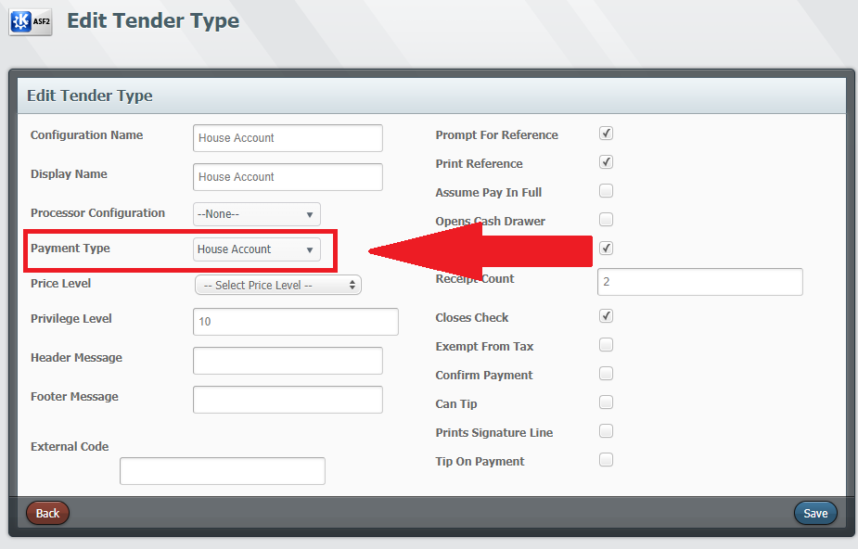

- Confirm the House Account Tender is assigned to the terminal.

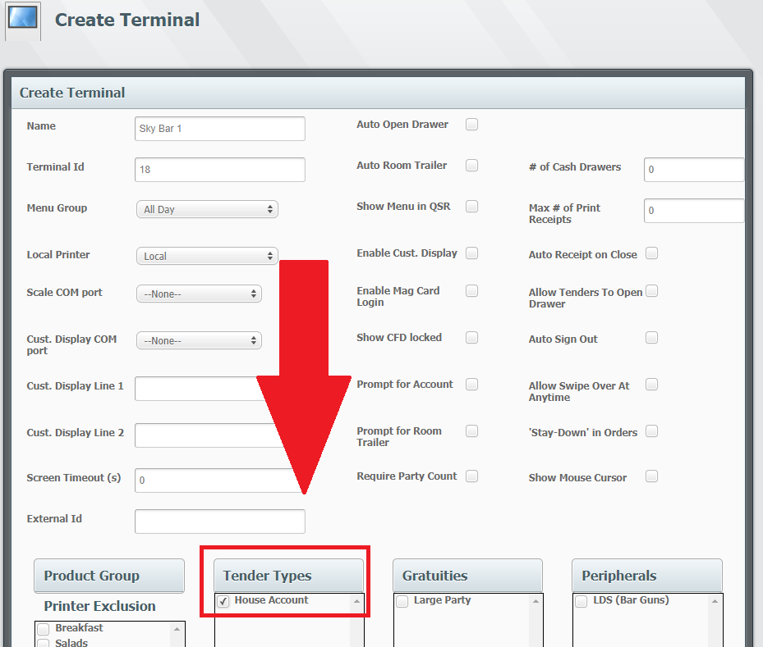

Tags
Tags provide an additional level of reporting for specific sale data or product description. Tags created are assigned to products. Tags can be created at the enterprise level, property level and profit center level.

- Select “Settings.”

- Select “Tags.”
- Select “Create.”

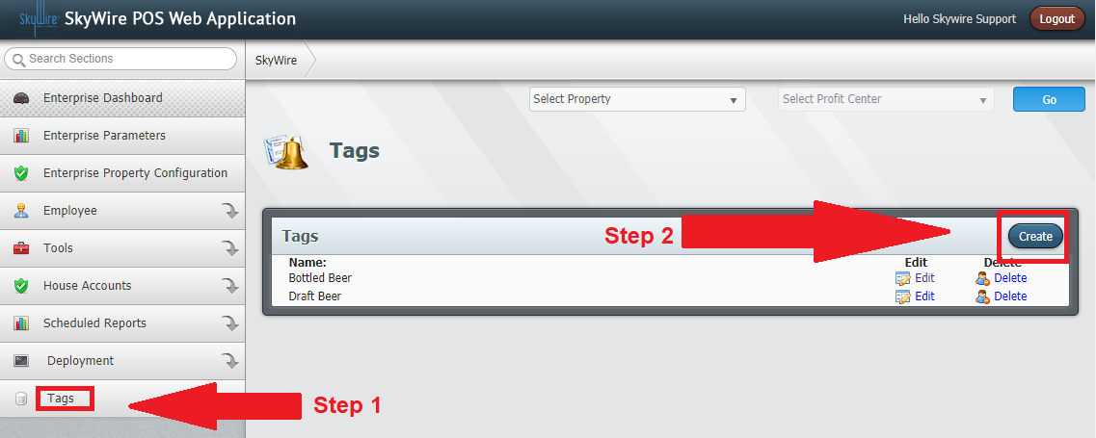

- Enter the name of the Tag.
- Select “Save.”

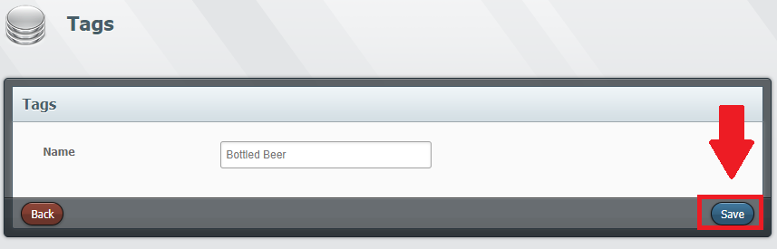

- Confirm the Tag is assigned to the product.

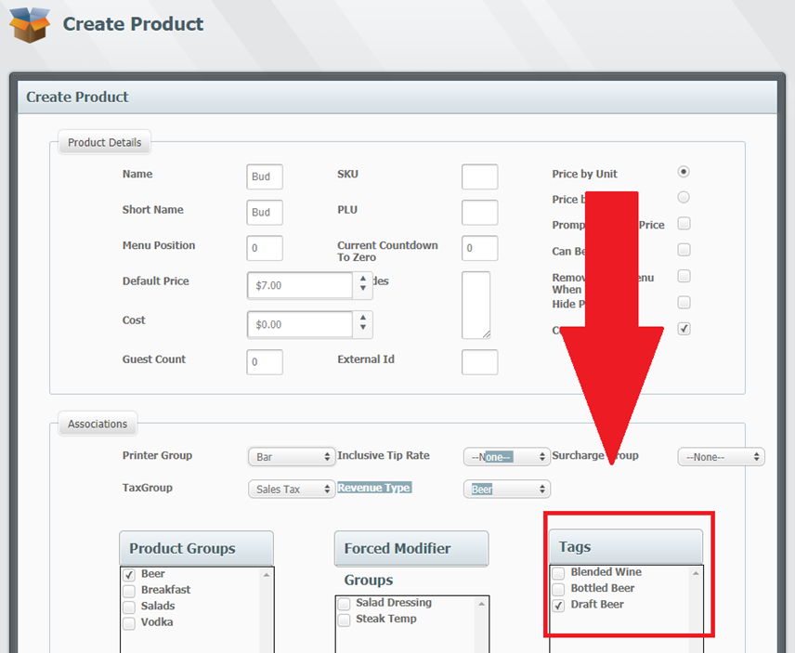

Note: Multiple Tags can be assigned to a product.

Property Level Configuration

How to Create a Profit Center
- Select a Property.
- Select “Go.”

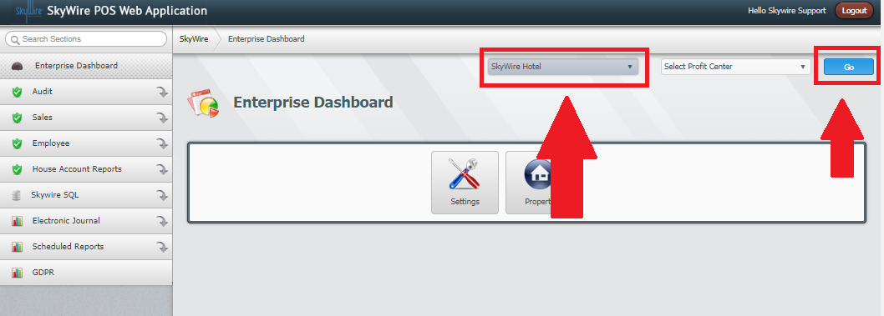

- Select “Profit Center Configuration.”
- Select “Create.”

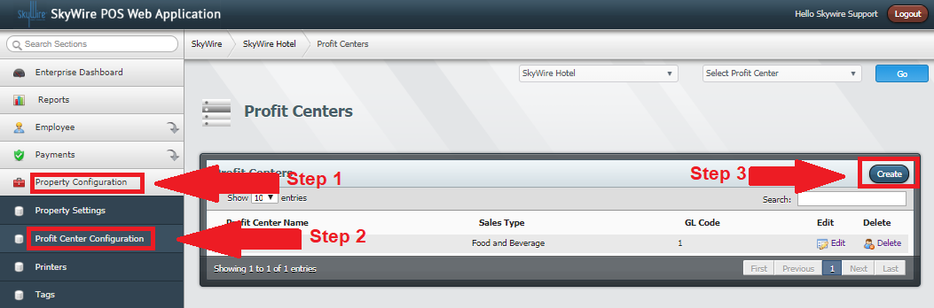

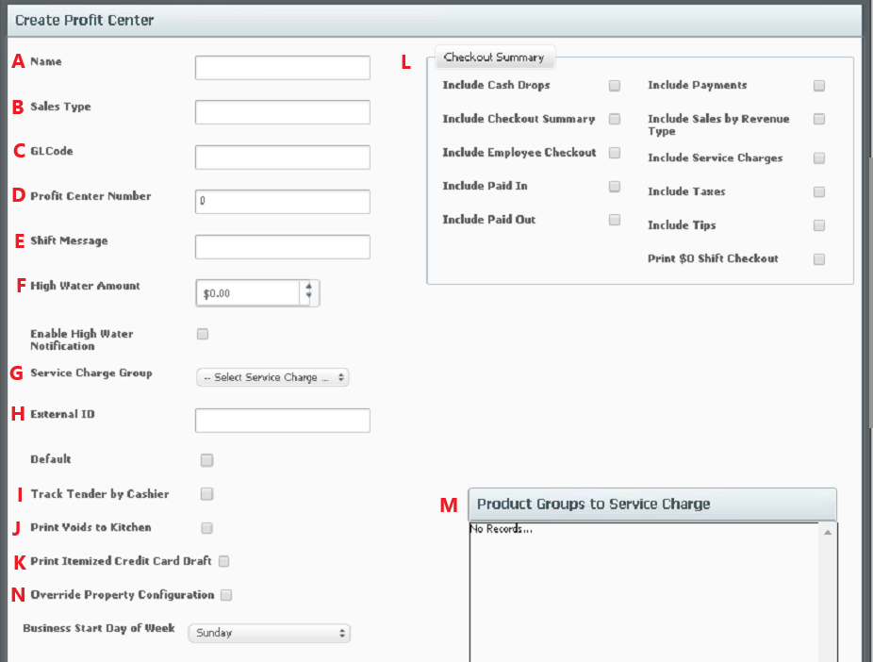

- Name: Enter the name of the profit center.
- Sales Type: Enter the sales type. E.g. food and beverage.
- GL Code: Allows you to enter a General Ledger code for accounting.
- Profit Center Number: A number will automatically populate once a profit center is created. This may need to change depending on interfaces.
- Shift Message: Enter a message to prompt the user on the terminal when starting shift.
- High Water Amount: Set an amount to be notified. Select box underneath to enable notifications.
- Service Charge Group: Select a service charge group if automatic service charges are applicable.
- External Code: Code used for mapping interfaces. Select box underneath to set as default
- Track Tender by Cashier: Select this option to track sales by the cashier of the check. If not selected, sales are tracked by server. Server is the user who opens or owns the check. Cashier is the user who closes the check.
- Print Voids to Kitchen: Select this option to automatically have voided items print to remote printers.
- Print Itemized Cred Card Draft: Select this option to print an itemized copy of the credit card authorization draft. If this option is not selected a draft will print without items.
- Checkout Summary: These are the print options for reports. Select the data to be shown for the profit center.
- Product Groups to Service Charge: Select the product groups to add the automatic service charge to, if applicable.
- Override Property Configuration (detailed description below)

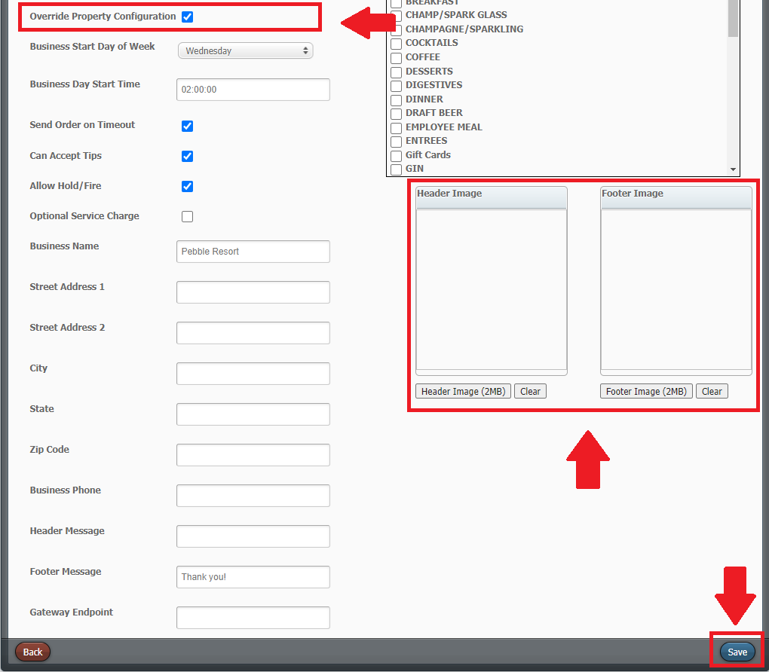
- Override Property Configuration: By default, the profit center will use the property configuration. Select this option to override the property configuration. Once this option is checked, the fields will become available and allow you to input profit center specific information.
- Select this option if using the following:
  - Allow Hold / Fire
  - Optional Service Charges
  - Gateway Endpoint
- Header & Footer Image: Select an image to upload an image for receipt header and footer
- Select “Save.”

Local and Remote Printers

Printers are created to print locally for guest's orders, authorization drafts and terminal reports. They are also created to print remotely to other printers like the kitchen or bar. Remote printers are then assigned to a group and the group is then assigned to a product. For example, a salad that needs to print to cold and expo will need to be assigned to a group containing both printers.

How to Create a Printer in WebConfig

- Select a Property.
- Select “Go.”
- Select "Property Configuration.”
- Select “Printers.”
- Select “Create.”

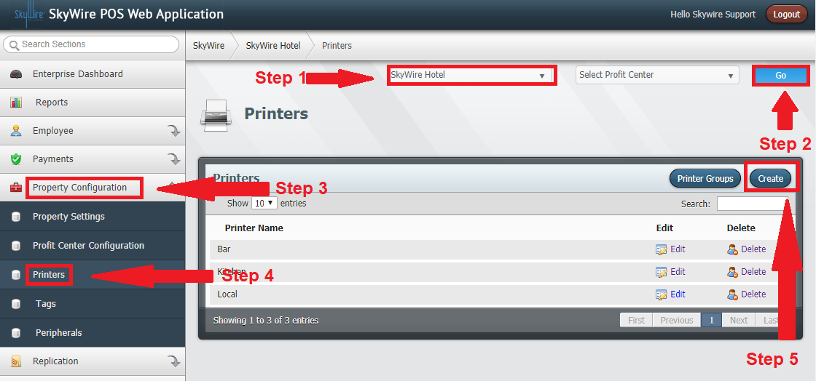

Detailed description below.

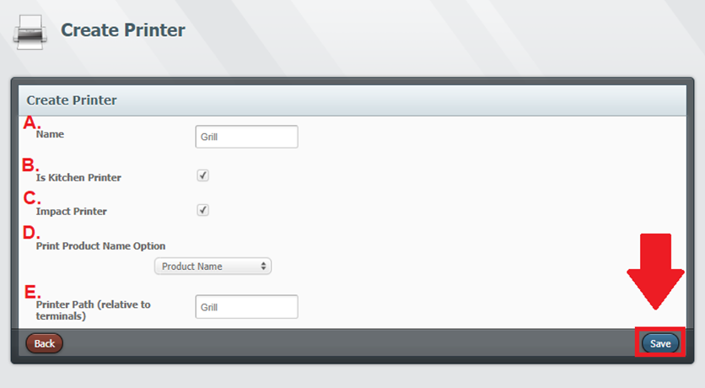
- Name: Enter the name of the printer.
- Is a Kitchen Printer: Check this box for network printers. Local printers connected USB will not need this box checked.
- Impact Printer: Select this option if you are using an impact printer. This will need to be checked to print modifiers and special requests in red.
- Print Product Name: Select an option for name printing. Options include: Product Name, Short Name or Product and Short Name.
- Printer Path: This will be the name of device on the POS terminal.
- Select "Save.”

How to Create a Printer Group

- Select a Property.
- Select “Go.”
- Select “Printers.”
- Select “Printer Groups.”

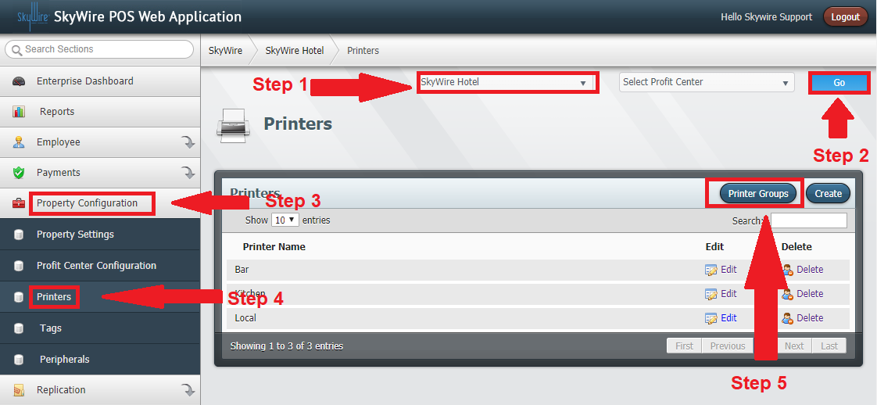

- Select "Create.”

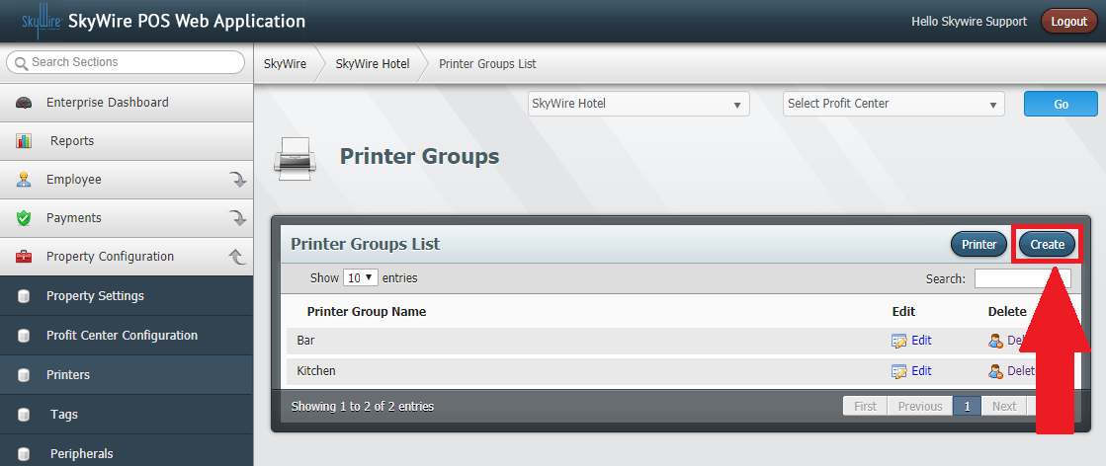
Detailed description below.

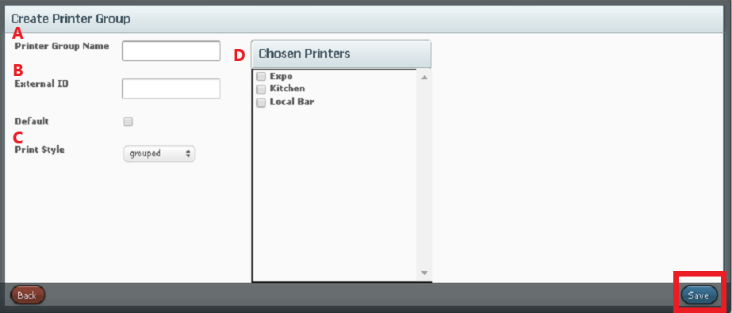

- Printer Group Name: Enter the group name. E.g. Food, for products to print to the kitchen.
- External ID: Enter the External ID for the printer group. External IDs are for POS integrations.
- Printer Style: Options include Grouped or Single.
  - Grouped – Consolidates products.
  - Single – Does not consolidate products.
- Chosen Printers: Choose the printers that the group will print to. This is for remote printers only. Local printers do not need to be assigned to a group.

Confirm the Printer Groups is assigned to the Product.

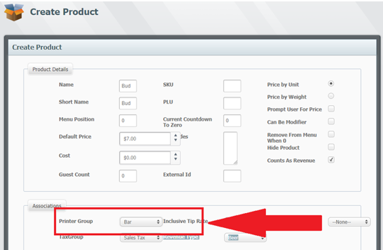

How to Create Peripherals

POS terminals using bar guns and QSR kitchen Video will need a Peripheral configured. Peripherals are then assigned to terminals.

- Select a Property.
- Select “Property Configuration.”
- Select “Peripherals.”
- Select “Create.”

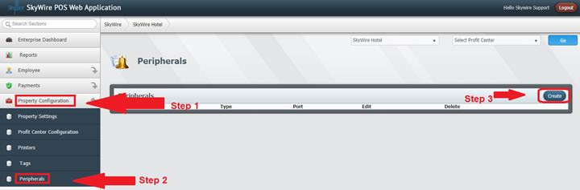

Detailed description below.

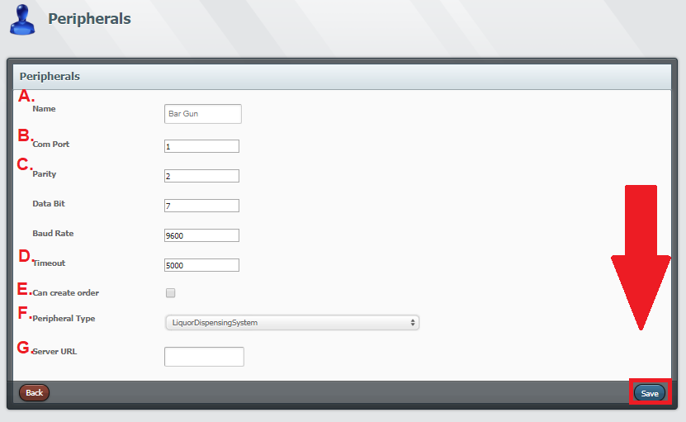
- Name: Enter the name of the peripheral.
- Com Port: Select the com port the peripheral is connected to.
- Enter the specifications for the device.
- Timeout: Enter the time for the device to timeout if the device is not working or not connected.
- Can Create Order: Select this option if the device can create a new order by using it. This option is typically for bar guns. Using the bar gun from the main screen will automatically start an order.
- Peripheral Type: Select the device type.
- Server URL: Enter the server URL for the device. Typically, this option is for kitchen video. Enter the destination for the kitchen display system.

- Select “Save.”

Confirm the Peripheral is assigned to the terminal (s) using a bar gun or kitchen display system.

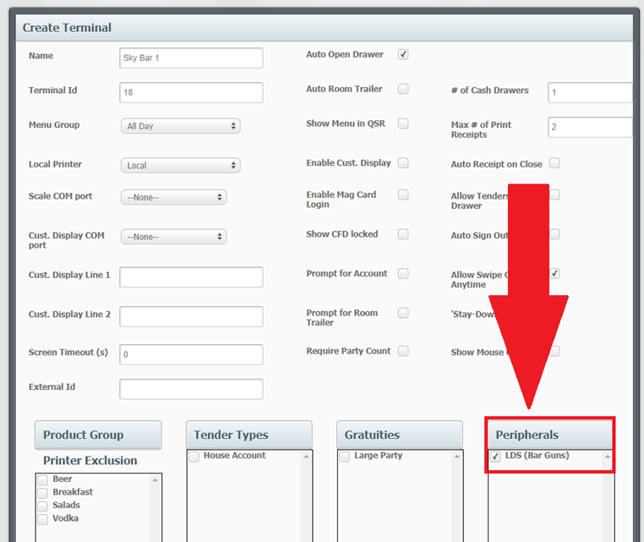

Check Trailers

Check Trailers can be configured to print at the bottom of the check. There are two default trailers that can be used for room charges and tip lines. Default trailers cannot be deleted or modified. To view default trailers, select "Edit.” Check Trailers can also be created and customized. Check Trailers are assigned then assigned to terminals.

Create a Custom Check Trailer

- Select a Property.
- Select "Go.”
- Select "Property Configuration.”
- Select "Check Trailers.”
- Select "Create.”

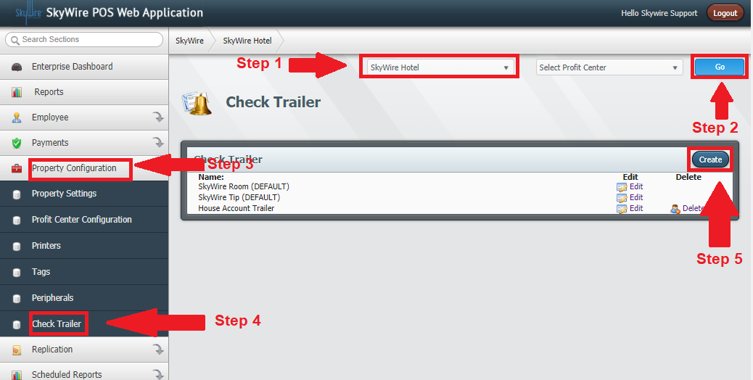

Detailed description below.

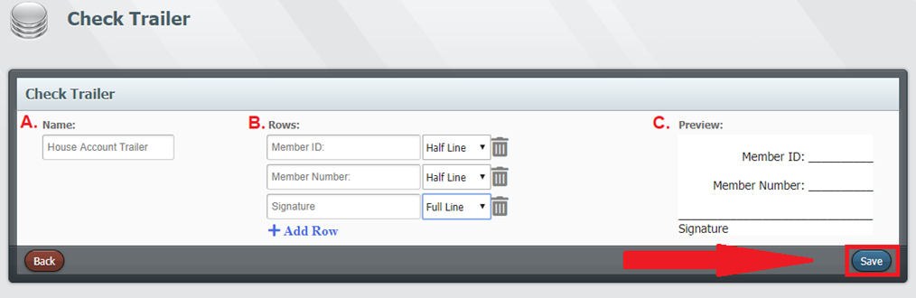
- Name: Enter the name of the customer check trailer.
- Rows: Enter the information you would like to see on the check trailer. Select "Half Line" or "Full Line" to change the size of the line. Select the trash icon to delete the row. Select "+ Add Row" to add rows to the check trailer.
- Preview: Preview the check trailer.
- Select "Save.”

Confirm the check trailer is assigned to terminal (s).

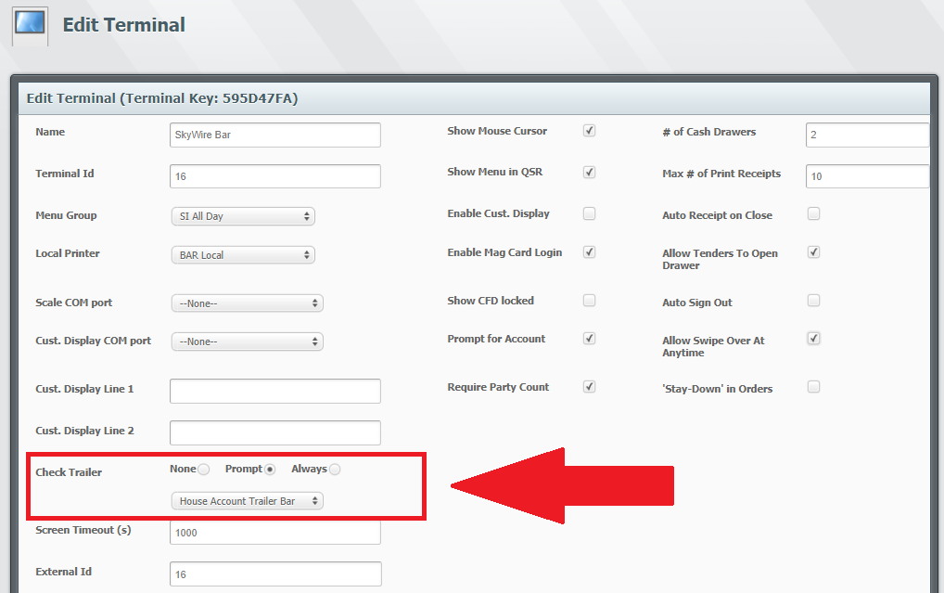

Property Level Users

All users will need an Access Level, User and User Role created or assigned. See “Enterprise Level Users.”
- Select a Property.
- Select "Go.”
- Select "Employee.”
- Create an Access Level.
- Create a User.
- Create a User Role.

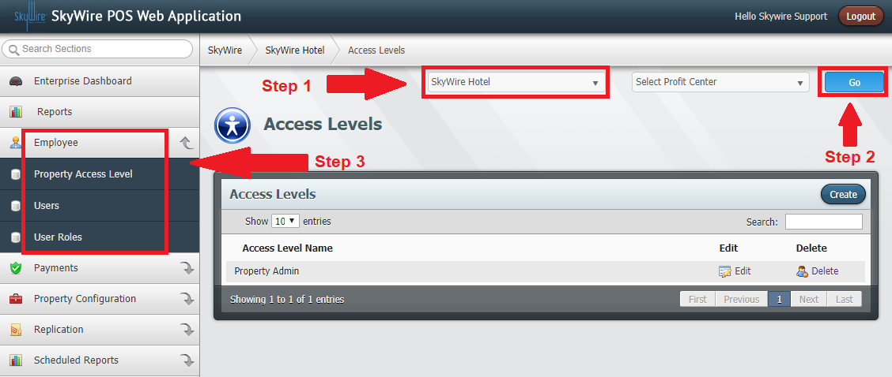

Payment Configuration

Tenders

Tenders are forms of payment. Tenders can be interactive and non-interactive. Tenders that act like cash would be considered non-interactive because it does not require a two-way flow of information. Credit cards would be considered an interactive Tender because it does require a two-way flow of information. Interactive Tenders will need an electronic payment configured prior to creating the Tender. Tenders are created at the property level and are assigned to terminals. All profit centers in the property will have access to the Tenders created.

How to Create Tenders
- Select a Property.
- Select "Go.”
- Select "Payments.”
- Select "Tenders.”
- Select "Create.”

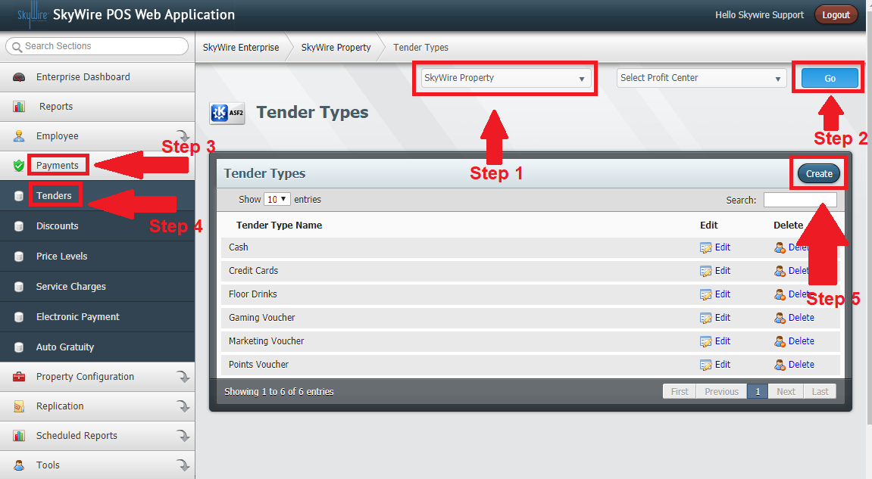

See detailed description below.

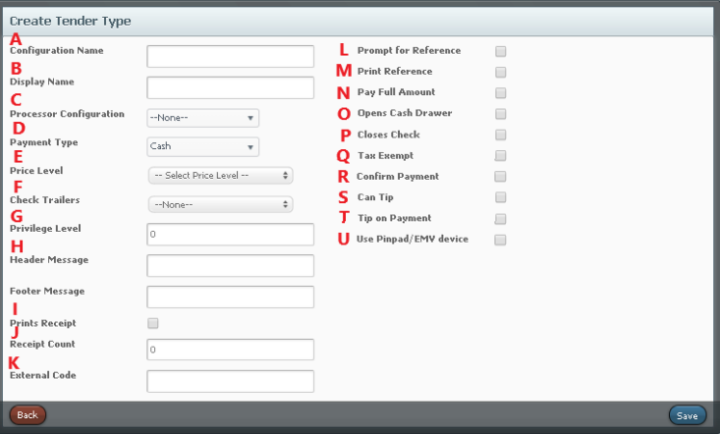

- Configuration Name: Enter the name used for configuration.
- Display Name: Enter the name to be displayed on the terminal and for reports.
- Processor Configuration: Use the drop down to select processor configuration. This is created in electronic payment.
- Payment Type: Select a payment type. Options include cash, house account or other when the tender does not have an electronic payment. Payment types will change based on processor configuration.
- Price Level: Select a price level to be applied after the tender is applied, if applicable.
- Check Trailer: Select a check trailer to print when the tender is applied.
- Privilege Level: Select a number from 0-10, 0 being the highest and 10 being the lowest level of privilege. Privilege levels dictate which users can apply tenders created. The privilege level is also configured in "User Roles.” Confirm the privilege level correlates with the users who need to apply the tender.
- Header and Footer Message: Enter a message for the header or footer for the receipt.
- Prints Receipt: Select this option to print a receipt once the tender is applied.
- Receipt Count: Enter the number of receipts to print.
- External Code: Code for mapping interfaces.
- Prompt for Reference: Select this option to prompt the user to input data when applying this tender.
- Print Reference: Select this option to print the input data.
- Pay Full Amount: Select this option if the tender closes the check without giving an option to apply multiple or partial payments.
- Opens Cash Drawer: Select this option to open the cash drawer when the tender is applied.
- Closes Check: Select this option to close the check after the tender is applied.
- Exempt from Tax: Select this option to remove tax when this tender is applied.
- Confirm Payment: Select this option for a confirmation prompt before the tender is applied.
- Can Tip: Select this option to prompt for tip when closing order.
- Tip on Payment: Select this option to prompt for tip before the tender is applied.
- Use Pinpad / EMV device: Select this option when using a payment device.
- Select “Save.”
- Confirm the Tender is assigned to terminal (s) applicable.

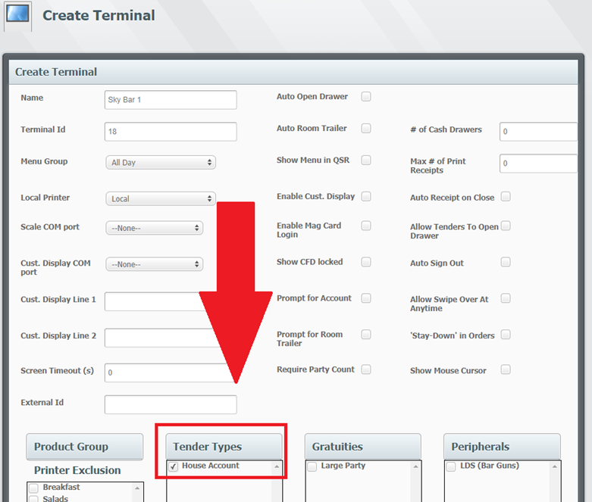

How to Create an Electronic Payment

- Select a Property.
- Select “Go.”

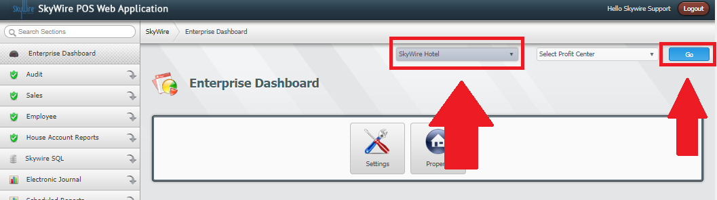

- Select “Payments.”
- Select “Electronic Payments.”
- Select “Create.”

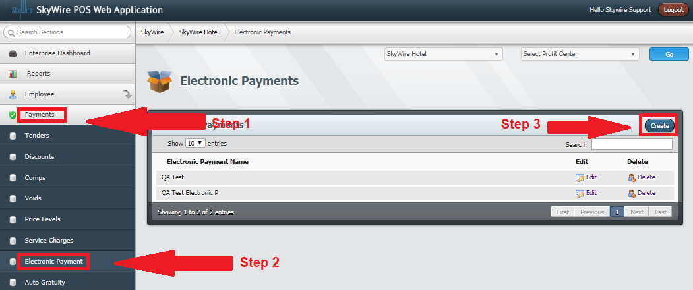

See detailed description below.

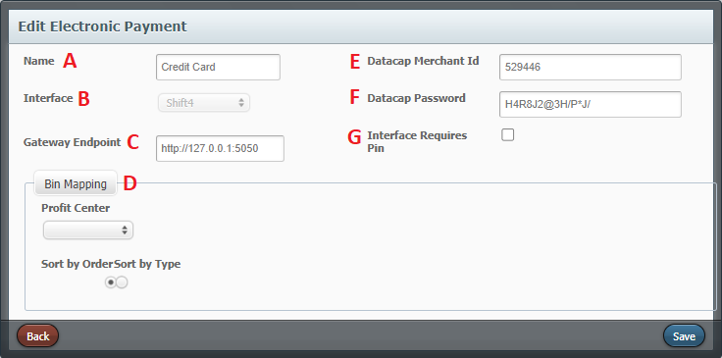

- Name: Enter the name of the electronic payment.
- Interface: Select the interface type.
- Gateway Endpoint: Enter the IP and port number
- Bin Mapping: See below to assign Bins to Revenue Types
- Datacap Merchant ID: Information provided by 3rd party
- Datacap Password: Information provided by 3rd party
- Require Pin: Select this option if this payment requires a pin number.

Create BINs for Mapping Interfaces

BIN Mapping is setup on a per Profit Center basis to ensure that all items and revenue types are being mapped correctly.

NOTE: All Electronic Payments of the same type (like LMS) will use the same bin mapping.

See detailed description below.

To create BINs:
- select a property, then hit go
- Select “Electronic Payments” under the “Payments tab”.
- Select “Edit” if creating bins for an existing electronic payment or “Create” to create a new electronic payment method.

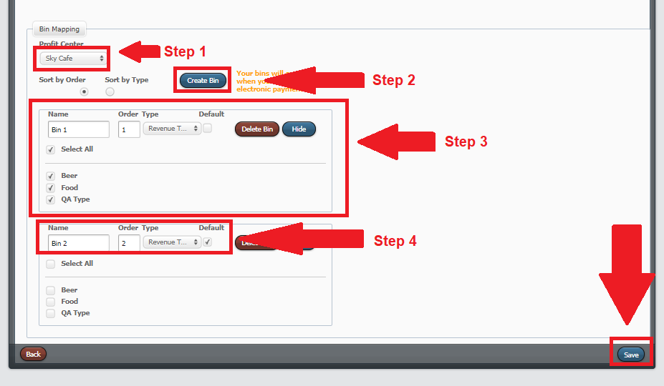

- Select a profit center.
- Select “Create Bin.”
- Select a type to map and select the itemizers for that bin. For each type, there can be one BIN designated as the default and any selection can only exist in one BIN. If a bin is marked as default, any un-mapped selection of its type will be associated to it. Only 1 default is allowed for each type.
- Select “Save.”

Price Levels

Price Levels allow for a product's selling price to change under certain circumstances. To change the product price based on day and time, assign the desired Price Level to the menu applicable. Price levels can also be assigned to house account groups. Price Levels assigned to menus and house account groups will take effect once the products assigned Price Levels are applied.
Price Levels can also be assigned to tenders. When the form of payment is used to dictate the selling price of a product, assign the Price Level to the tender applicable. Price Levels assigned to tenders will take effect once they are applied.
Note: Price Levels assigned to tenders will be the final Price Level used.

How to Create a Price Level
- Select a Property.
- Select “Payments.”
- Select “Price Levels.”
- Select “Create.”

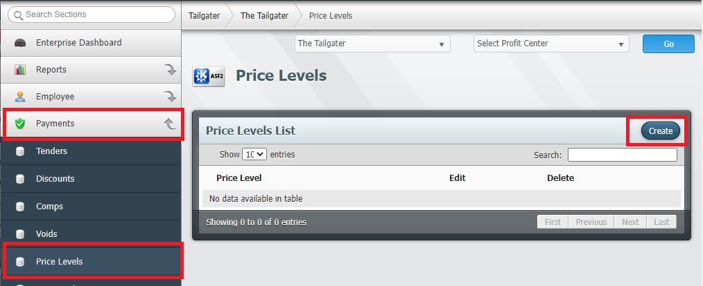
- Enter the name of the Price Level.
- Select “Save.”

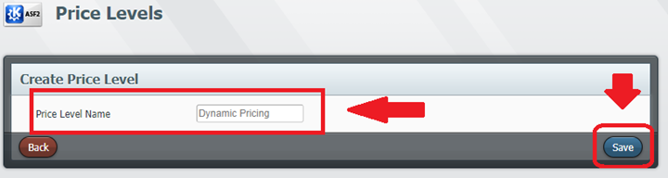

Confirm the Price Level is assigned at the bottom of the product form.

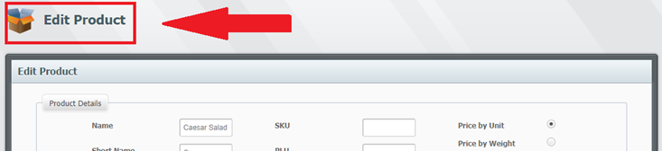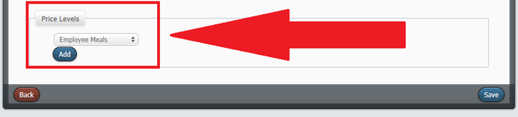
If using menus to dictate Price Level, confirm the Price Level is assigned to the menu applicable.

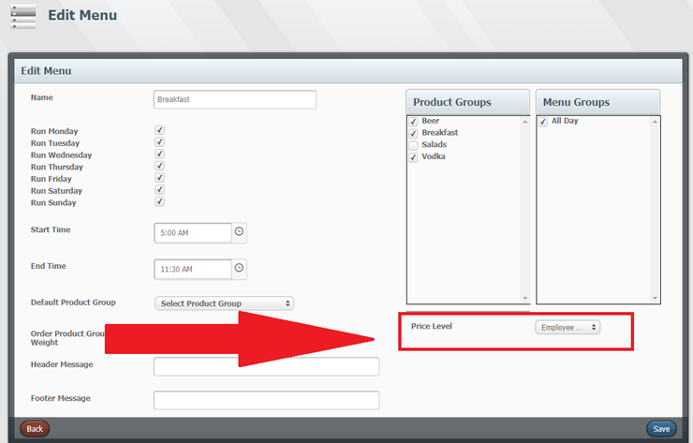
If using a tender to apply the Price Level after the payment is applied, confirm the Price Level is assigned to the tender.

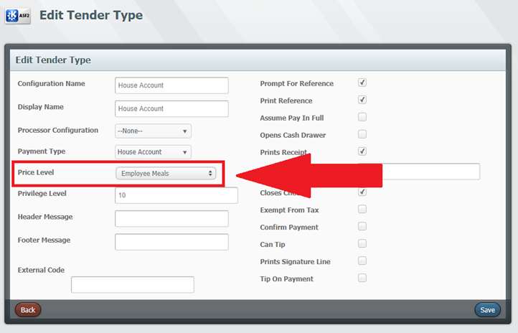

If using house account groups to apply the Price Level after the account is selected, confirm the Price Level is assigned to the tender.

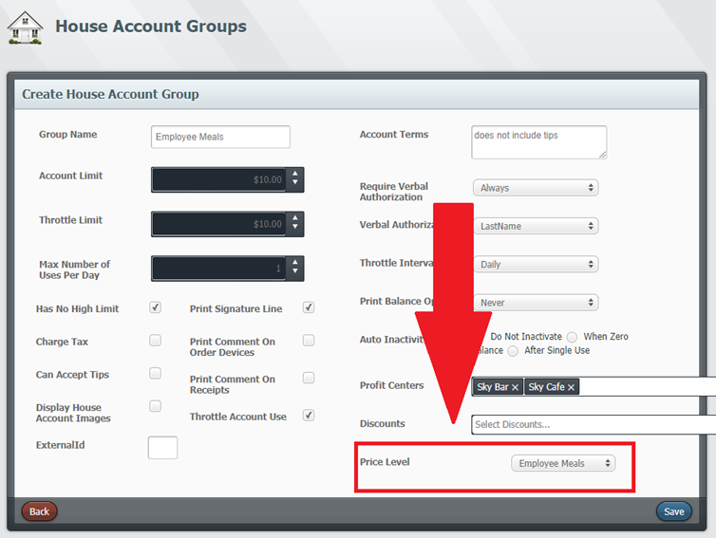

Discounts

Discounts are created to deduct an amount in price for promotions or specials. They can also be created to deduct an amount in price for employees or locals.

How to Create Discounts

- Select a Property.
- Select “Payments.”
- Select “Discounts.”
- Select “Create.”

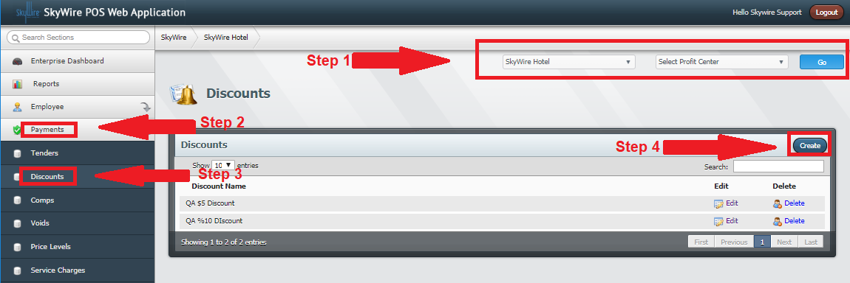

- Discount Reason: Enter the name if the discount.
- GL Code: Code for General Ledger Accounts, if applicable.
- Header and Footer Messages: Enter Header and Footer Messages for receipts, if applicable.
- Header and Footer Messages: Enter Header and Footer Messages for receipts, if applicable.
- External ID: Code for mapping interfaces.
- Prompt for Reference: Select this option to prompt the user to input data when the discount is applied.
- Print Reference Information: Select this option to print the input data.
- Open Amount: Select this to allow users to put in custom amounts for the discount.
- Print Signature Line: Select this option to print a signature line on the receipt.
- Is a Percentage Amount: Select this option to deduct a percentage.
- Is a Dollar Amount: Select this option to deduct an amount.
- Maximum Amount: Enter the amount of the discount, or comp.
- Can Combine with Other Discounts: Select this option if the discount is not exclusive.
- Use SkyWire Coupon API: Select this option if using SkyWire Coupon Api. (Optional)
- This is a Mobi Mantis Discount: Select this option if using Mobi Mantis. (Optional)
- Is a Percentage Amount: Select this option to deduct a percentage.
- IS a Dollar Amount: Select this option to deduct an amount.
- Maximum Amount: Enter the amount of the discount, or comp.
- Can Combine with Other Discounts: Select this option if the discount is not exclusive.

See photo below.
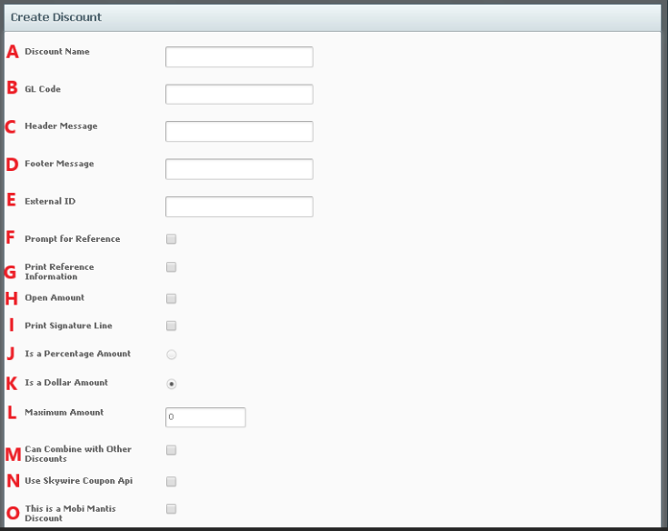

Select which Profit Center(s) this Discount will be available at.

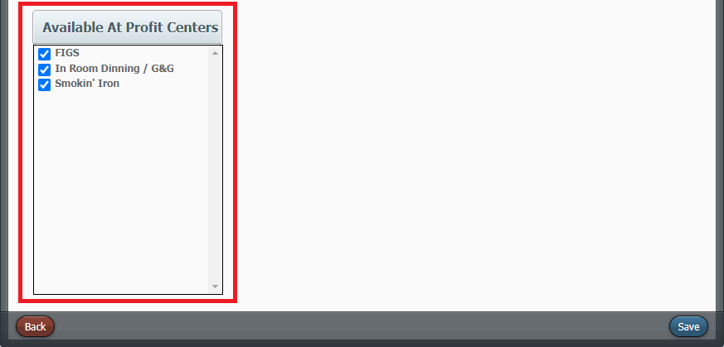

Comps

Comps are created to account for product that is being given away complementary. They can deduct a portion or deduct the entire amount in price. The amount deducted is paid for by the house.

How to Create Comps

- Select a Property.
- Select “Payments.”
- Select “Comps.”
- Select “Create.”

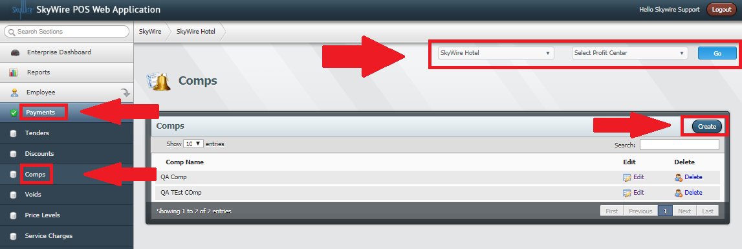

- Comp Reason: Enter the name if the comp.
- GL Code: Code for General Ledger Accounts, if applicable.
- Header Message: Enter Header Messages for receipts, if applicable.
- Footer Messages: Enter Footer Messages for receipts, if applicable.
- External ID: Code for mapping interfaces.
- Price Level: Select a Price Level, if applicable.
- Prompt for Reference: Select this option to prompt the user to input data when the comp is applied.
- Print Reference Information: Select this option to print the input data.
- Print Signature Line: Select this option to print a signature line on the receipt.
- Available at Profit Centers: Select which profit centers this comp is applicable for.
- Select “Save.”

See photo below.
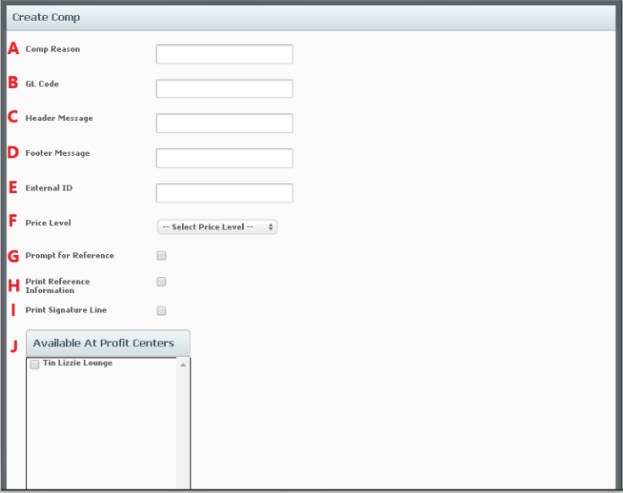

Void Reasons

Voids are created to account for mistakes. Voids deduct the entire amount and count the product as consumed but no revenue is collected. Discounts, Comps and Void Reasons are all created under Payments in WebConfig.

How to Create Void Reasons

- Select a Property.
- Select “Payments.”
- Select “Voids.”
- Select “Create.”

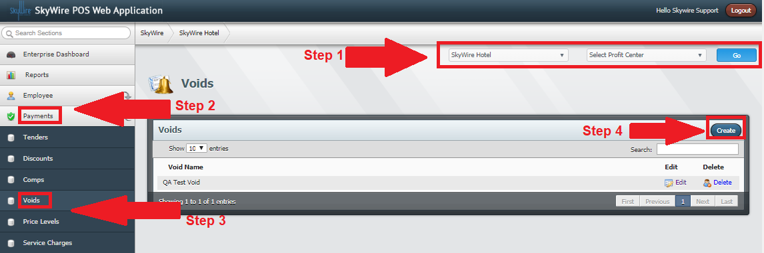

- Void Reason: Enter the name if void reason.
- GL Code: Code for General Ledger Accounts, if applicable.
- Header Message: Enter Header Messages for receipts, if applicable.
- Footer Messages: Enter Footer Messages for receipts, if applicable.
- External ID: Code for mapping interfaces.
- Price Level: Select a Price Level, if applicable.
- Prompt for Reference: Select this option to prompt the user to input data when the void is applied.
- Print Reference Information: Select this option to print the input data.
- Print Signature Line: Select this option to print a signature line on the receipt.
- Available at Profit Centers: Select which profit centers this void is applicable for.
- Select “Save.”

See photo below.
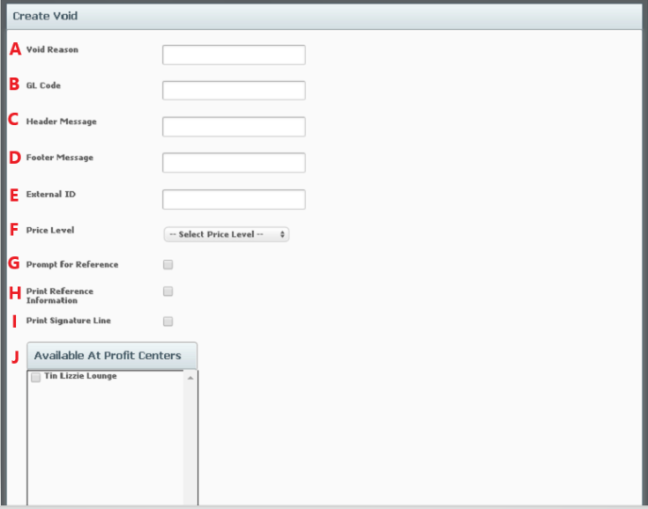

Service Charges

A Service Charge is typically an extra charge assessed for a provided service. Service Charges are created and then assigned to a group. Service Charge Groups are assigned to profit centers, products or modifiers.

How to Create a Service Charge

- Select a Property.
- Select “Payments.”
- Select “Service Charges.”
- Select “Create.”

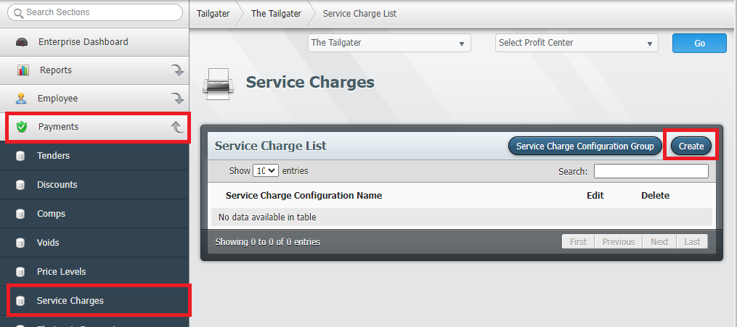
Detailed description below.

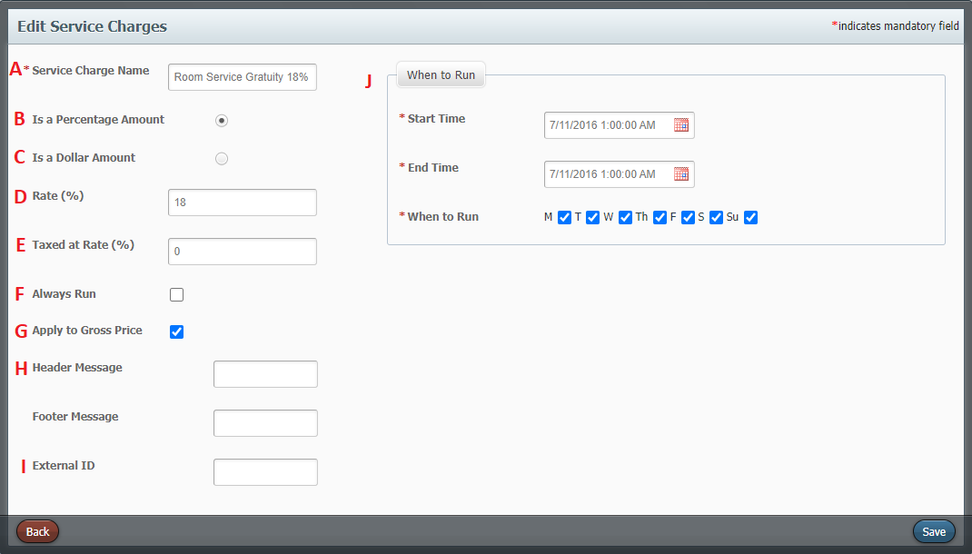
- Service Charge Name: Enter the name of the service charge.
Is a Percentage Amount: Select if this will be a percentage
- Is a Dollar Amount: Select if this will be a flat dollar amount
- Rate: Enter the service charge rate, either percentage or flat dollar amount
- Taxed at Rate: Enter the tax rate if the service charge should be taxed.
- Always Run: Select this option to always apply this service charge.
- Apply to Gross Price: Select this option to apply the service charge to the gross price. If this option is unchecked, the service charge will be applied to the net price. Net is the remaining amount after discounts have been applied. Gross amount is the amount prior to discounts being applied.
- Header and Footer Message: Enter a header or footer message to print on the receipt when this service charge is applied.
- External Code: Code for mapping interfaces, if applicable.
- When to Run: Select the start and end times when “Always Run” is not selected.
- Select “Save.”

How to Create a Service Charge Group

- Select “Service Charge Configuration Group.”

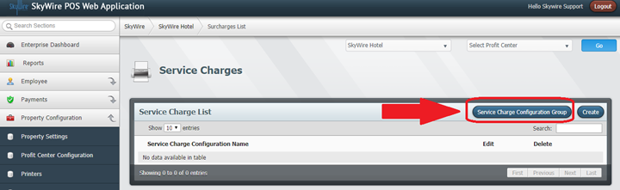

- Select “Create.”

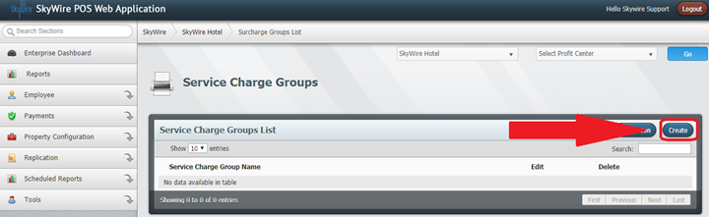

- Enter the name of the service charge group.
- External ID: Used for mapping interfaces
- Default: Select to make this service charge the default
- Configurations in Group: services charges that have been added to this service charge group.
- Available Service Charges: Service charges that are available to be added to the group.

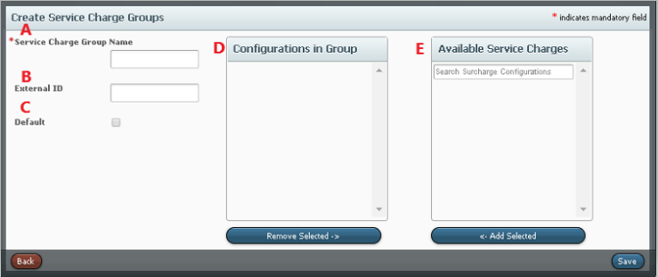

To always apply the service charge, assign the Service Charge Group to the profit center. Then select the Product Groups that the Service Charge can be applied to.

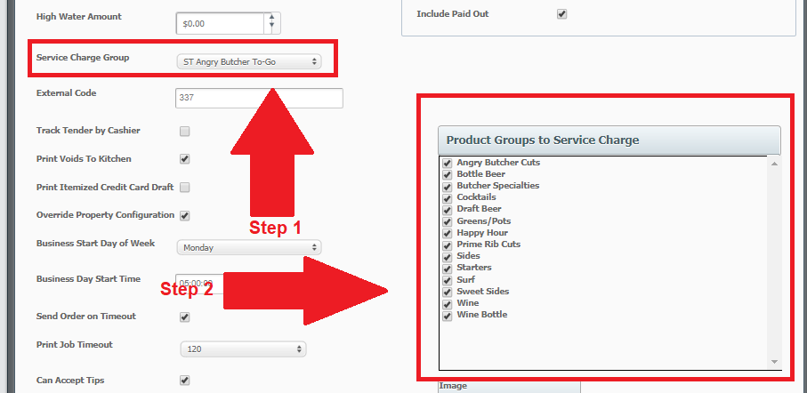
To prompt the user to optionally apply a Service Charge, select the Product Groups the Service Charge Group can be applied to.

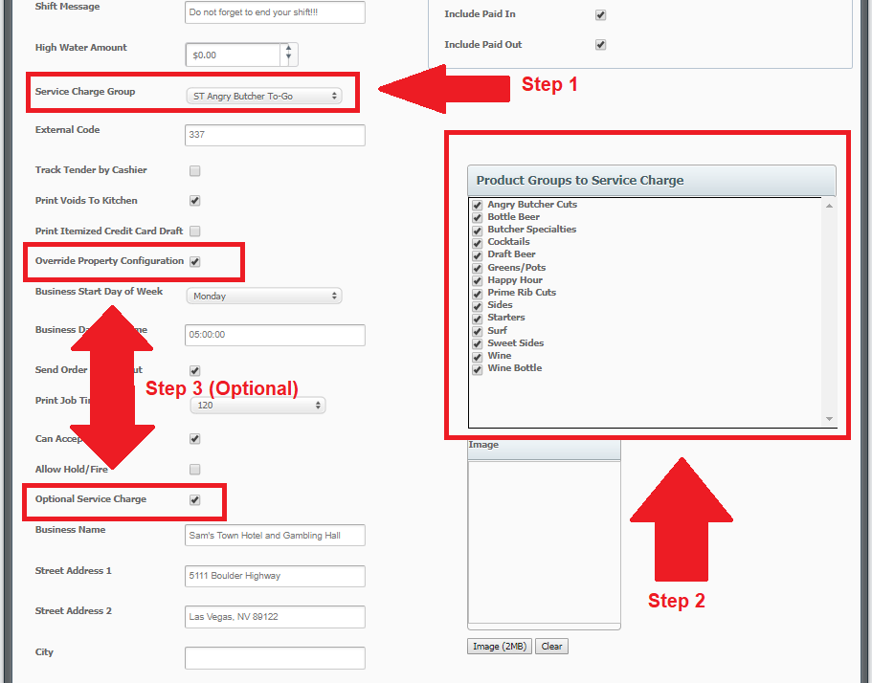

Service Charge Groups can also be applied to a product under Surcharge Group.

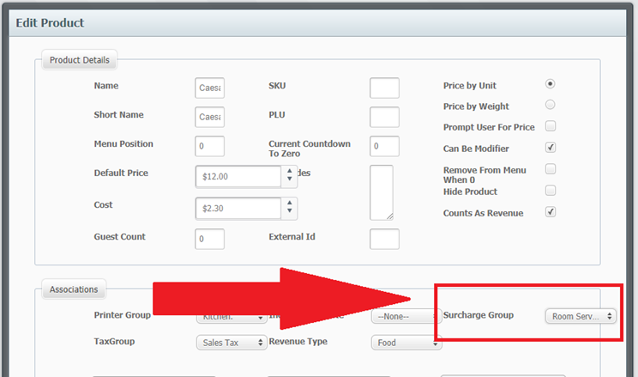

Automatic Gratuities

A gratuity, also known as a tip, can be created and configured to calculate on an order automatically. Auto Grats created are then assigned to terminal (s).

How to Create an Auto Grat

- Select a Property
- Select “Payments.”
- Select “Auto Gratuities.”
- Select “Create.”

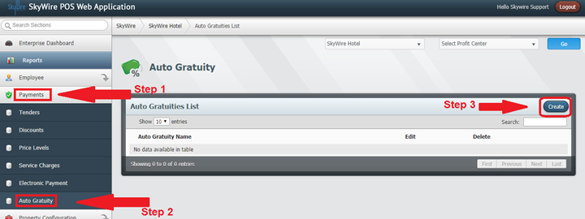

Detailed description below.

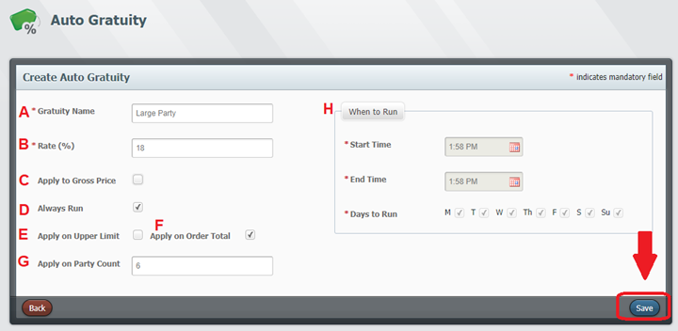

- Gratuity Name: Enter the name of the Gratuity.
- Rate: Enter the gratuity percentage.
- Apply to Gross Price: Select this option to apply the gratuity to the gross amount. When this option is not selected, the gratuity will be applied to the net amount. Net is the remaining amount after discounts have been applied. Gross amount is the amount prior to discounts being applied.
- Always Run: Select this option to always apply this gratuity.
- Apply on Upper Limit: Select this option to apply this gratuity only if the order is over the specified amount.
- Apply on Order Total: Select this option to apply this gratuity to the total amount.
- Apply on Party Count or Apply on Upper Limit: This field will allow to enter a guest count for the gratuity to be applied when selecting "Apply on Order Total.” If “Apply Upper Limit” is selected, then the field will allow you to enter the amount.
- When to Run: Select the start and end times when “Always Run” is not selected.
- Select “Save.”

Confirm the Auto Grat is assigned to terminal (s).

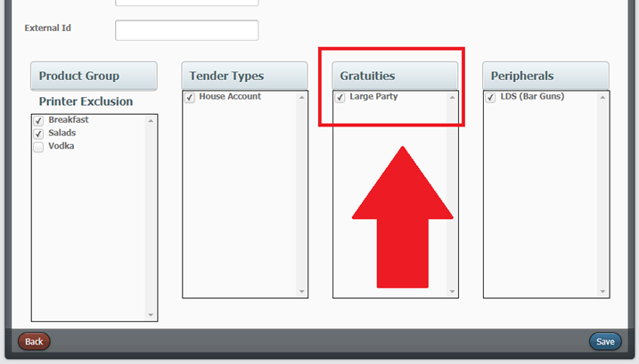

Profit Center Level Configuration

POS Terminals

POS Terminals are to be configured in the profit center where they will exist. Terminal configuration tab dictates products, printing, hardware, tenders and other components that can or will be used.

How to Create a Terminal

- Select a Property.
- Select a Profit Center.
- Select "Go.”
- Select "Profit Center Configuration.”
- Select "Terminals.”
- Select "Create.”

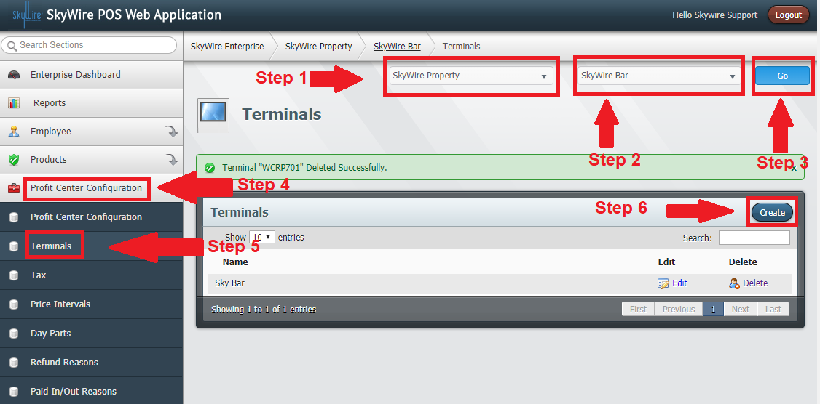

Detailed description below.

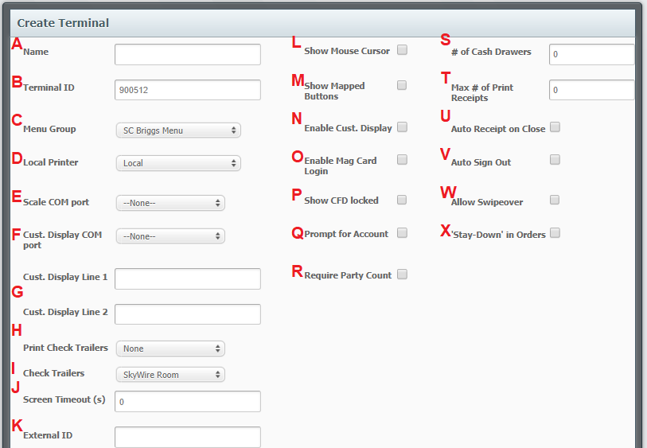
- Name: Enter the Terminal name. The name must match the PC name.
- Terminal ID: Assign a terminal Number. An ID will automatically populate when a terminal is created but can be changed. This will be the number used in the order ID.
- Menu Group: Assign a menu group.
- Local printer: Assign a Local receipt printer. All terminals in the profit center must have the same name for local printers.
- Scale COM Port: Select the port number the scale is connected to. (Optional)
- Cust. Display COM Port: Select a port number the customer display is connected to. (Optional)
- Cust. Display Line 1& 2: Enter the text to display on the customer face display device. (Optional)
- Print Check Trailers: Select a check trailer and select when the trailer should print.
- Check Trailers: Select a check trailer and select when the trailer should print.
- Screen Timeout (s): Enter in seconds, how long the terminal can stay on an order screen before timing out if the terminal is idle. This will take the user to the lock screen. Enter 0 to disable the auto timeout.
- External ID: Enter an external ID number for mapping interfaces. (Optional)
- Show Mouse Cursor: Select this to allow a computer mouse to be used to control the terminal.
- Show Mapped Buttons: Select this option to enable quick service rows. These are to show Map Ordered Buttons configured.
- Enable Cust Display: Select this option to enable a customer face display device on the terminal.
- Enable Mag Card Login: Enable users to sign-in to the terminal using a Mag Card.
- Show CFD Locked: Select this option to show “Locked” on Customer Face Display when the terminal is left idle.
- Prompt for Account: Select this option for house account interfaces that require the user to enter an account when starting an order.
- Require Party Count: Select this option to prompt for guest count when starting an order.
- # of Cash Drawers: Enter the number of cash drawers connected to the terminal.
- Max # of Print Receipts: Enter how many receipts a user can print before a manager approval is required.
- Auto Receipt on Close: Select this option to print a receipt when an order is closed.
- Auto Sign Out: Select this option to sign the user off the terminal after each transaction.
- Allow Swipe Over at Any Time: Select this option to allow a user to swipe over an existing user and take over the screen transaction. If the order is open, this will also change the owner of the order, like a transfer.
- Stay Down in Orders: Select this option to prevent the terminal from going to the lock screen after each transaction. When this option is not selected the terminal will ask for a table number when an order is started.

Detailed description below.

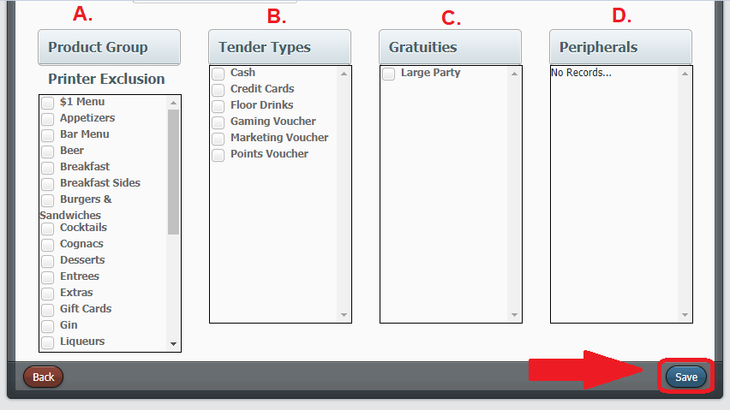

- Product Group Printer Exclusions: Select the Product Groups to exclude from printing.
- Tender Types: Assign tenders the terminal will use.
- Gratuities: Assign Auto Gratuities the terminal will use.
- Peripherals: Assign peripherals if the terminal is going to use bar guns.
- Select "Save.”

Advanced Tab

The Advanced Tab allows you to access additional, advanced terminal settings.

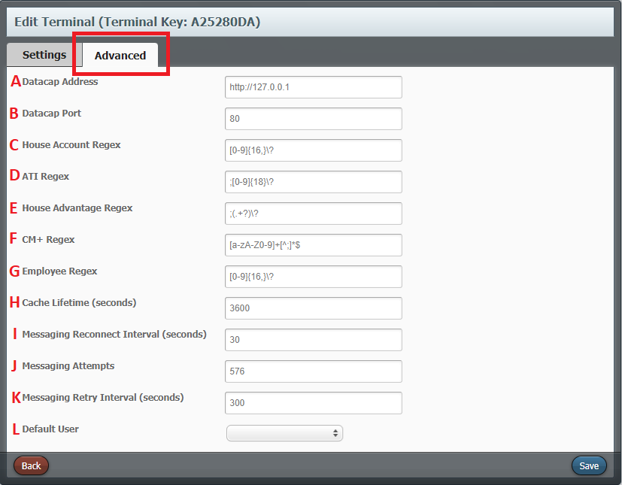

- Datacap Address: Endpoint of the Datacap software
- Datacap Port: Port for Datacap software
- House Account Regex: Regex applied to card swipes for House Account charges
- ATI Account Regex: Regex applied to card swipes for ATI charges
- House Advantage Regex: Regex applied to card swipes for House Advantage charges
- CM+ Regex: Regex applied to card swipes for CM+ charges
- Employee Regex: Regex applied to card swipes for Employee login / Swipe Over
- Cache Lifetime: How often POS will refresh users
- Messaging Reconnect Interval: How often the POS will attempt to reconnect to Web Config to post sales
- Messaging Attempts: How many times POS will attempt to post a sale
- Messaging Retry Interval: How often POS will attempt to repost a sale that failed

Cache Lifetime

In order to better support Imports and ensure that the POS will have more accurate information, the POS will fully refresh Product and Menu information at preset intervals.In the Advanced Terminal Settings, you can find an option for Cache Lifetime. This will tell the terminal to refresh the products and menus at an interval based on that time.
For example, if Cache Interval is set to 90 minutes, then the POS will refresh at 1:30 AM, 3:00 AM, 4:30 AM, etc.

Taxes

Taxes rates are configured at the profit center level. Taxes created are then added to a group. Tax Groups are then assigned to products and modifiers. Taxes can be exclusive, inclusive or a flat fee.

How to Configure Taxes
- Select a Property.
- Select a Profit Center.
- Select "Go.”
- Select "Profit Center Configuration.”
- Select "Tax.”
- Select "Create.”

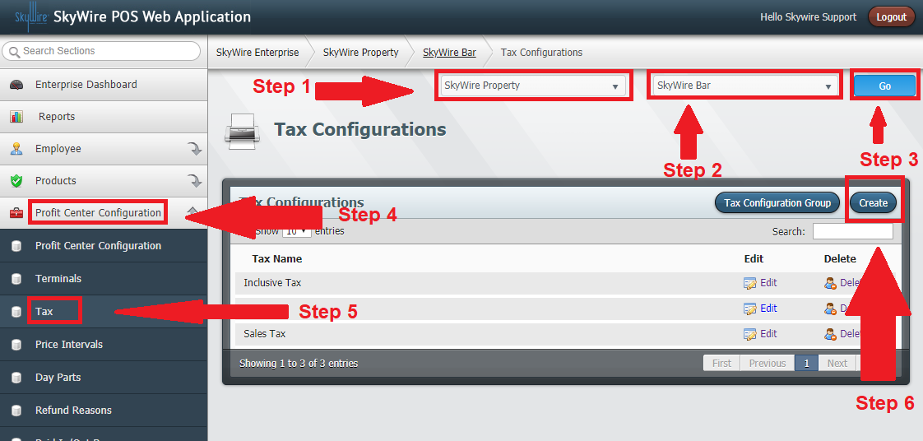

See Photo below.

- Name: Enter the name of the tax.
- Prefix: Enter a prefix for the tax. This will print as a prefix to the product on the printed receipt.
- External ID: Used for mapping interfaces
- Is Flat Fee: Toggle this option if the tax is a flat fee rather than a percentage.
- Rate: Enter the tax rate percentage.
- Is Inclusive: Toggle this option if the tax in inclusive (hidden).
- Always Run: Toggle this option if the tax rate is always applied.
- Apply to Gross Price: Toggle this option if the tax is applied to the gross price. When this option is not selected the tax is applied to the net price.
- Print on Receipt: Toggle this option if the tax should print on the receipt.
- When to Run: Enter a time to run the tax if it is not set to always run.
- Select "Save.”

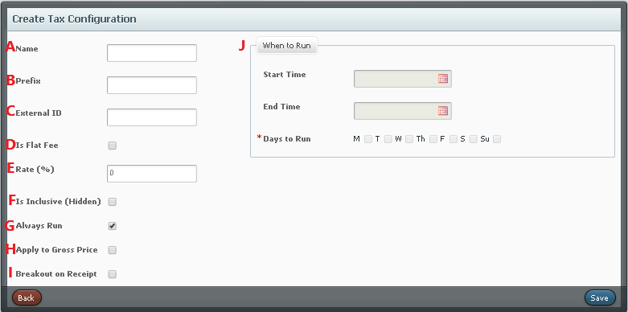

How to Create a Tax Group

- Select "Tax Configuration Group.”

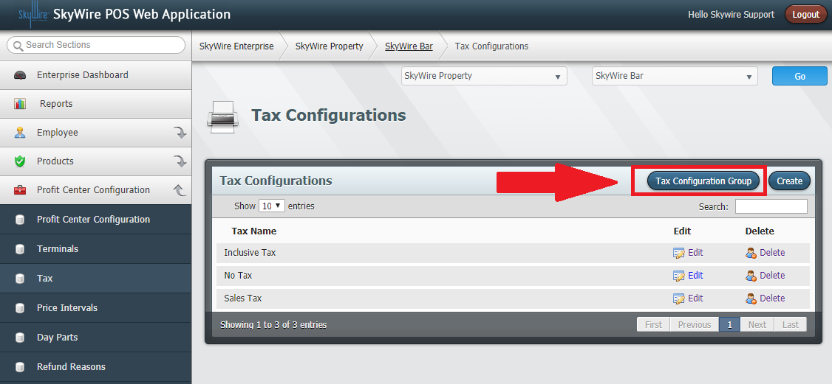

- Select "Create.”

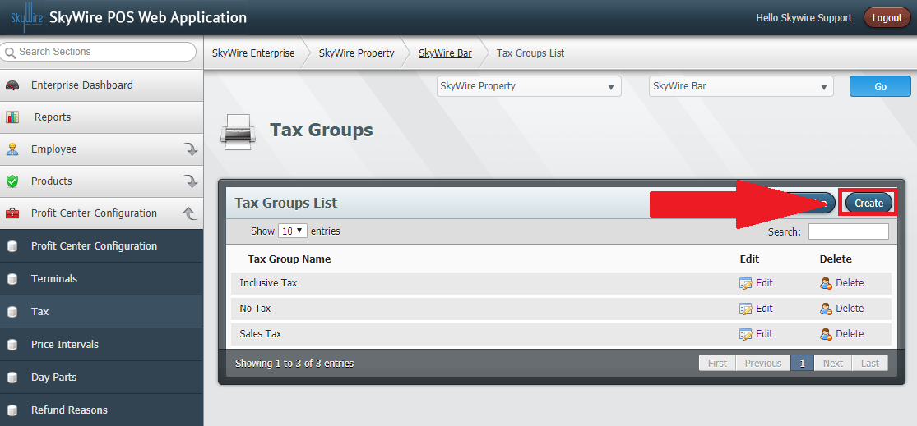

- Enter the name of the Tax Group.
- External ID: Used for mapping interfaces
- Default: Use this to set this tax group as the default
- Configurations in Group shows tax configurations that have been added he group. Click “Add Selected” under “Available Tax Configurations” to add a configuration to the group.
- Available Tax Configurations: Tax configurations that are available to be added to the group.

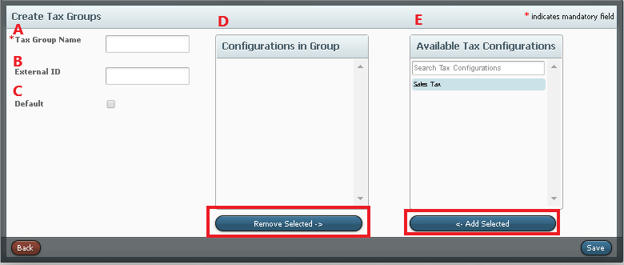

Tax Groups are assigned to products and modifiers.

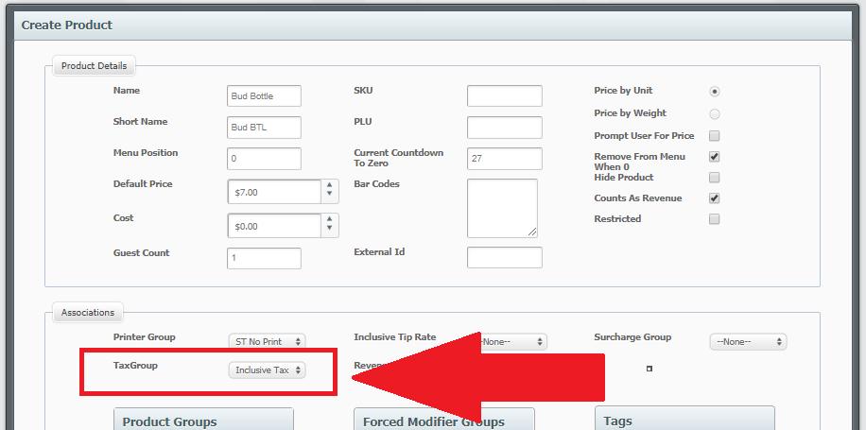

Price Intervals

Price Intervals are created to automate scheduled price changes. Price Intervals created are assigned to product groups.

How to Create Price Intervals

- Select a Property.
- Select a Profit Center.
- Select "Go.”
- Select "Profit Center Configuration.”
- Select "Price Intervals.”
- Select "Create.”

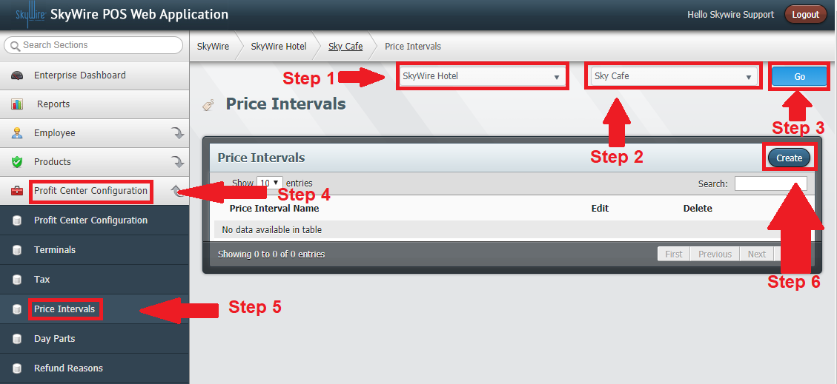

- Name: Enter the name of the price interval.
- Price Change: Select the desired price change.
- Amount or Percent: Select the amount or percentage of increase or decrease.
- When to Run: Select the times this interval will take effect.
- Select "Save.”

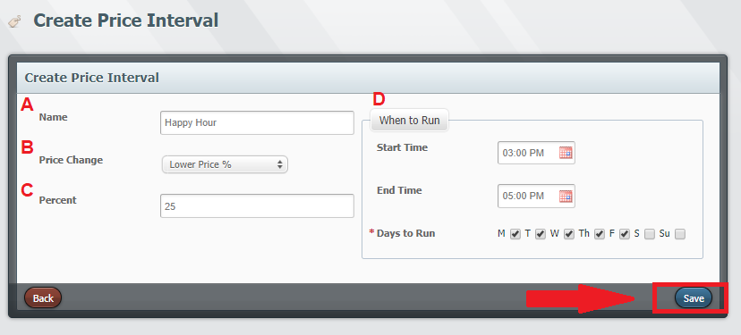
- Then navigate to the Product Group this Price interval should apply to and select the check box.

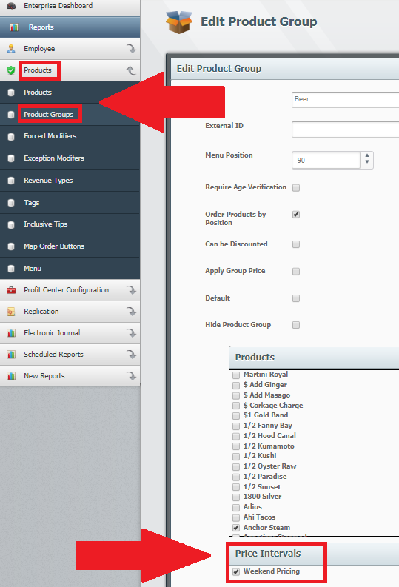

- Select “Save.”

Day Parts

Day Parts are created to provide an additional level of reporting. Day Parts are not optional; they must be created and configured.

How to Create Day Parts
- Select a Property.
- Select a Profit Center.
- Select "Go.”
- Select "Profit Center Configuration.”
- Select "Day Parts.”
- Select "Create.”

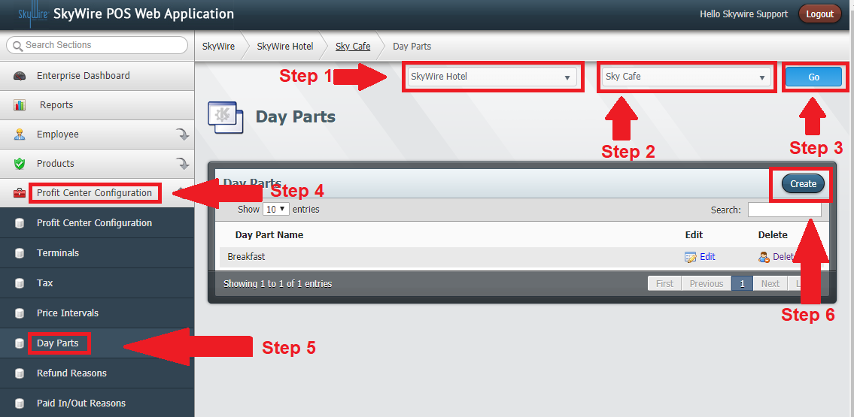

Detailed description below.

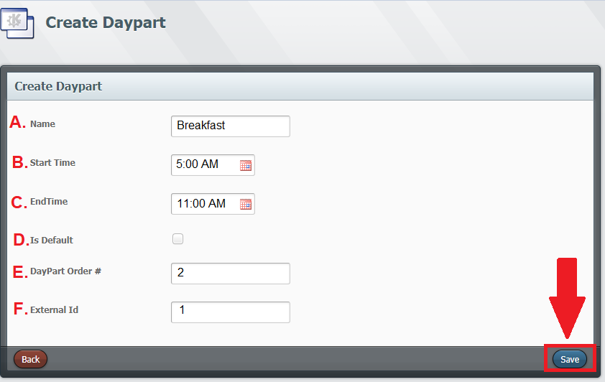
- Name: Enter the name of the day part.
- Start Time: elect the time the day part starts.
- End Time: Select the time the day part ends.
- Is Default: Toggle this option if the day part is the default.
- Day Part Order #: Enter the day part order #.
- External Code: Enter the external code to map interfaces. (Optional)
- Select "Save.”

Refunds

Refund Reasons populate when refunding a check. This allows for accurate refund tracking. At least one reason must be configured to refund checks from the POS terminal.

How to Create Refund Reasons

- Select a Property.
- Select a Profit Center.
- Select "Go.”
- Select "Profit Center Configuration.”
- Select "Refund Reasons.”
- Select "Create.”

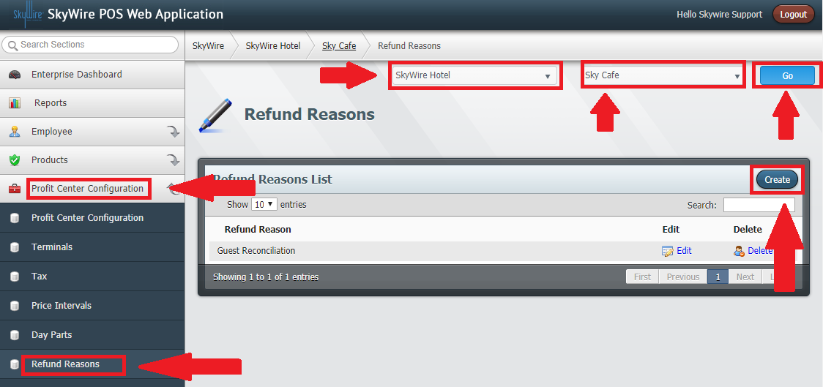

- Enter a Refund Reason.
- Select "Save.”

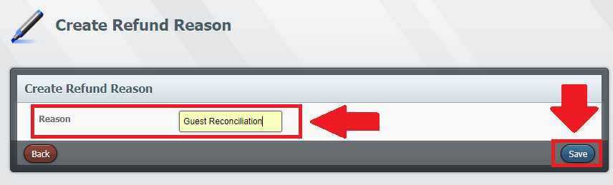

Paid In / Paid Out Reasons

Paid In / Paid Out Reasons are for Non-POS transactions. Reasons are created to track house monies in and monies out.

How to Create Paid In / Out Reasons

- Select a Property.
- Select a Profit Center.
- Select "Go.”
- Select "Profit Center Configuration.”
- Select "Paid In / Paid Out Reasons.”
- Select "Create.”

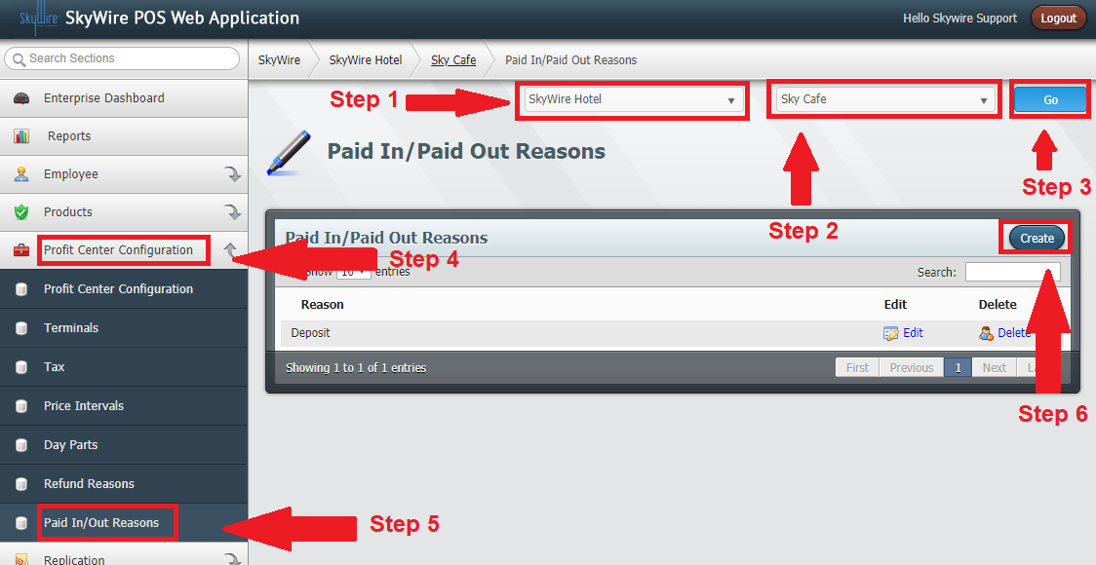

- Enter the name of the Paid In / Paid Out reason.
- Select "Save.”

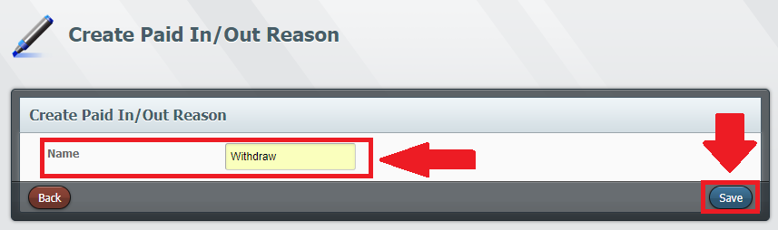

Profit Center Level Users

All users will need an Access Level, User and User Role created or assigned. See “Enterprise Level Users.”
- Select a Property.
- Select a Profit Center.
- Select "Go.”
- Select "Employee.”
- Create an Access Level.
- Create a User.
- Create a User Role.

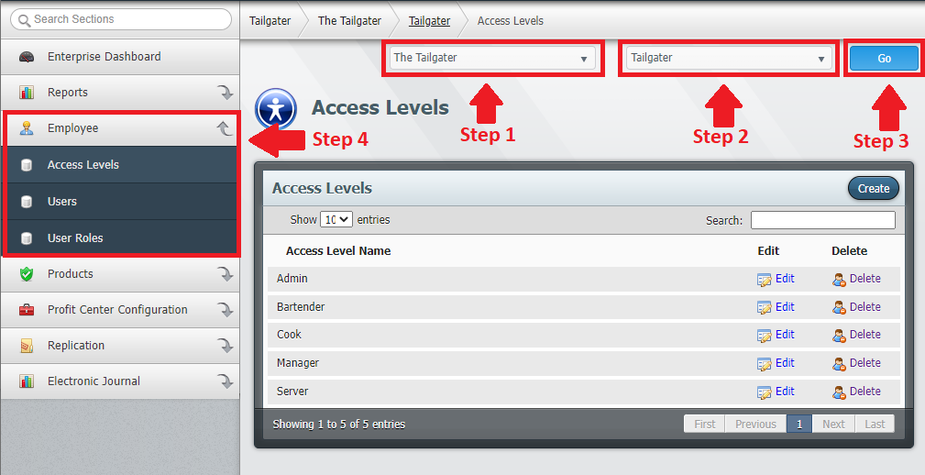

Product Configuration

Revenue Types

Revenue Types are created to categorize products and modifiers for reporting. Revenue Types are then assigned to products and modifiers.

How to Create Revenue Types

- Select a Property.
- Select a Profit Center.
- Select "Go.”
- Select "Products.”
- Select "Revenue Types.”
- Select "Create.”

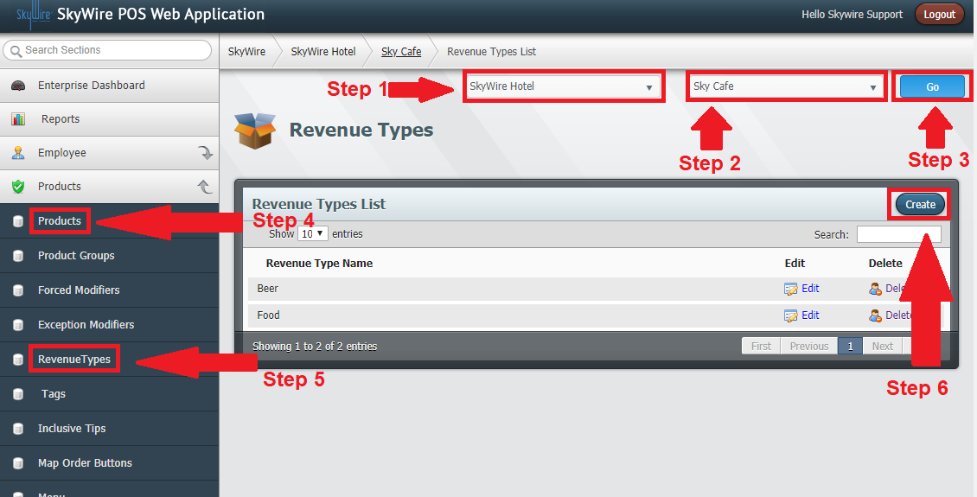

Detailed description below.
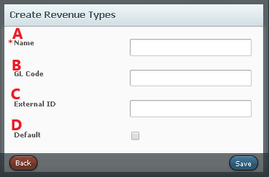

- Name: Enter the name of the Revenue Type.
- GL Code: Enter a General Ledge Code. (Optional)
- External ID: Enter an External Code. (Optional)
- Default: Set this revenue type as the default
- Select "Save.”

Revenue Types are assigned to products and modifiers.

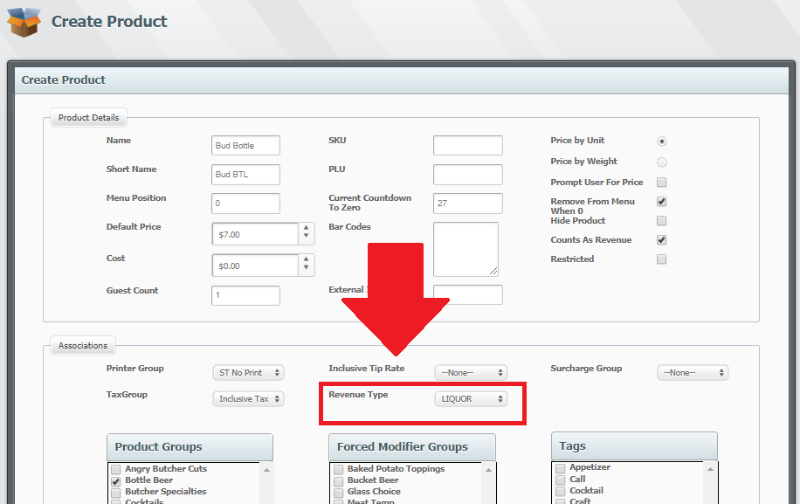

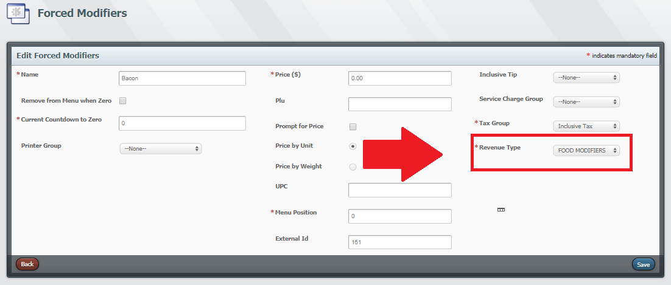

Menus

Menus are created to schedule dates and times for which products are available. Menus are then assigned to a group. Menu Groups are then assigned to terminals.

How to Create Menu Groups

- Select a Property.
- Select a Profit Center.
- Select "Go.”
- Select "Products.”
- Select "Menu.”
- Select Menu Groups.””

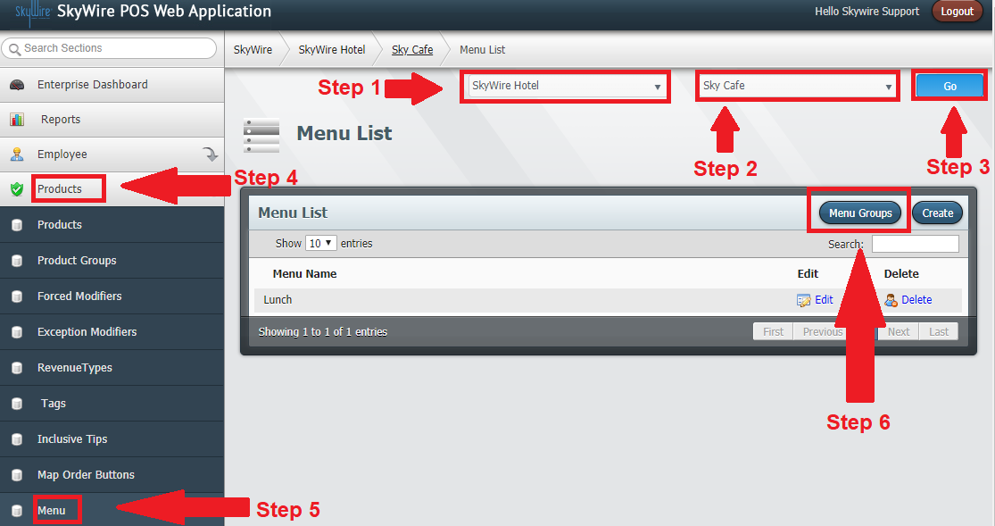

- Select "Create.”

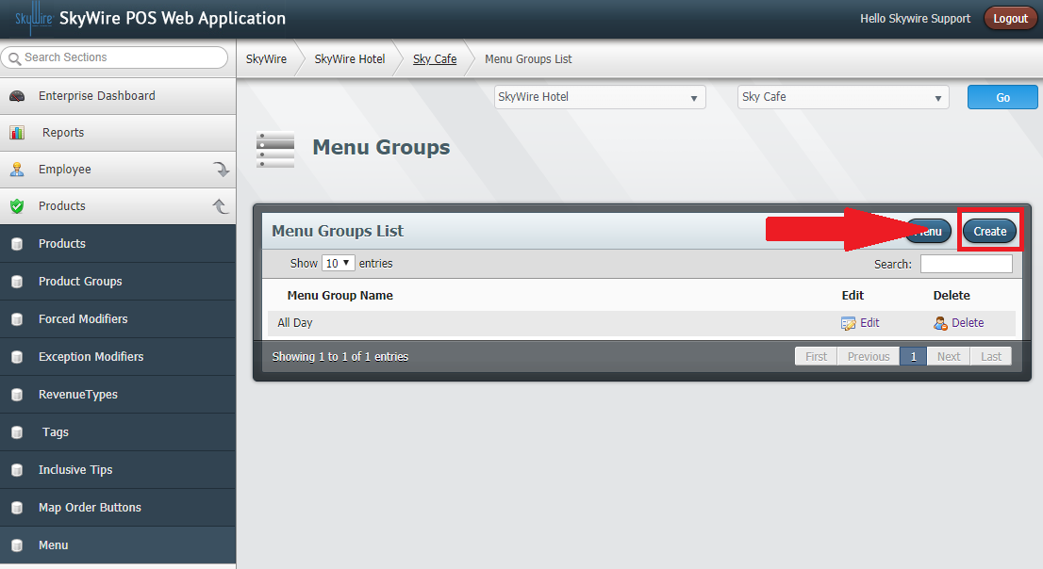
- Enter the name of the Menu Group.
- Select "Save.”

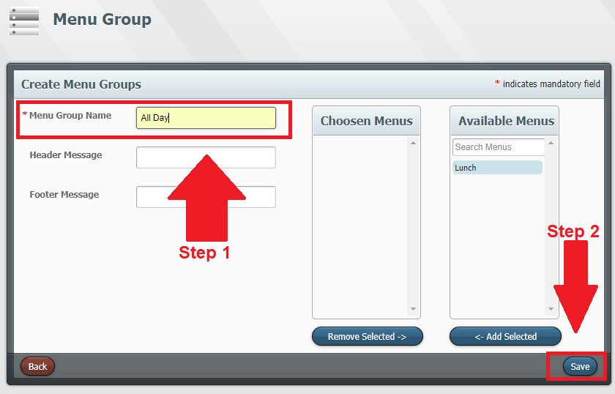

How to Create Menus

- Select "Menu.”

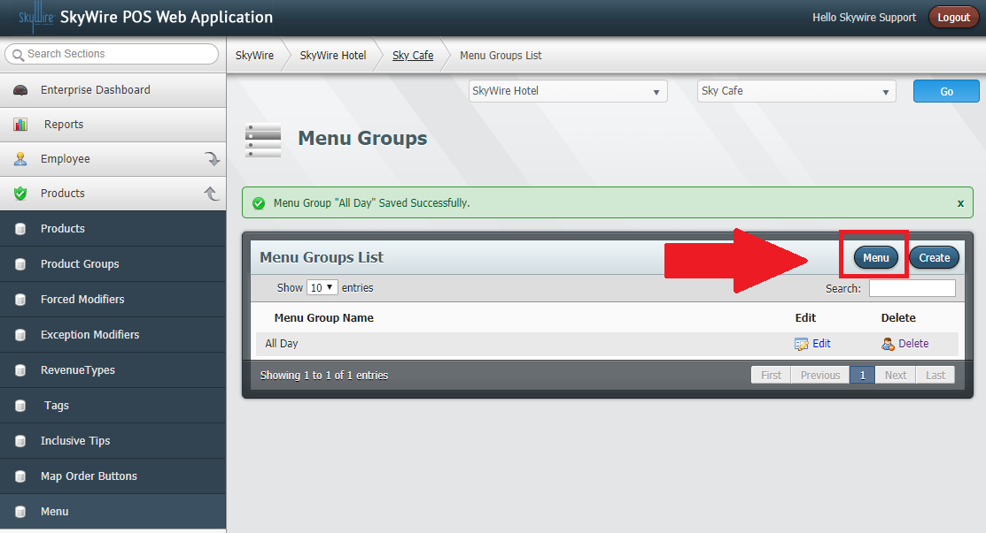
- Select "Create.”

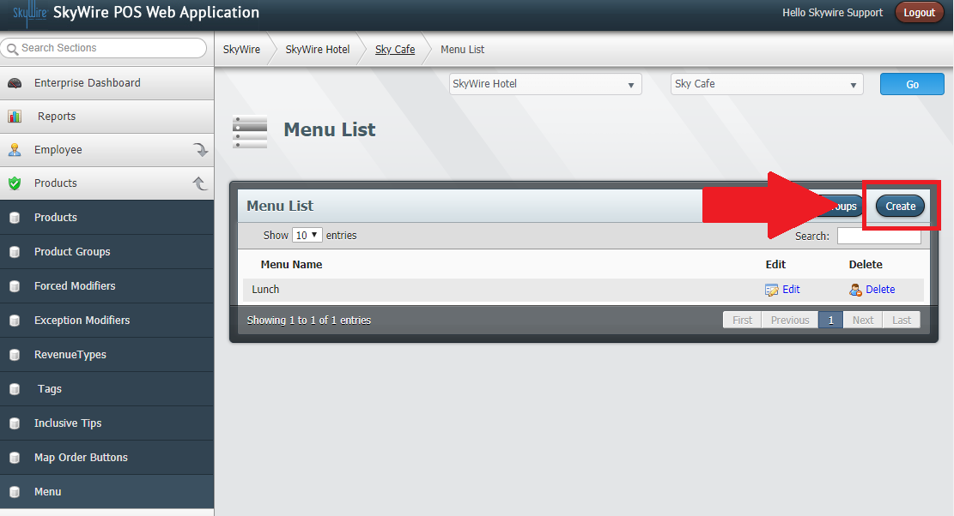

Detailed description below.

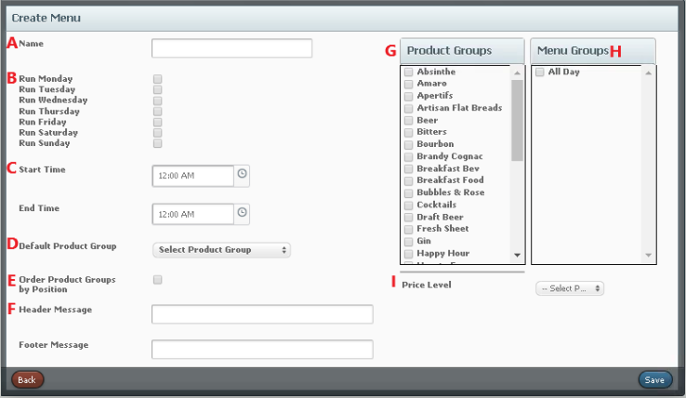
- Name: Enter the name of the menu.
- Run: Select the days the menu is available.
- Start Time: Select the start and end time of the menu's availability.
- End Time: Select a product group to default to.
- Order Product Groups by Position: Toggle this option if product groups are ordered by position.
- Header and Footer Messages: Enter header and footer messages for the guest's receipt when this menu is ordered from.
- Product Groups: Select the Product Groups for this menu.
- Menu Groups: Select the Menu Groups this menu belongs to.
- Price Level: Select the Price Level for the menu
- Select "Save.”

Forced Modifiers

Forced Modifiers are modifiers that automatically prompt after selecting a product. To achieve this, the Forced Modifier must be assigned to a group. Example, meat temperature for a steak. Meat temperature is the Forced Modifier Group and the actual temperature would be the Forced Modifier.

How to Create Forced Modifiers

- Select a Property.
- Select a Profit Center.
- Select "Go.”
- Select "Products.”
- Select "Forced Modifiers.”
- Select "Create.”

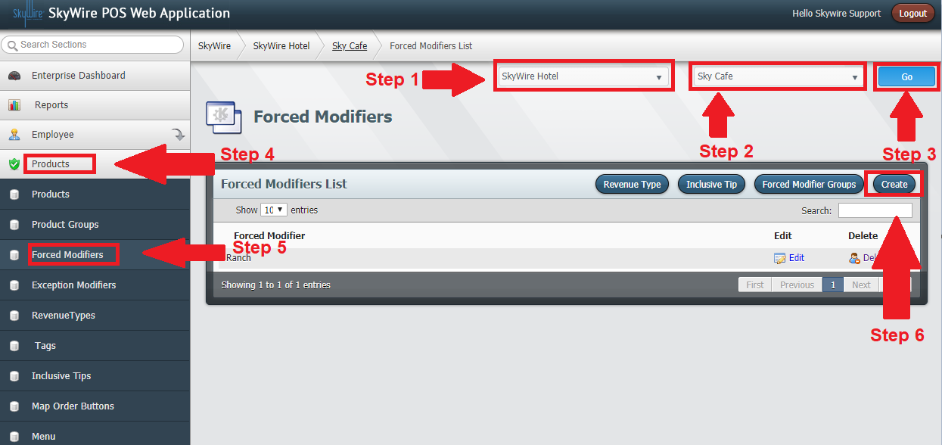

Detailed description below.

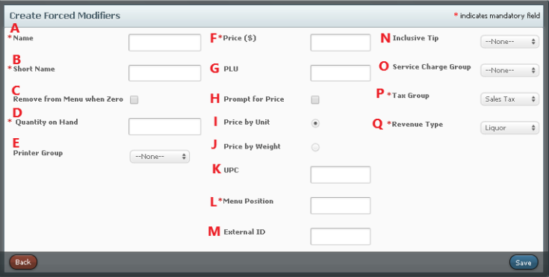

- Name: Enter the name of the forced modifier.
- Short Name: Shorthand name for modifier
- Remove from Menu when Zero: Toggle this option to enable Countdown to Zero. Countdown to Zero will remove the modifier as a choice and will no longer be available to order.
- Quantity on Hand: Enter the amount on hand. If you do not wish to use this function, simply enter 0 and do not select "Remove from Menu when Zero.”
- Printer Group: Select the printer group the modifier prints to.
- Price: Enter the price, if this is a priced modifier.
- PLU: Enter the Price Look Up code, if applicable. (Optional)
- Prompt for Price: Toggle this option to prompt for a price at the terminal, when the modifier is selected.
- Price by Unit: Toggle this option to apply the price when selecting this modifier.
- Price by Weight: Toggle this option if this modifier is priced by weight.
- UPC: Enter the Universal Product Code, if applicable. (Optional)
- Menu Position: Enter the desired menu position of the modifier. All modifiers can be assigned a number 1-100. The terminal will then show all modifiers in descending order.
- External ID: Code used to map interfaces.
- Inclusive Tip: Select an inclusive tip, if applicable. (Optional)
- Service Charge Group: Select a service charge, if applicable. (Optional)
- Tax Group: Select the tax group applicable to this modifier.
- Revenue Type: Select the revenue type.
- Select "Save.”

How to Create a Forced Modifier Group

- Select "Forced Modifier Group.”

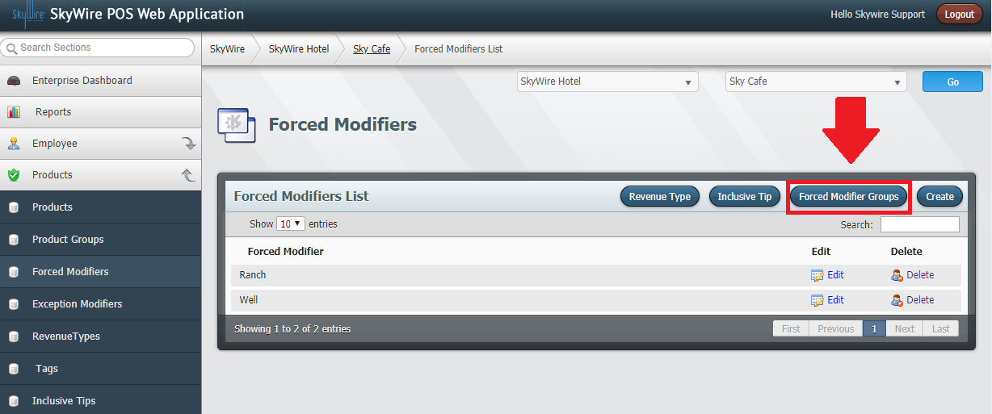

- Select "Create.”

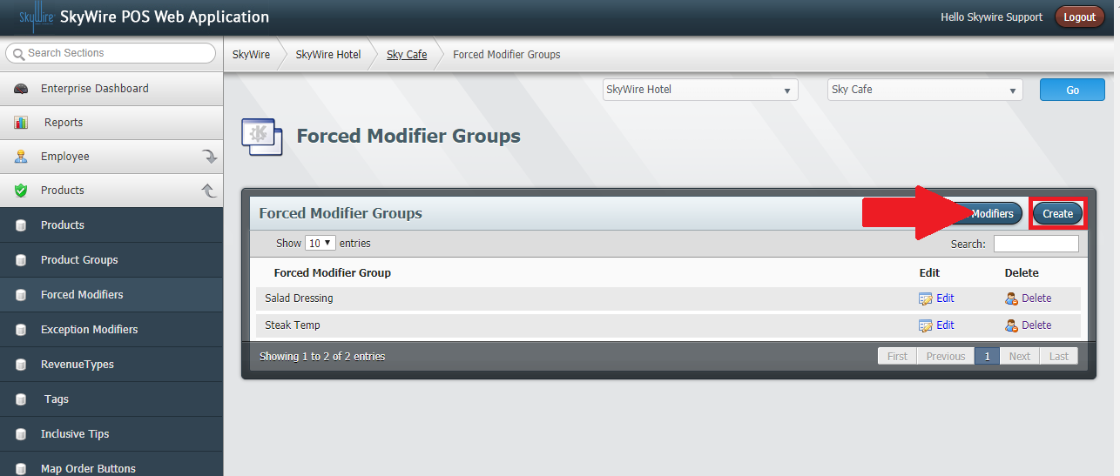

Detailed description below.

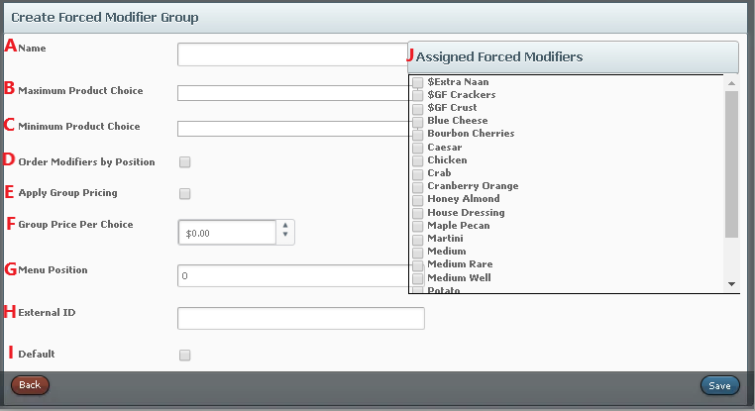

- Name: Enter the name of the forced modifier group.
- Maximum Product Choice: Select the maximum number of modifiers that can be selected when ordering products assigned to this group.
- Minimum Product Choice: Select the minimum number of modifiers that must be selected when ordering products assigned to this group.
- Order Menu Items by Positions: Toggle this option to enable menu positioning.
- Apply Group Pricing: Toggle this option to enable group pricing.
- Group Price per Choice: Enter the group price. All modifiers assigned to the group will apply this price.
- Menu Position: Enter the desired menu position of the modifier. All modifiers can be assigned a number 1-100. The terminal will then show all modifiers in descending order.
- External ID: Code used to map interfaces.
- Default: Select this to set this forced modifier group as the default.
- Assigned Forced Modifiers: Select the forced modifiers that belong to this group.
- Save

Exception Modifiers

An Exception Modifier is one that is optionally added to modify a product due to a special circumstance or request. Exception Modifiers are assigned to a group and then assigned to a menu.

How to Create Exception Modifiers
- Select a Property.
- Select a Profit Center.
- Select "Go.”
- Select "Products.”
- Select "Exception Modifiers.”
- Select "Create.”

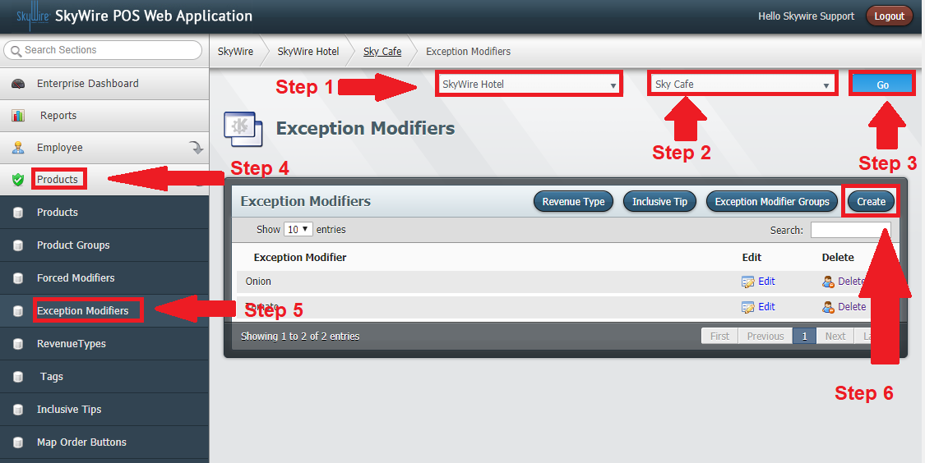

Detailed description below.
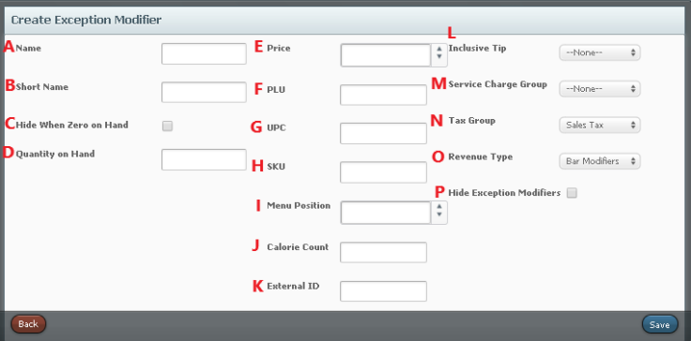

- Name: Enter the name of the exception modifier.
- Short Name: Shorthand name to be displayed for modifier
- Hide When 0 on Hand: Toggle this option to enable Countdown to Zero. Countdown to Zero will remove the modifier as a choice and will no longer be available to order.
- Quantity on Hand: enter the quantity left in inventory
- Price: Enter the price, if this is a priced modifier.
- PLU: Enter the Price Look Up code, if applicable.
- UPC: Enter the Universal Product Code, if applicable.
- SKU: Enter the Stock Keeping Unit number if the modifier has a bar-code and a scanner is being used to ring the modifier.
- Menu Position: Enter the desired menu position of the modifier. All modifiers can be assigned a number 1-100. The terminal will then show all modifiers in descending order.
- Calorie Count: Enter the calorie content of the modifier.
- External ID: Code used for mapping interfaces.
- Inclusive Tip: Select an inclusive tip, if applicable.
- Service Charge Group: Select a service charge, if applicable.
- Tax Group: Select the tax group applicable to this modifier.
- Revenue Type: Select the revenue type.
- Hide Exception Modifiers: Toggle this option if this modifier should not print. The option needs to be toggled in the printer tab for the device it should not print.
- Select "Save.”

How to Create an Exception Modifier Group

- Select "Exception Modifier Group.”

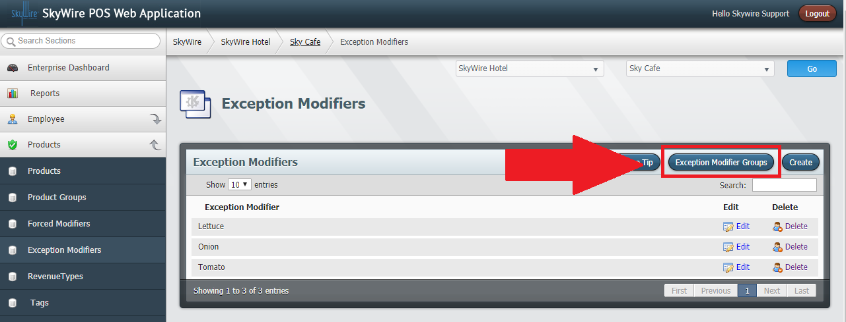

- Select "Create.”

- Enter the name of the Exception Modifier Group.
- Toggle this option to enable group pricing.
- Toggle this option to enable menu positioning.
- Enter the desired Menu Position of the modifier. All modifiers can be assigned a number 1-100. The terminal will then show all modifiers in descending order.
- Select the modifiers that belong to this group.
  - Select the modifiers from the Available Mods window.
  - Select "Add Selected.”
- Select "Save.”

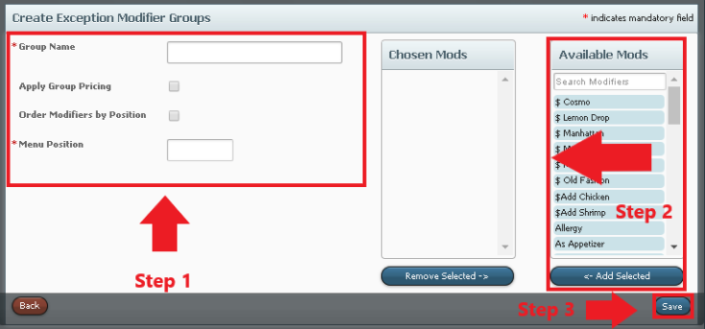

Inclusive Tips

Inclusive Tips are created to add a tip automatically when a product or modifier is ordered. Inclusive Tips are assigned to products and modifiers.

How to Create Inclusive Tips
- Select a Property.
- Select a Profit Center.
- Select "Go.”
- Select "Products.”
- Select "Inclusive Tips.”
- Select "Create.”

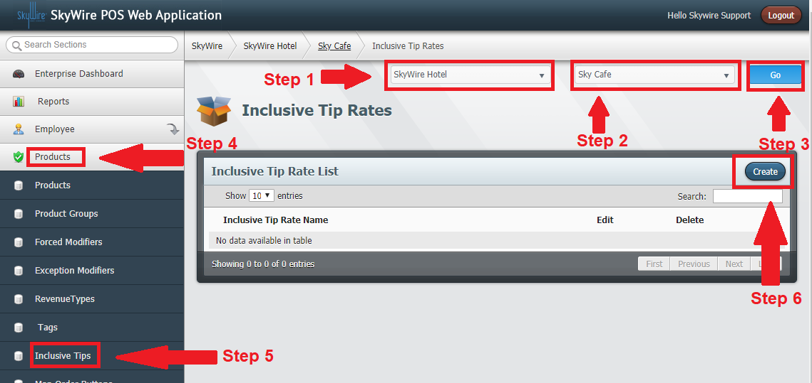

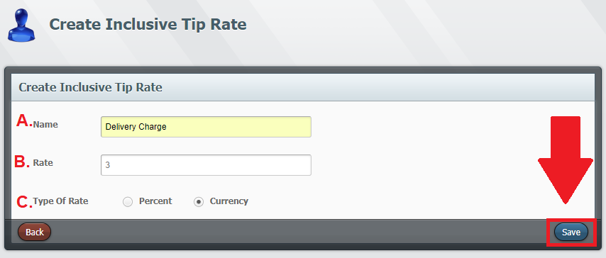

- Name: Enter the name if the inclusive tip.
- Rate: Enter the tip rate.
- Type of Rate: Select if this tip is an amount or a percentage.
- Select "Save.”

Product Groups

Product Groups are created to categorize and organize products. Products are then assigned to a group. The Product Groups will show as tabs on the POS terminal. End users will select the Product Group where the product exists.

How to Create Product Groups

- Select a Property.
- Select a Profit Center.
- Select "Go.”
- Select "Products.”
- Select "Product Groups.”
- Select "Create.”

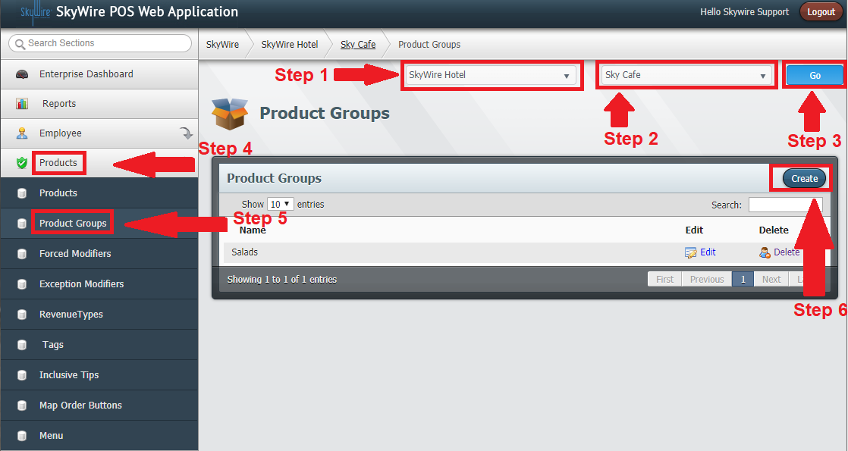

Detailed description below.

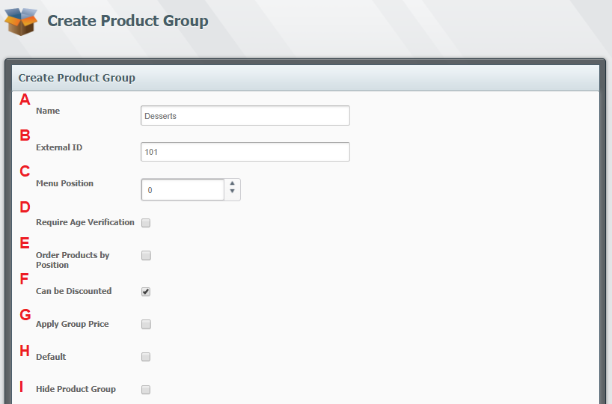

- Name: Enter the name of the product group.
- External ID: Code used for mapping interfaces
- Menu Position: Enter the desired menu position of the product group. All product groups can be assigned a number, 1-100. The terminal will then show all product groups in descending order on the POS terminal.
- Require Age Verification: Toggle this option if this product group requires the user to verify the age of the guest.
- Order Products by Position: Toggle this option if products in this group are ordered by position.
- Can be Discounted: Toggle this option if the products in this group can be discounted.
- Apply Group Price: Toggle this option to use the group price.
- Default: Select to make this the default product group.
- Hide Product Group: Select this option to hide this Product Group from the screen. This option is typically used for retail outlets using bar code scanners.
- Select "Save.”

Detailed description below.

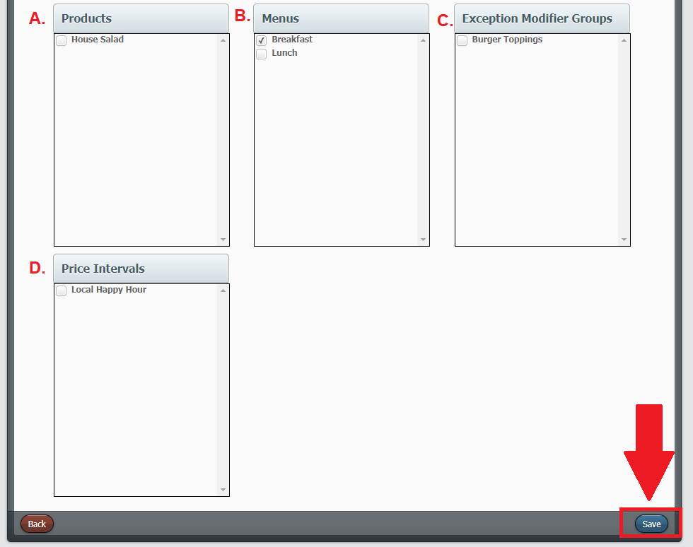

- Products: Select the products that belong to this group.
- Menus: Select the menu (s) this product group belongs to.
- Exception Modifiers Groups: Select the exception modifier groups that belong to this product group.
- Price Intervals: Select the price intervals that apply when this product group is being used.
- Select "Save.”

Products

Products are items to be sold.

How to Create Products

- Select a Property.
- Select a Profit Center.
- Select "Go.”
- Select "Products.”
- Select "Products.”
- Select "Create.”

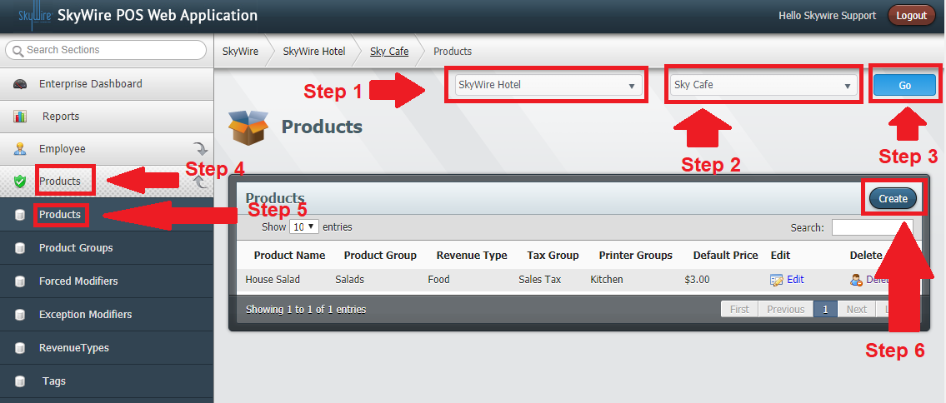

Detailed description below.

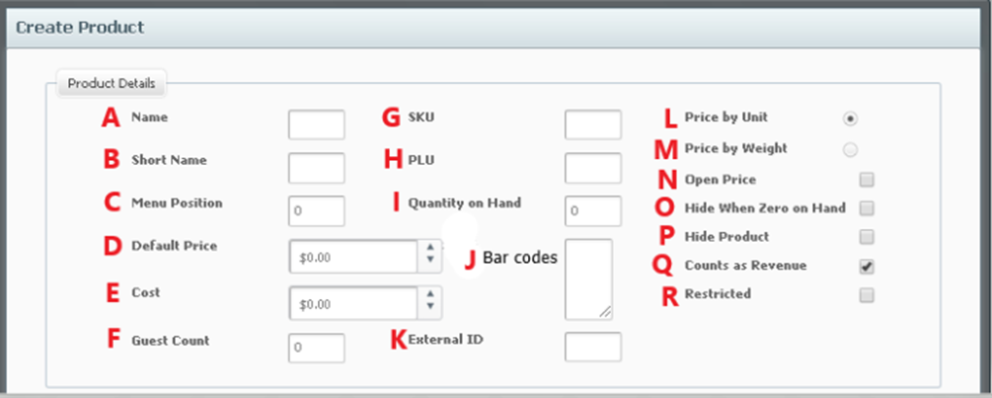
- Name: Enter a name of the product.
- Short Name: Enter a short name for the product.
- Menu Position: Enter the desired menu position of the product. All products can be assigned a number, 1-100. The terminal will then show all products in descending order on the POS terminal.
- Default Price: Enter the price of the product.
- Cost: Enter the cost of the product.
- Guest Count: Enter the guest count if this product should count a cover when ordered.
- SKU: Enter the Stock Keeping Unit number if this item is a bar coded item and a scanner is being used to order the item.
- PLU: Enter the Price Look Up code, if applicable.
- Quantity on hand: Enter the amount on hand. If you do not wish to use this function, simply enter 0 and do not select "Remove from Menu when Zero.”
- Bar Codes: Enter the hex code if this item is a using a bar gun to ring the item.
- External ID: Enter the external ID for mapping, if applicable.
- Price by Unit: Toggle this option to use the default price.
- Price by Weight: Toggle this option if this product is priced by weight and is using a scale to ring the item.
- Open Price: Toggle this option to prompt for a price at the terminal when the product is selected.
- Hide when 0 on Hand: Toggle this option to enable Countdown to Zero. Countdown to Zero will remove the modifier as a choice and will no longer be available to order.
- Hide Product: Toggle this option to hide the product from printing. The option must also be selected in the printer tab for the device.
- Counts as Revenue: Toggle this option to count this product as revenue.
- Restricted: Toggle this option for a manager override prompt when ordering this product.

Detailed description below.

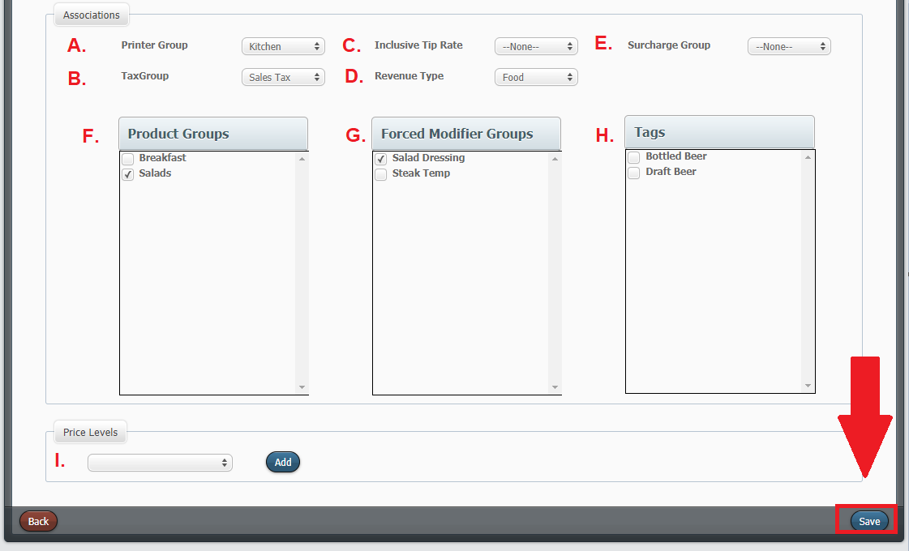
- Printer Group: Select a printer group this product should print to.
- Tax Group: Select a tax group the product should apply when ordered.
- Inclusive Tip: Select an inclusive tip, if applicable.
- Revenue Type: Select the revenue type.
- Surcharge Group: Select a service charge, if applicable.
- Product Groups: Select the product group (s) the product belongs to.
- Forced Modifier Groups: Select the forced modifier groups that belong to this product. All available forced modifier groups will appear in the box. Select the one or multiple forced modifier groups you wish to apply to the product, followed by selecting by checking the box. The forced modifier group will then appear on the left chosen forced modifier groups field. You can also remove a forced modifier group by selecting the group followed by unchecking the box.
- Tags: Select the tags that belong to this product, if applicable.
- Price Level: Select a price level if this product needs additional pricing, if applicable.
- Select "Save.”

Map Order Buttons

Map Order Buttons are created to provide quick service. Products are mapped to the buttons selected and allow for easy access to popular products.

How to Create Map Order Buttons

- Select a Property.
- Select a Profit Center.
- Select "Go.”
- Select "Products.”
- Select "Map Order Buttons.”

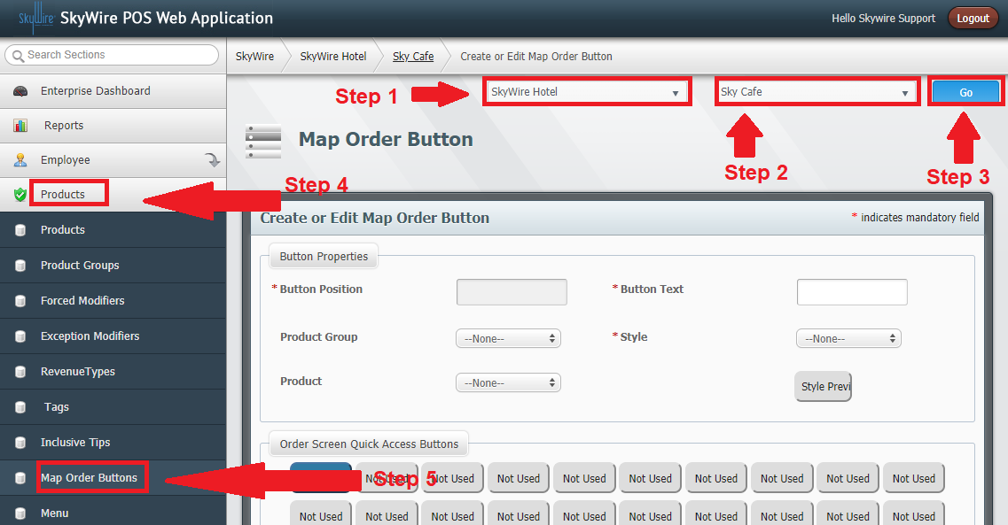

Detailed description below.

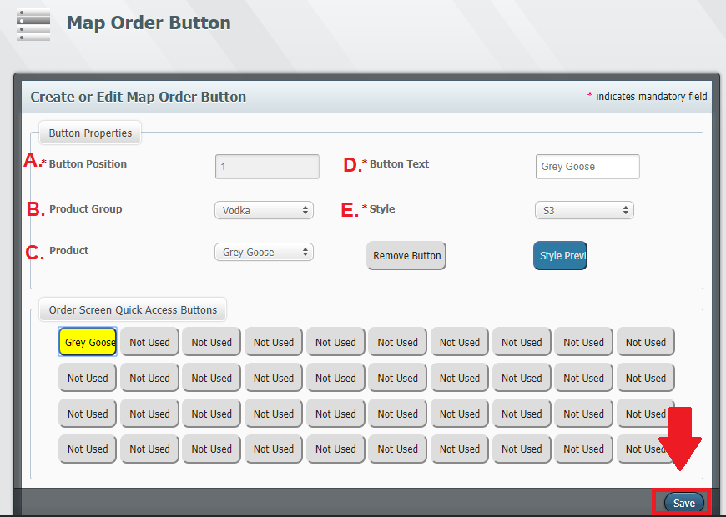

- Button Position: Enter a button position for the desired map button. You can also select one of the "Order Screen Quick Access Buttons" and the button position will automatically populate in the field.
- Product Group: Select the product group the product belongs to.
- Product: Select the product to be mapped to the quick service access button.
- Button Text: Enter desired button text for the button. The product name will automatically populate.
- Style: Select a style for the quick service access button.
- Select "Save.”

How to Remove Map Order Buttons

- Select the Order Screen Quick Access Button to remove.
- Select "Remove Button.”

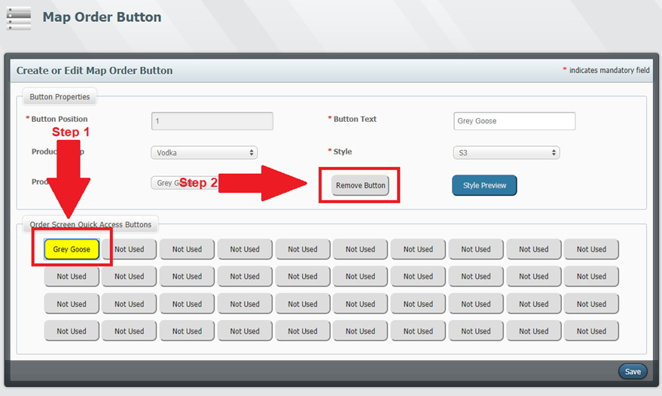

Confirm "Show Menu in QSR" is toggled for the terminal using map order buttons.

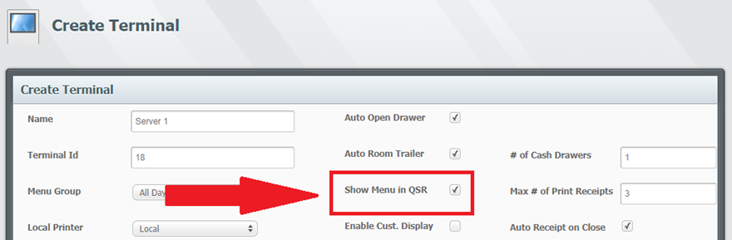

Pebble Tools

The Replication Tool allows you to copy settings from one profit center to another.

How to Use Profit Center Replication Tool

- Select a Property.
- Select "Go.”
- Select "Replication.”
- Select "Profit Center Replication.”

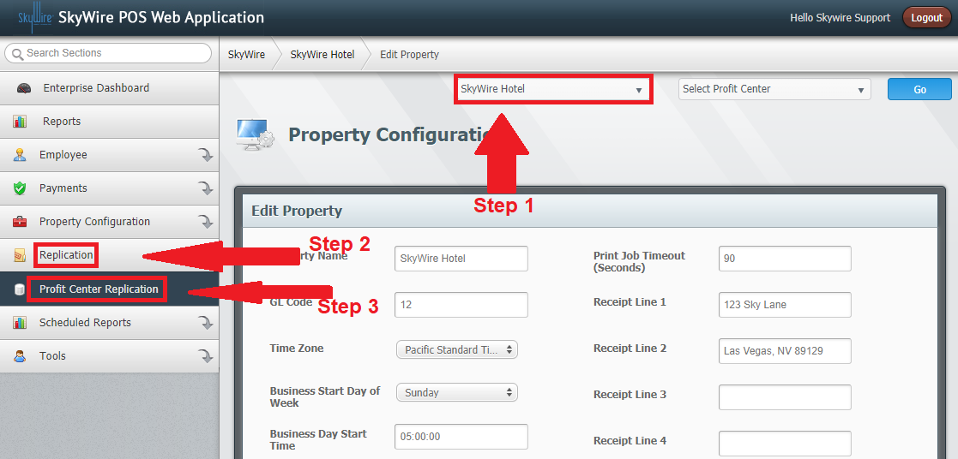

See photo below.

- Profit Centers Selection
  - Select the source profit center. This is the profit center that contains the data you want to copy.
- Options:
  - Overwrite Destination
    - Select this option to overwrite records that currently exist.
    - Un-select this option to keep existing records and wish to add and create new records.
      - Note: Duplicate records will be created if the records you are copying are the same as the existing records.
  - Update Only: Select this option to only create new records.
    - Select this option to create new records if they do not exist.
- Dependency
  - Replicate only Profit Center Setting
    - This will only duplicate the Profit Center configuration setting tab.
  - All modules
    - This will copy all profit center configurations modules from the source profit center.
  - Selected modules
    - This will copy only selected modules. Use the drop down to select modules. You can select multiples modules.
- Destination Selection
  - Select a destination you want to copy the records to.
    - Selecting Enterprise will copy all selected settings to all Properties and all Profit Centers.
    - Selecting Property will copy all selected settings to all profit centers to other Property Profit Centers.
    - Selecting a Profit Center will only copy all the selected settings to the selected Profit Center.
- Select “OK.”

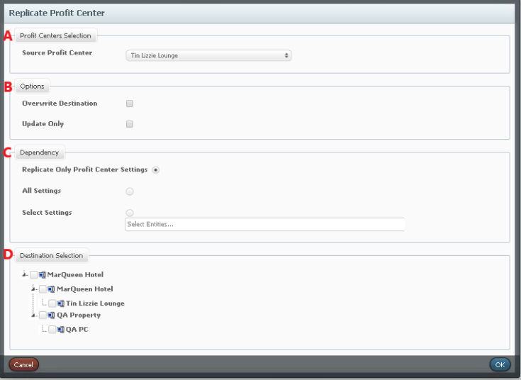

How to Use Product Replication Tool

- Select a Property.
- Select a Profit Center.
- Select "Go.”
- Select "Replication.”
- Select "Product Replication.”

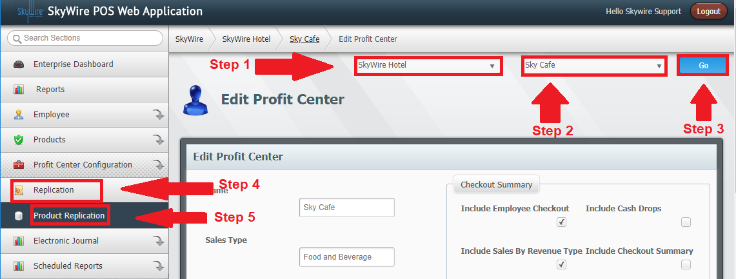

- Record Selection: Select "All Products" to replicate all products and product groups. Select "Selected Products" to select specific products.
- Destination Selection: Select profit centers to replicate the data to.
- Select “OK.”

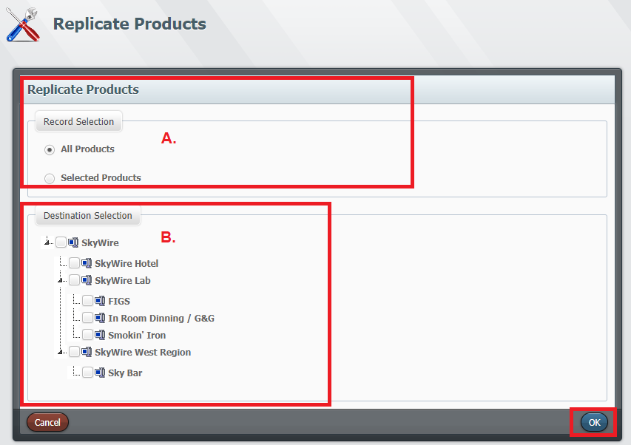

Electronic Journal

The Electronic Journal is a utility used for monitoring and auditing closed orders. Queries can be ran and saved from WebConfig.

How to Run an Electronic Journal Query

- Select "Electronic Journal.”
- Select "Run Query.”

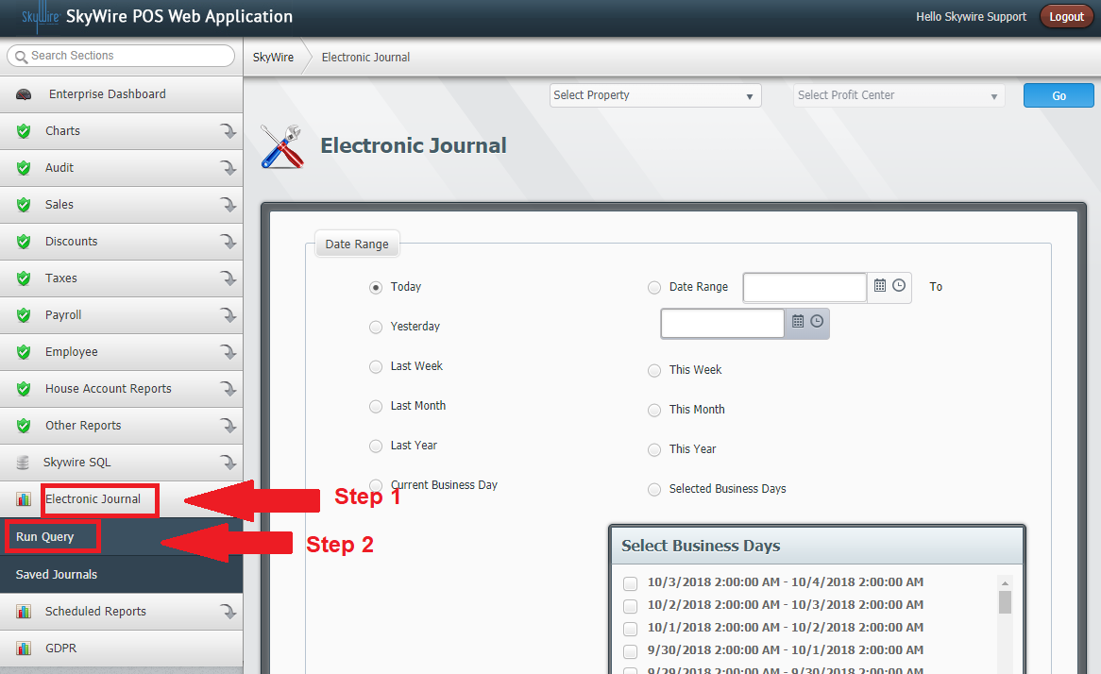

Select a Date Range

- Date Range: Allows you to run the action to date or for a predetermined interval of time.
- Date Range: Allows you to run the action within a specified time and date range.
- Report Scope: Allows you to select specific profit centers, employees, or terminals. Select the desired "Report Scope on the left and the options for that category will appear on the right.

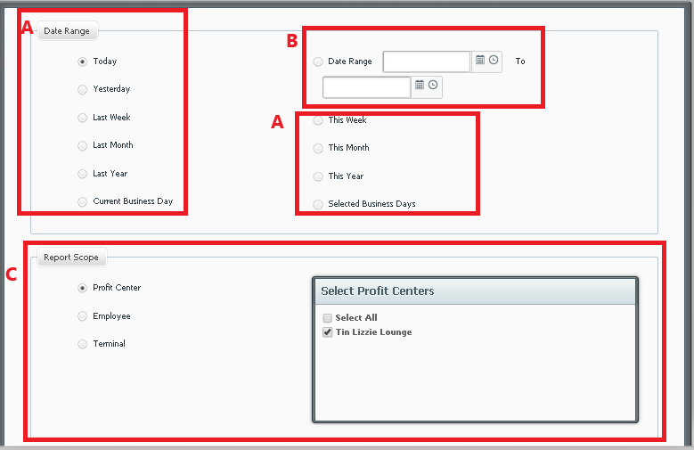

- Keyword Search: Enter a keyword, if applicable.
- Table Number: Enter the table number used for the order.
- Customer Name: Enter the customer's name.
- Part of Order ID: Enter a part of the order ID number.
- Three Column Report: Select this option to view results in three rows. Default settings show all checks in a single row.
- Select Specific Discounts: Select discounts to filtered, if applicable.
- Select Specific Discounts: Select discounts to filtered, if applicable.
- Sort By: Select how to sort the data
- Select "Generate" to view data.

See photo below.
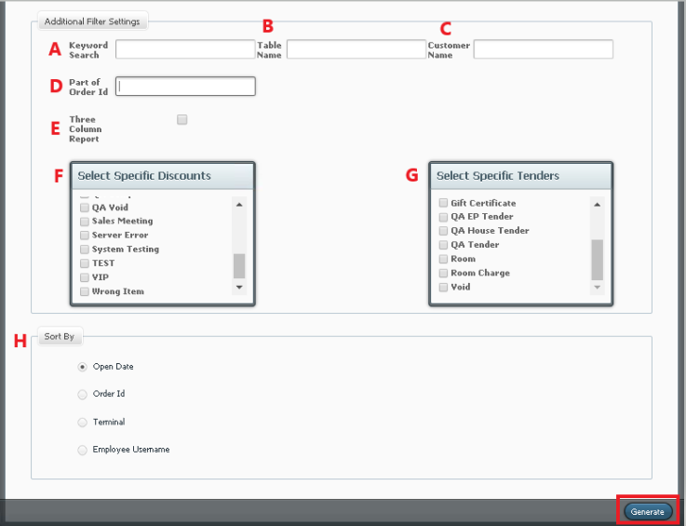

- Results will show in check format.

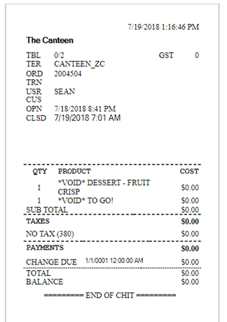

How to Save a Journal

- Select "Electronic Journal.”
- Select "Saved Journal.”
- Select "Create Journal.”

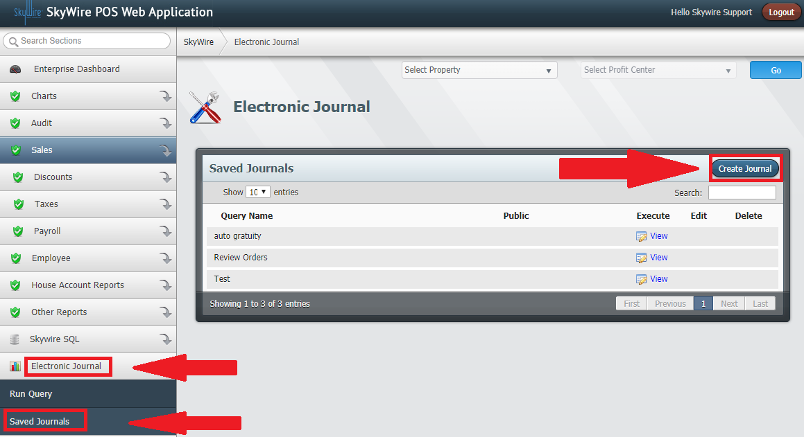

- Enter the name of the query.
- Check “Is Public” to allow other users to access this query.

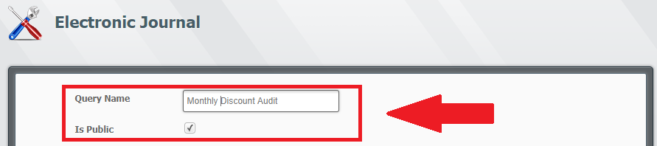
- Select the Date Range, Report Scope, Additional Filter Options and Sort By options desired.
  - See "How to Run an Electronic Journal Query.”
- Select "Save Journal.”

SkyWire SQL

SQL Queries can be ran from WebConfig to request data or information from the database. Queries can be saved, edited and executed from SkyWire SQL.

Executing SkyWire SQL queries

- Select "Skywire SQL.”
- Select "Execute SQL Query.”
- Copy and paste the SQL query to execute.
- Select "Execute.”

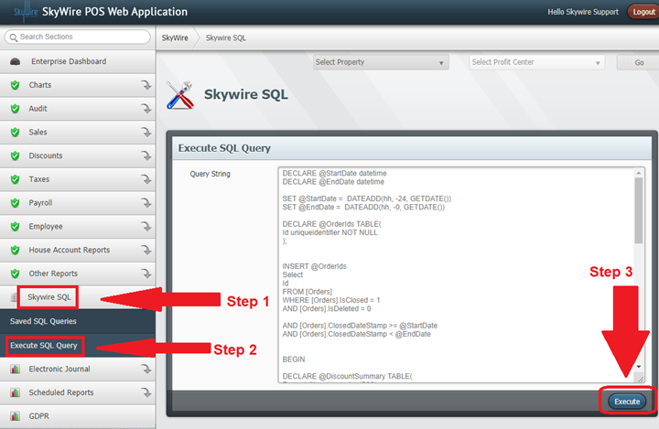

Saving SkyWire SQL queries

- Select "Skywire SQL.”
- Select "Saved SQL Queries.”
- Select "Create Query.”

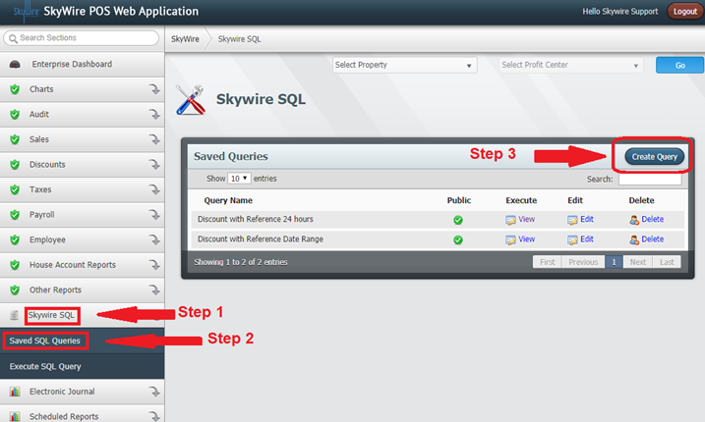

Detailed description below.

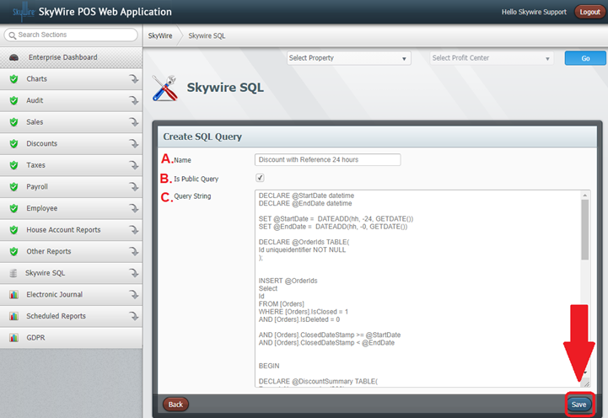
- Name: Enter the name of the query to be saved.
- Is Public Query: Check if this box to allow other users to access this query.
- Query String: Copy and paste the SQL query to execute.
- Select “Save.”

Viewing and editing SkyWire SQL Queries

- Select "Skywire SQL.”
- Select "Saved SQL Queries.”
- Select "View" to see and execute or select "Edit" to modify query.

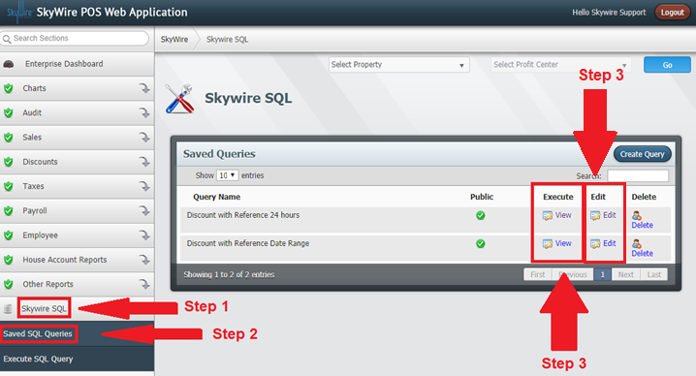

- Edit query.
- Select "Save.”

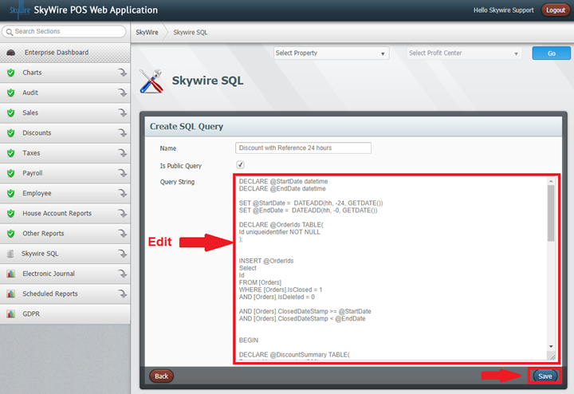

Filtering SkyWire SQL Query Results

- Select desired column header to filter data. Use arrows on bottom left-hand side to scroll through pages.

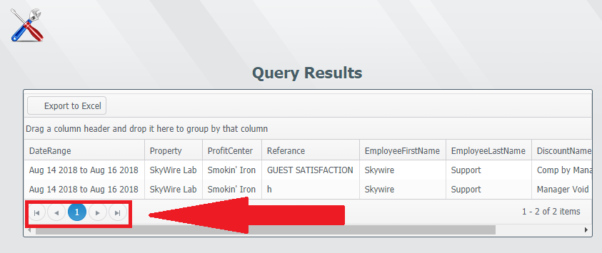

- Select Export to Excel to export query results in Excel.
  - Note: When creating headers for SkyWire SQL Queries, if there is a space in the header it will not export the query to excel.
  - Example
    - Thiswillwork
    - This will not

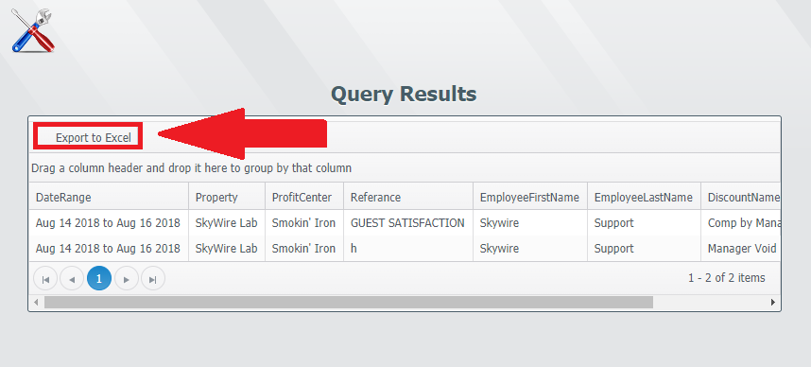
You can also drag a column header to the top to change grouping.

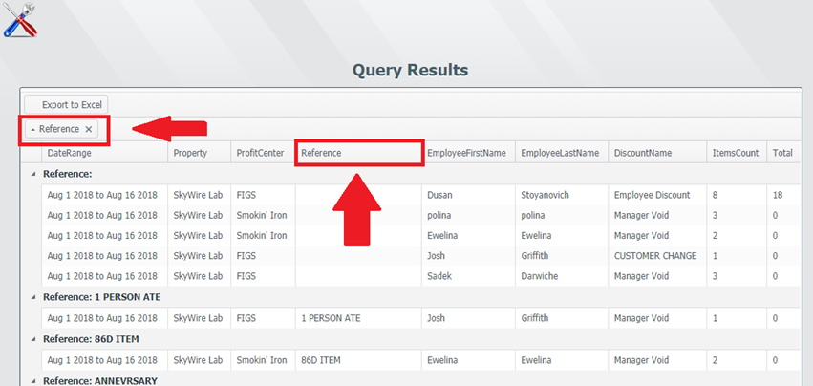

Back Office Reporting

Reports can be ran from POS terminals as well as the back-office application. Reporting access will depend on where the user exists. Enterprise level users will have access to run reports for all properties and profit centers. Property level users will have access to run reports for that property and all profit centers that exist in the property. Profit center level users will only have access to run reports for the profit center they exist in.

How to Run WebConfig Reports

- Select a report.

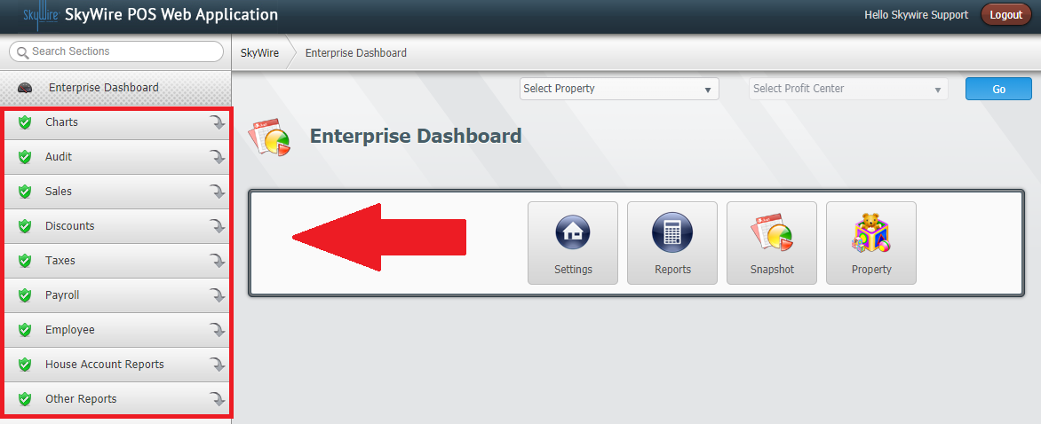

Select a Date Range
- To Date: Allows you to run the action to date.
- Specific Date: Allows you to run the action within a specified time and date range.
- Business Day: Allows you to select specific or multiple business days based on set business periods.

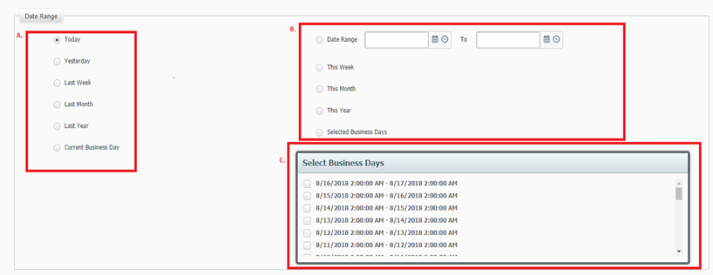

Select a Report Scope.
- Select "Generate.”

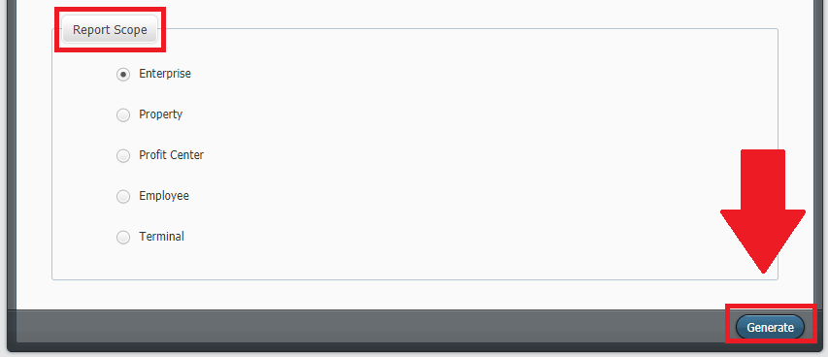

Destinations for Scheduled Reports

Reports, Imports and Exports can be scheduled and sent to an email or FTP site. A destination for the scheduled action needs to be created prior to scheduling.

How to Create Destinations

- Select "Scheduled Reports.”
- Select "Destinations.”
- Select "Create.”

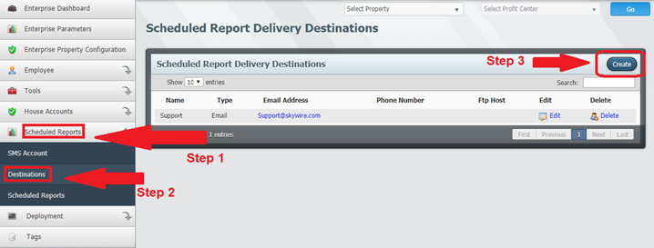

Destination for Email

- Select email for Destination Type.
- Enter the name and email address of action recipient.
- Select "Save.”

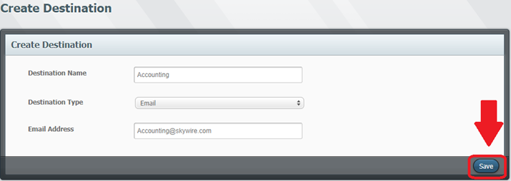

Destination for FTP

- Select email for Destination Type.
- Select FTP.
- Enter the FTP host, where the FTP server lives.
- Enter credentials if needed to access server.
- Enter credentials if needed to access server.
- Select "Save.”

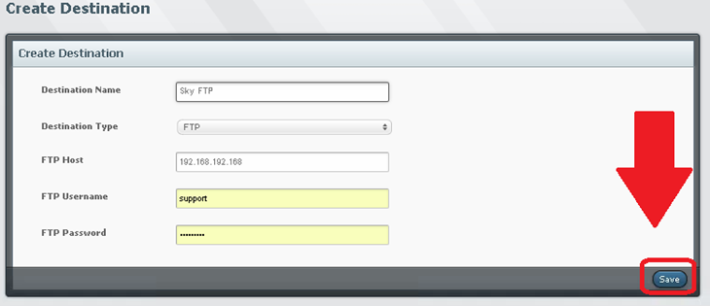

Scheduling Reports, Imports and Exports

Reports can be scheduled and sent to an email or FTP site. A destination for the scheduled action needs to be created prior to scheduling.

How to Schedule Actions

- Select “Scheduled Reports.”
- Select “Scheduled Reports.”
- Select “Create.”

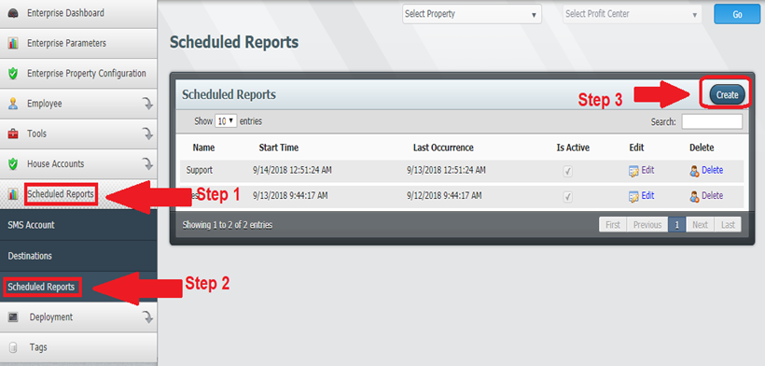
Detailed description below.

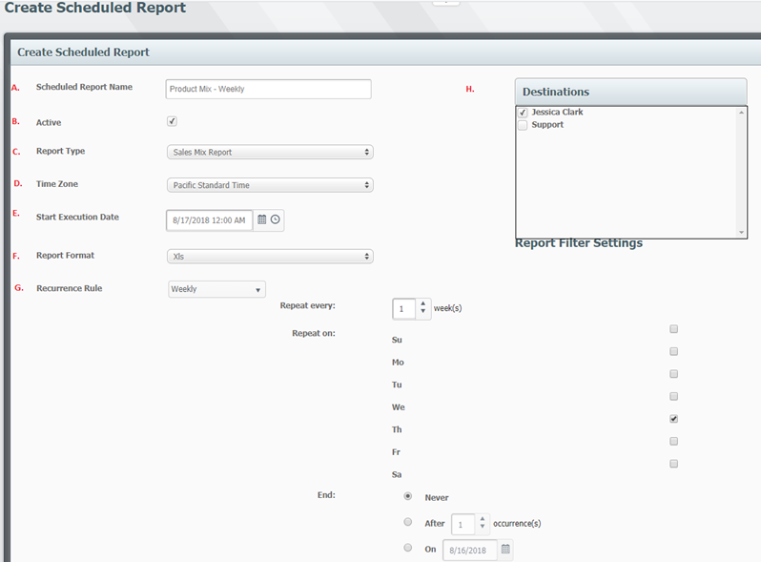

- Scheduled Report Name: Create a name for the scheduled report, import or export.
- Active: Actions can be activated or deactivated by using this toggle.
- Report Type: Select desired report, import or export.
- Time Zone: Select time zone.
- Start Execution Date: Date for the report, import or export to be ran and sent.
- Report Format: Chose the desired format. Options include Excel, PDF and CSV.
- Recurrence Rule: Select a recurrence rule. Options include Daily, Weekly, Monthly and Yearly.
  - Repeat every: Select how many times the report should recur.
  - Repeat on: Select the weekday.
  - End: Select when to stop recurrence.
- Destinations: Select the recipient/s.
  - Select a Date Range

Detailed description below.

- To Date: Allows you to run the action to date.
- Specific Date: Allows you to run the action within a specified time and date range.
- Business Day: Allows you to select specific or multiple business days based on set business periods.
  - Select a Report Scope.

  - Select "Save.”

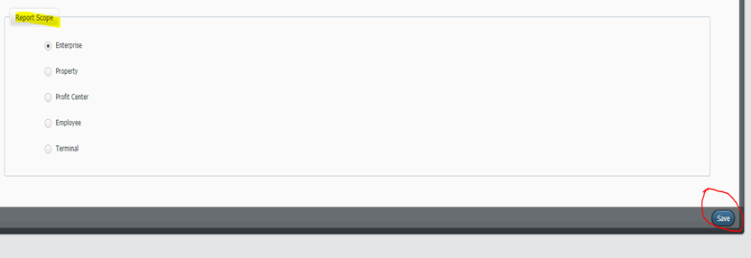

Create Public Reports

- Select “Public Reports.”
- Select the desired report and select “Create.”

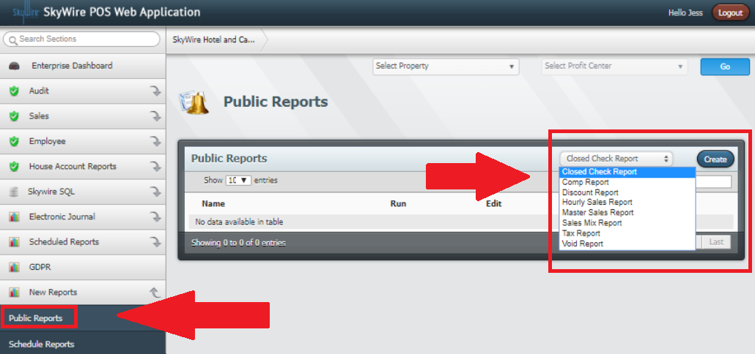

- You can enter a customized name for the report.
- On the right, select report filters.

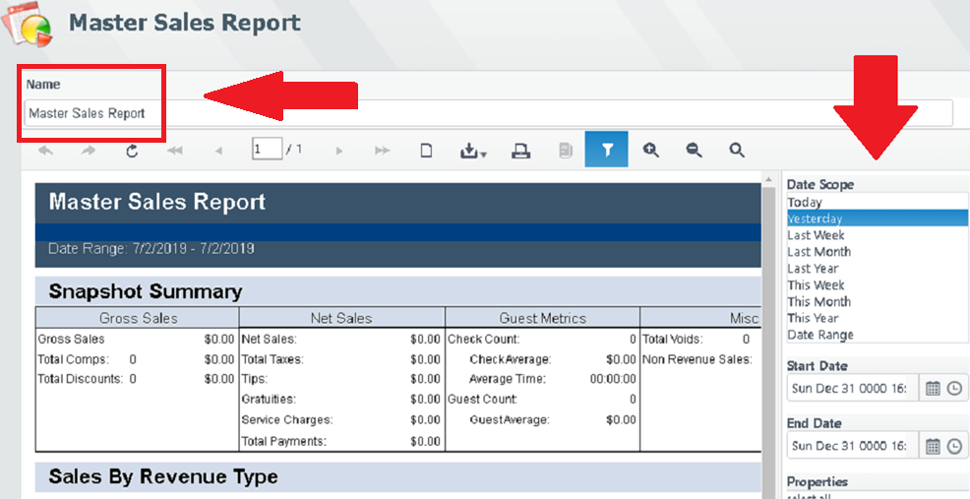
- Select all applicable filters below.

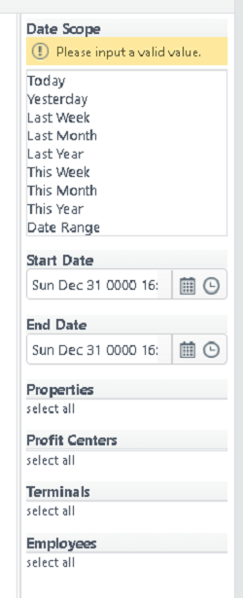
- To view the report prior to saving, select “Preview.”
- Select “Save” to save the report with the selected filters and custom name.

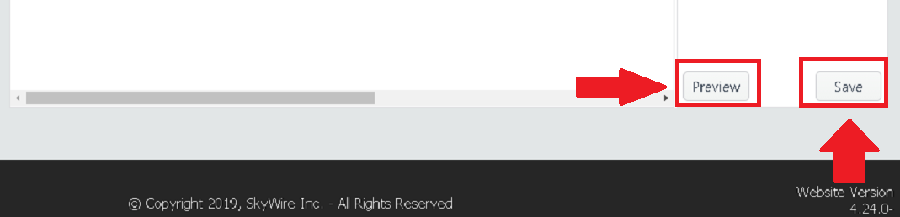

Schedule Public Reports

After public reports are created, they can be scheduled to automatically send. Existing destinations for email and FTP will available as well.

- Select “Schedule Reports” and select “Create.”

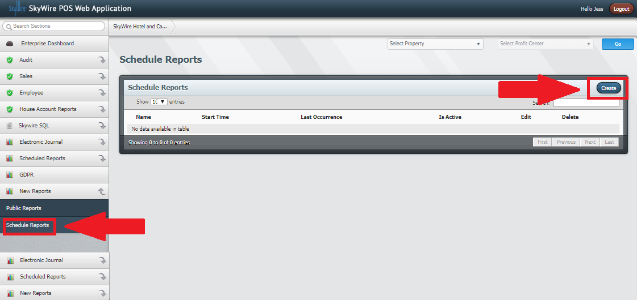

- Create the scheduled report and select “Save.”

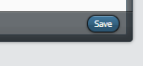

Available Reports

Audit
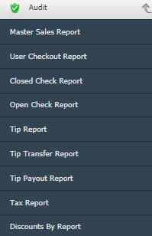

- Master Sales – The Master Sales report can be generated per property, profit center, individual employees or terminals. The report provides a summarized overview of Gross Sales, Net Sales, Guest Metrics and Voids. The report also details sales by revenue type, tender totals, tax totals, discounts, comps and voids.
- User Checkout – The user checkout report provides a detailed view of all Sales, Discounts, Comps, Voids, Gift Cards sold, Service Charges, Tenders used, Tips, any cash paid in or paid out, and any cash drops for the users specified. The report yields data base on what was accumulated during the user’s shift. For data to appear in this report, the users specified must end their shift.
- Closed Checks – The Closed Check report provides check data to help research missing checks and to help reconcile business financial data. It gives all basic check data, including Order Number, Table Number, Guest Count, Open/Reopen Times, Initial Time Opened, Order Subtotal, Taxes, Gratuities, Service Charges, Discounts, Payments, and Total Order Amount Due.
- Open Checks – The Open Check report provides check data. The report scan be generated per enterprise, property, profit center, individual employees or terminals A report with the open order and table numbers, guest count, open/ closed times, tax amount, any gratuity, service charge or discount and total due.
- Tax Report – The tax report provides all taxes for a specified time period and organizes the data into six columns, showing the revenue type, tax type (Inclusive sales tax, ass-on sales tax, and no tax), tax rate, taxable sales, tax collected, and the total of the sale after tax. At the bottom of the report are the totals for all taxable sales, tax collected, and total sales after tax.
- Tips – The Tip report lists the total tips collected on sales, and a count of the number of tips applied to orders. The tenders that the tips were applied to is also listed.
- Tip Transfer – The Tip Transfer report lists all users that have transferred tips with the amount of the tips that they have transferred, along with the recipient of those tips, the time and date of the transfer and the status of the recipient’s acceptance of the transferred tips.
- Tip Payout – The Tip Payout report lists the amount of tips payed out to every user that has performed a tip payout.
- Discount By – Shows an itemized list of all discounts for a specified time period by type (vouchers, employee discounts, server errors, system testing, and voids). Has four columns which show the item that is discounted, number of times the item was discounted, total discounts for the item, and the percentage of all discounts that item accounts for. At the bottom of each type of discount is the total for the number of items discounted, total value of discounts applied, and total percentage of all discounts that type accounts for.

Sales
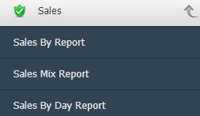

- Sales By – The products in the Sales By report can be sorted by day part, employee, product group, profit center, and revenue type. There are 8 different columns, showing the product, how many units of the product were sold, how many times the product was voided, Total discounts applied to the product, Gross sales, net sales (Less discounts, taxes, service charges, tips, and gratuities for each item), and gross sales and net sales percentage of total sales.
- Sales Mix – The Sales Mix report is a calculation that determines the proportion of each product a business sells relative to total sales. It is divided into six columns, showing the day, number of checks, number of guests that ordered each item, gross and net sales for each item, and the average revenue generated by each item per ticket.
- Sales By Day – The sales by day report provides the total sales for a specified day for each profit center. The report displays guest count, check count, gross sales, net sales, and gross and net sales percentage. Each column is separated by the hour, and the daily totals for each profit center and property can be found at the bottom of the report for the date specified.

Employee
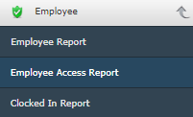

- Employee Report – A report that lists all active employees with usernames and contact info.
- Employee Access Report – A report that lists access levels for each user.
- Clocked In Report – A report that shows all users that are clocked in and how many checks they have open.

House Account Reports
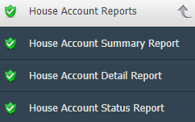

- House Account Summary Report – This report summarizes the stats of house accounts. This report includes limits, charges and the account balance.
- House Account Detail Report – This report shows transaction history for house accounts. Reports can also be filtered by house account groups.
- House Account Status Report – This report shows the status of an account which includes whether an account is active as well as the account limit and balance.

