Circulation Scope: Customer
Revision Date: December 7th, 2021
Pebble POS Front of House User Manual

Table of Contents
Starting Shift 3
Sign In / Clock In 3
Cash Drawers 4
End Shift 7
Placing an Order 9
New Order / New Table 9
Ordering a Menu Item 10
Forced Modifiers 10
Exception Modifiers 11
Special Request 12
Seat Number Ordering 14
Send & Stay vs Send & Exit 15
Delete Menu Item in Current Round 16
Print an Order 17
Seat Mode & Check Mode 18
Repeat Quantity 19
Adjusting and Splitting Orders 21
Splitting a Check 21
Splitting Checks by Seats 22
Equal Receipts 22
Transferring Orders 24
Merge Orders 25
Closing Orders 26
Payments / Tenders 26
Split Tenders & Multiple Tenders 27
How to Reauthorize a Payment 27
How to Print an Authorization Draft 29
How to Adjust a Tip 31
How to Void a Payment 34
Adjust Price – Discounts, Voids, and Comps 38
Tax Free Selected / Tax Free Check 39
Order Functions 40
Modify Table Number 40
Adjust Party Count 41
Naming an Order 42
Hold / Fire Functions 43
How to Hold an Item 44
How to Fire Items 45
How to Hold or Fire All Items 45
Barcode Lookup 45
Other Functions 47
Time Clock Functions 47
Start Break / End Break 47
Print Current and Previous Shift Reports 48
Pay Cash In / Pay Cash Out 50
Enroll Print 53
Assign Mag Card 55
Transactions 56
Order History 57
Refund Order 59
Tip Functions 61
Accept Tips 62
Payout Tips 62
Transfer Tips 64
Tips for Shift 66
Terminal Reports 67
Setup 70

Starting Shift

Sign In / Clock In

There are several options for signing-in to the POS terminal.

- Enter your “Front of House Password.”
- Or, swipe your employee Mag Card.
- Or, place your finger on the fingerprint pad.

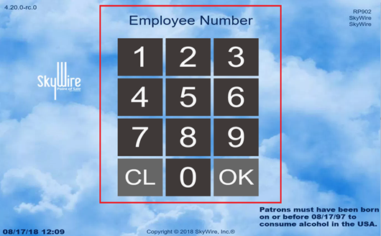

- Select the “Role” you are working for your current shift.

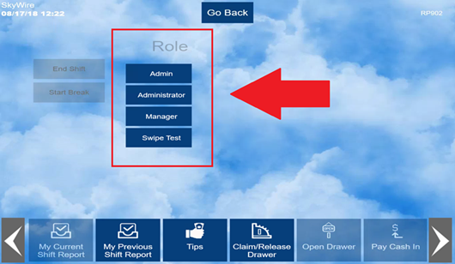
- Select “OK,” if prompted for shift notes.

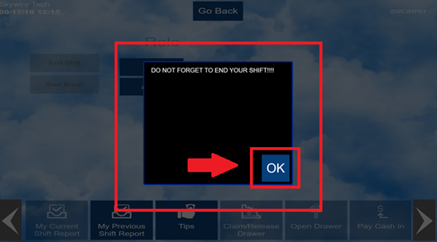

Cash Drawers

Some roles will automatically prompt you to claim a cash drawer.
If not prompted, you can claim a drawer by selecting “Claim / Release Drawer.”

- Select “Time Clock.”

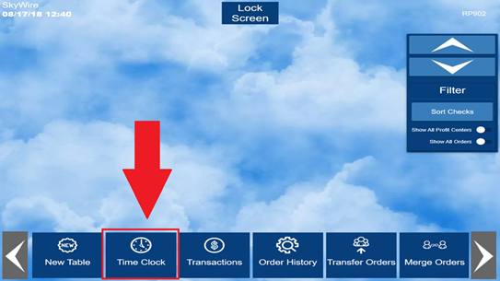
- Select “Claim / Release Drawer.”

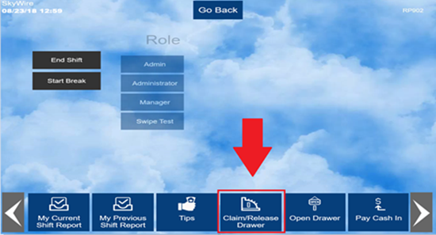

- If two drawers are available, select the desired cash drawer.

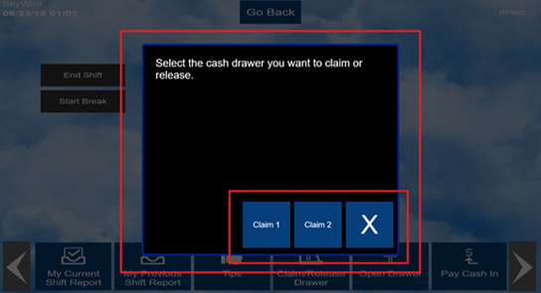

- Enter the Bank Amount.
- Select “OK.” The cash drawer will open automatically.

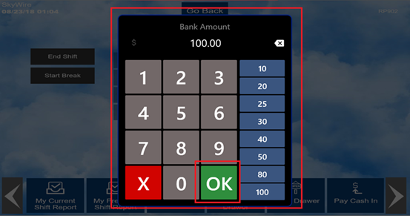

- Select “No Sale” to open the cash drawer. The drawer will only open if the cash drawer is claimed.

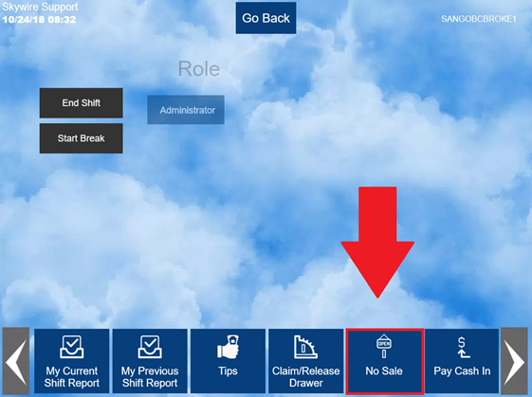

End Shift

All users with sales data must End Shift. This will reset sales data, allow your cash drawer to be released, and give you the opportunity to declare your cash tips.

- Select "Time Clock.”
- Select “End Shift.”

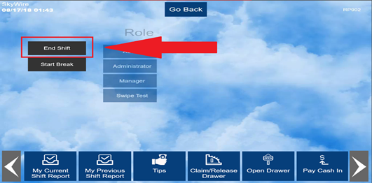

- A prompt to release the cash drawer will prompt if a drawer is assigned.
- Select “Yes” to release the cash drawer or select “No” to keep the cash drawer assigned.

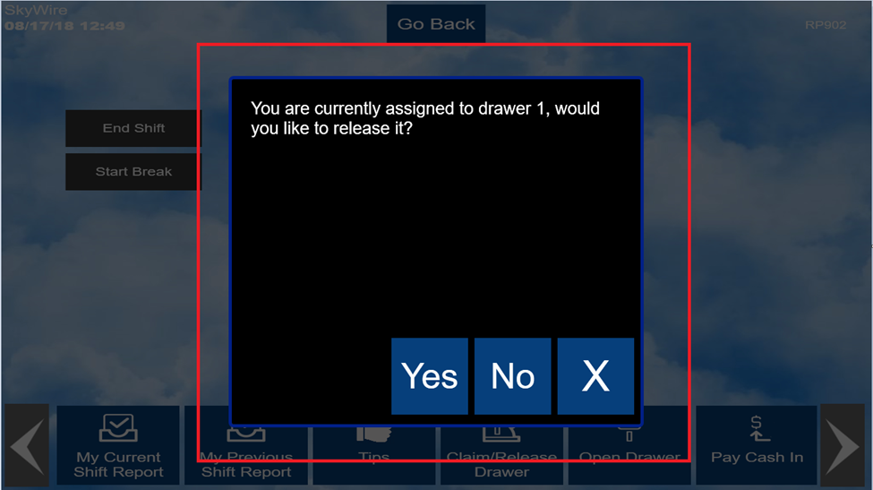
- Empty and paid orders will automatically close while ending shift.
- Select “OK.”

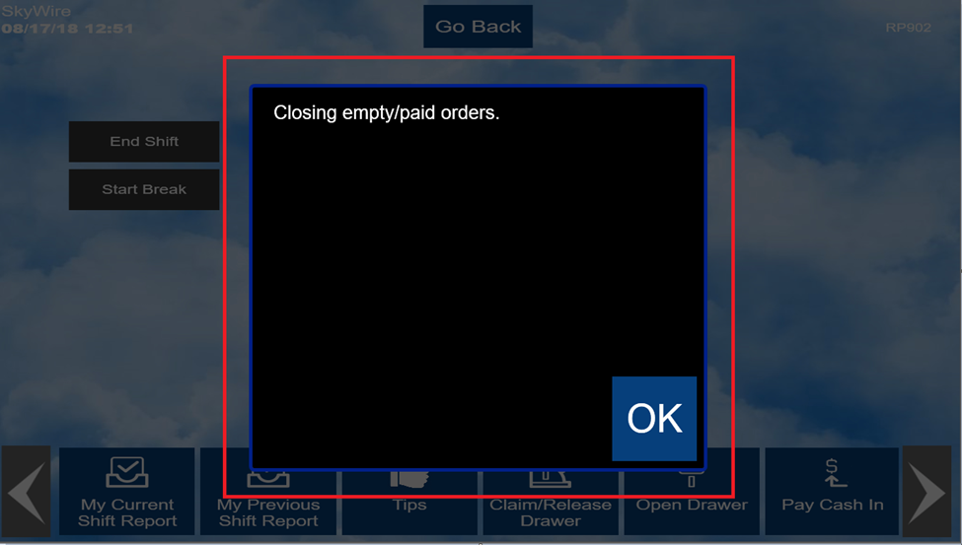

A prompt to declare cash tips may prompt.

- Enter the amount of cash tips.
- Select “OK.”

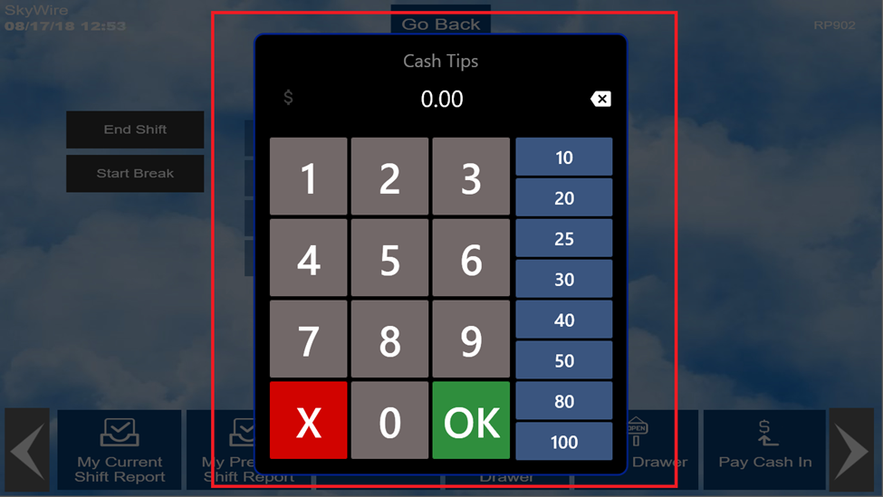

- Choose the number of desired shift reports.

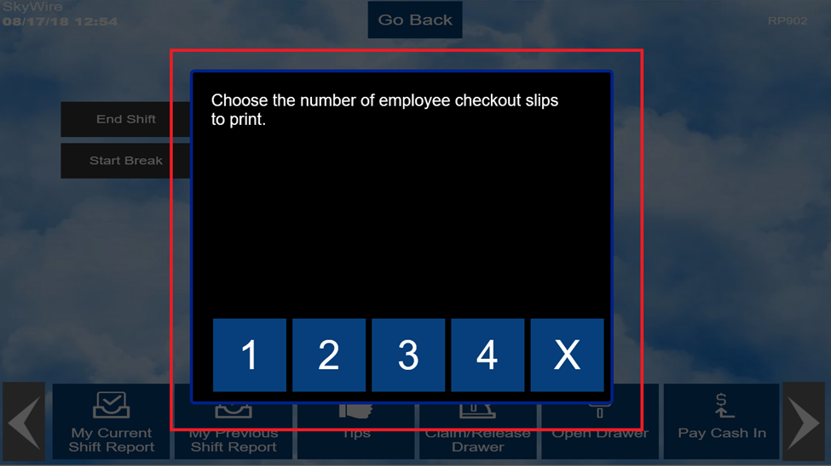

Placing an Order

New Order / New Table

- To start a new table / order, select “New Table” from the Main Screen.
- Single pass environments will only have to select "New Table" after signing-in.

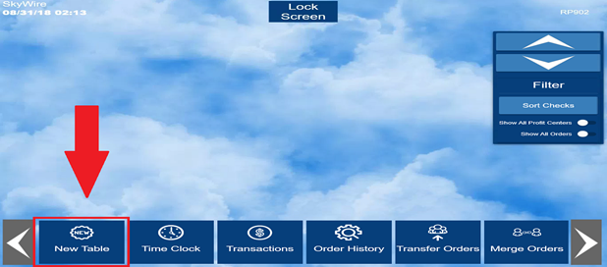

- Enter a table number.
- Select “OK.”

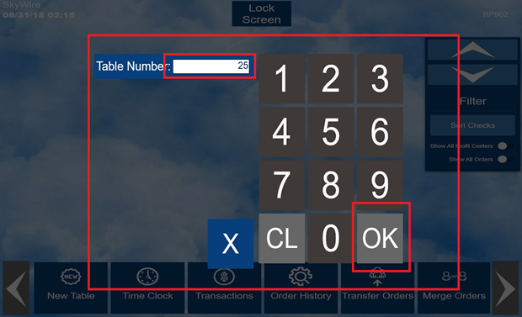

- If prompted, enter a party count (Guest Count).
- Select “OK.”

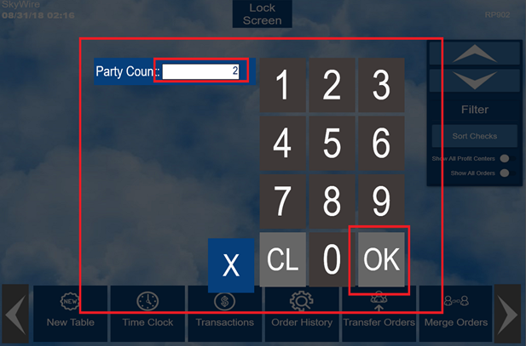

Ordering a Menu Item

- To order an item, select the Product Group the item is assigned to, once you have located the item, select the item desired.

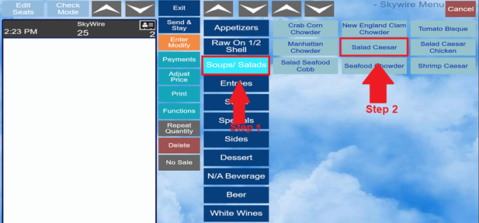

Forced Modifiers

- Forced Modifiers are modifiers that automatically prompt after selecting an item. Example, meat temperature for a steak.

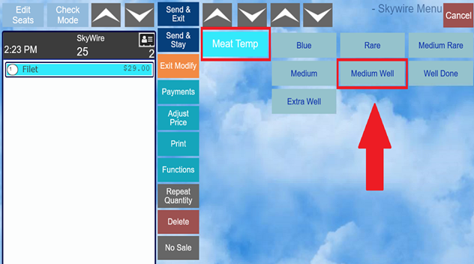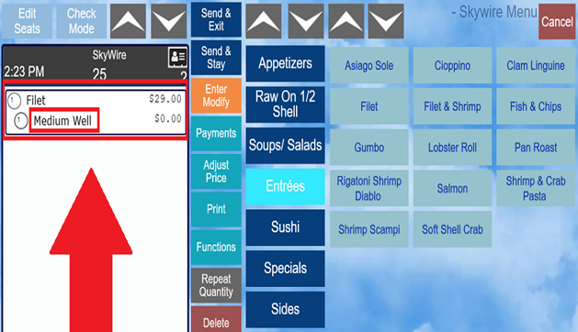

Exception Modifiers

- An “Exception Modifier” is one that is optionally added to modify an item due to a special circumstance or request.
- Select the Item.
- Select “Enter Modify.”

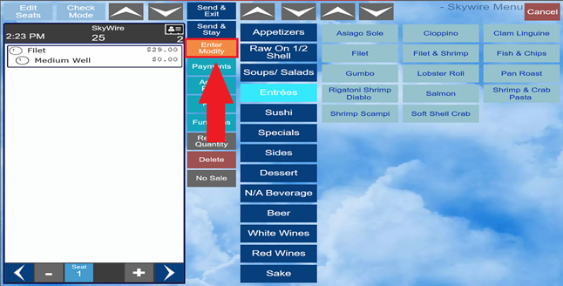

- Select the modifiers applicable.
- Select “Exit Modify” when all Exception Modifiers have been added.

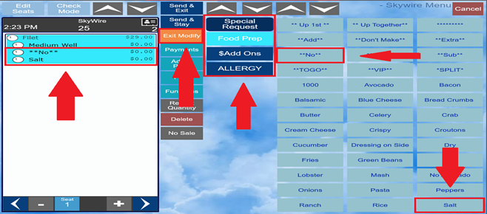

Special Request

- Special Request will allow you to type a special instruction.
- Highlight the item requiring the special request.
- Select “Enter Modify.”

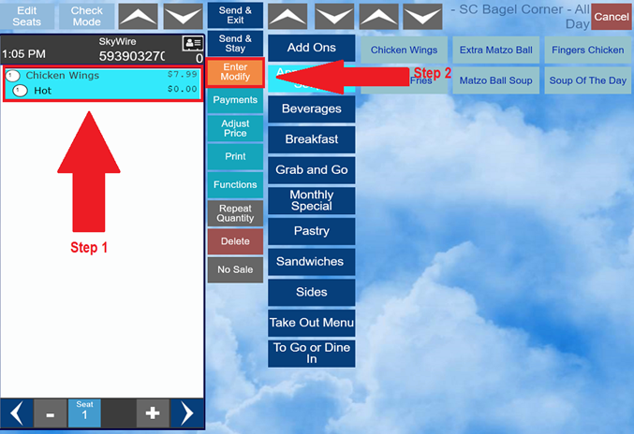

- Select “Special Request.”

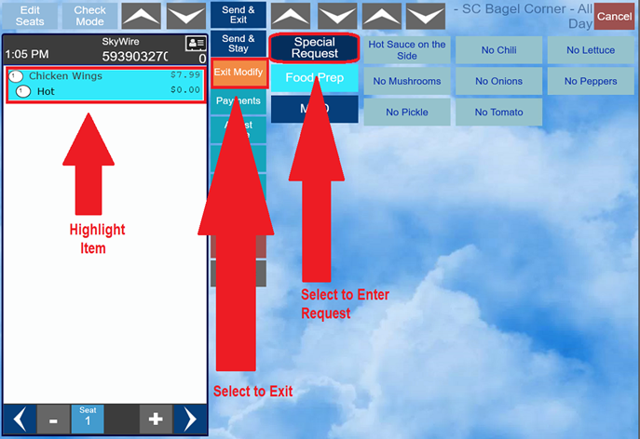
- Use the keyboard to type a special request.

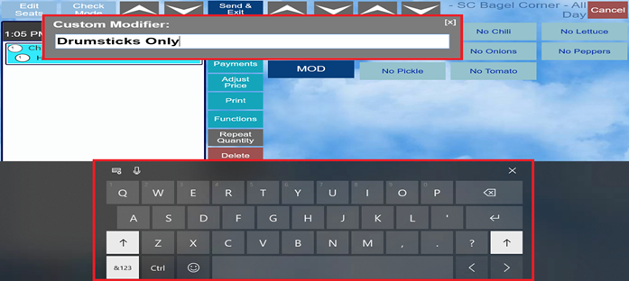

- Select “Exit Modify” when complete.

Seat Number Ordering

- By default, all items are automatically assigned to seat 1.
- To order items for another seat, select “+” to add a new seat.
- Select “-” to remove a seat.
- Select the seat number you are ordering for and select items for that seat.
- To move items to different seats, select “Edit Seats.”

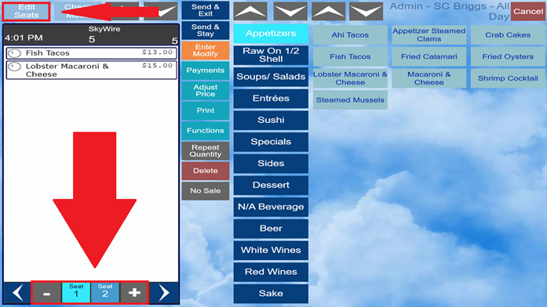
- Select the item to move and then select the seat that you are moving the item to.
- Select “Exit” when complete.

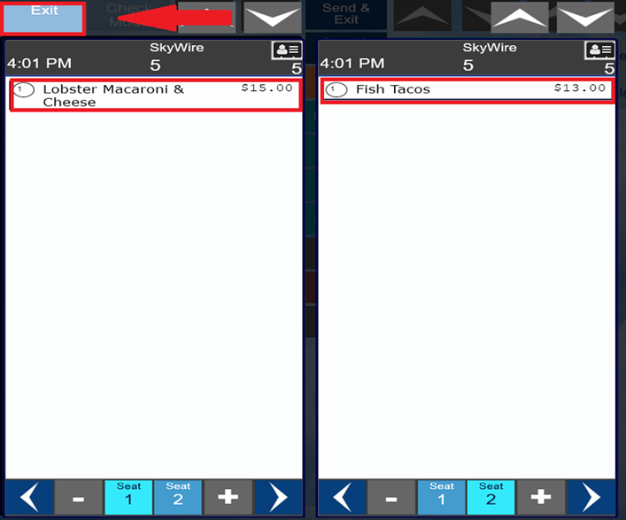

Send & Stay vs Send & Exit

- To send an item to a remote printer, select “Send & Exit” OR “Send & Stay.”
- Send & Exit will send the order to the remote printer(s), save the order, and exit the current screen.

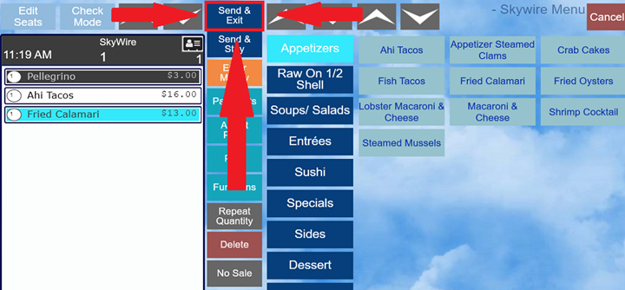

- Send & Stay will send the order to the remote printer(s), save the order, and keep the order on the screen.
- When an item has been sent to a remote printer, it will appear in gray on the screen.

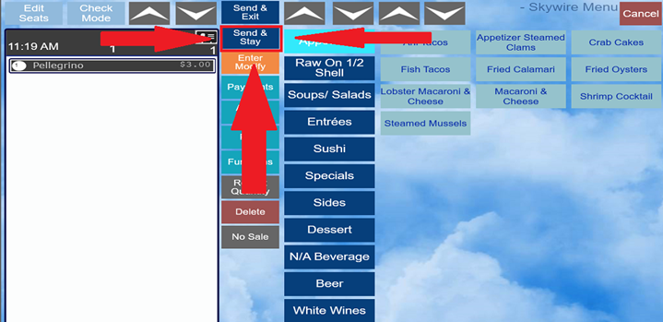

Delete Menu Item in Current Round

- To delete an item from an order before it has been saved, select the item.
- Select “Delete.”
- You can highlight multiple items if needed.

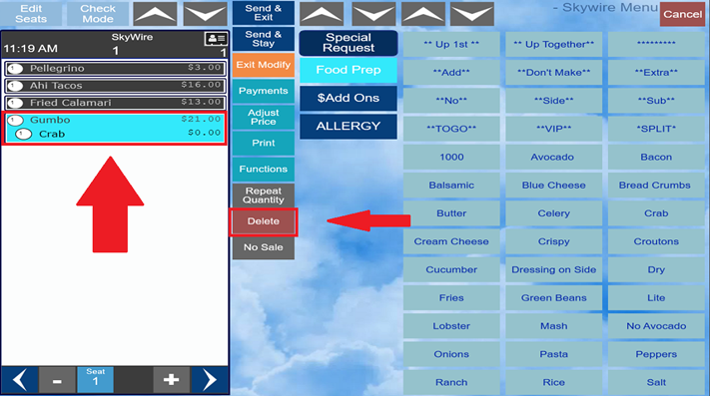
- You must be in seat mode to do this. If in check mode, a prompt will appear asking you to switch to seat mode.

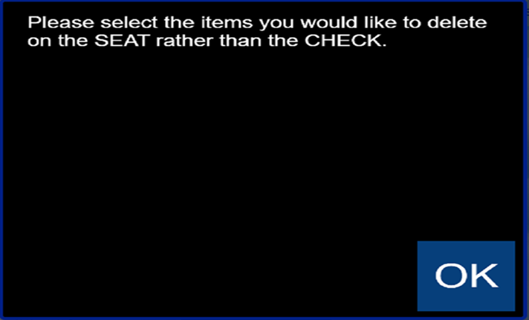

Print an Order

- To print a check, select “Print.”

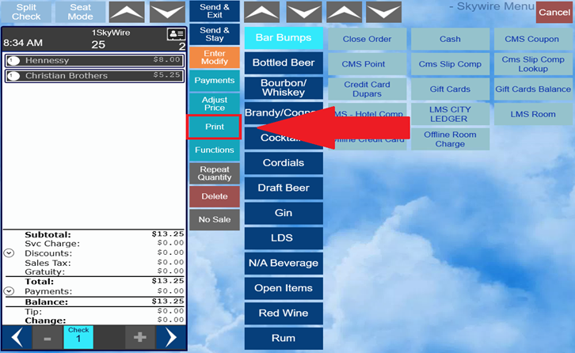
- Once the check has printed, the items will show in gray. This indicates the items have been saved and sent to remote printers if applicable.
- Depending on payments, you may be prompted with the option to print a trailer.

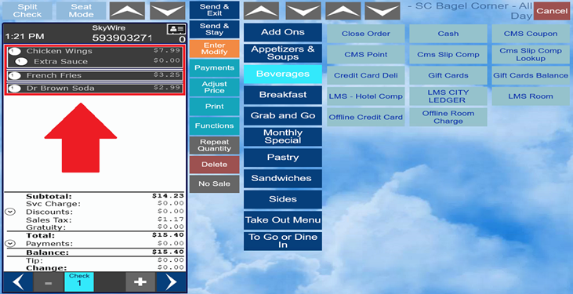

Seat Mode & Check Mode

- By default, the check is in Seat Mode once the order is opened. Here you can add items to each seat and edit seat numbers.
- Switching the order to Check Mode will allow you to apply tenders, discounts, functions, etc.

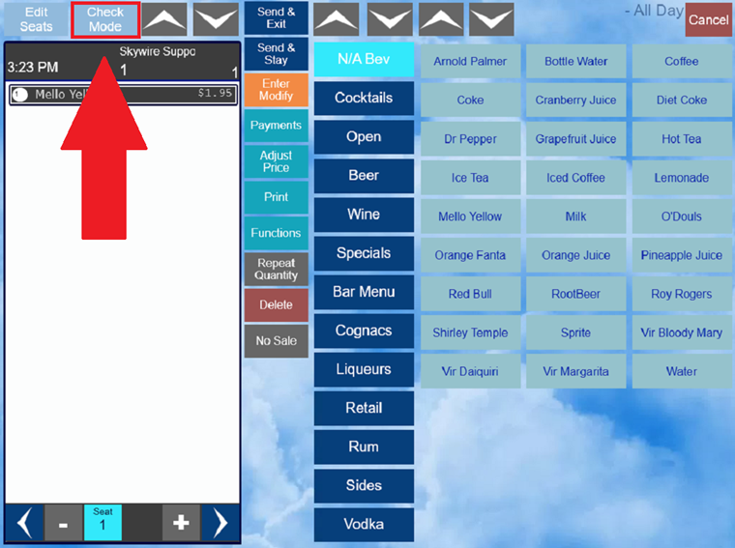
- You can toggle from “Seat Mode” to “Check Mode” using the buttons located on the top left of the screen.

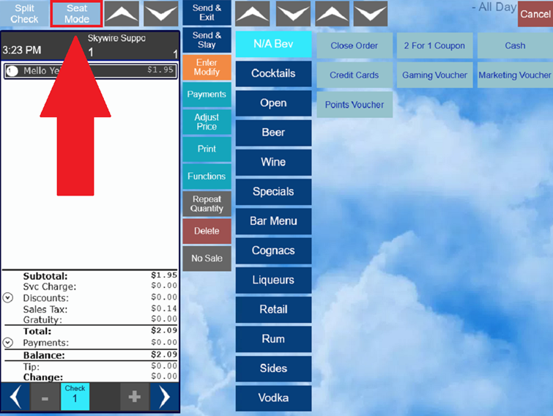

Repeat Quantity

- Select “Repeat Quantity” to order an item in quantity.
- This can be done before or after the item has been selected.

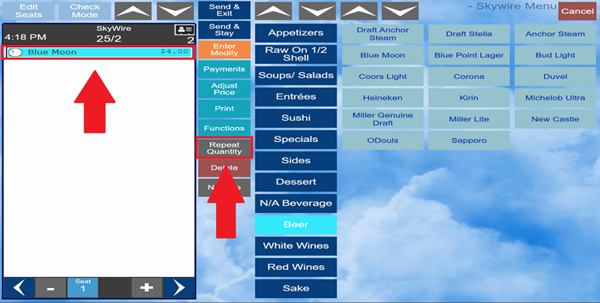
- After you enter a quantity, the next item you order will be ordered with that quantity.
- Or, select the item to be repeated and then select “Repeat Quantity.”

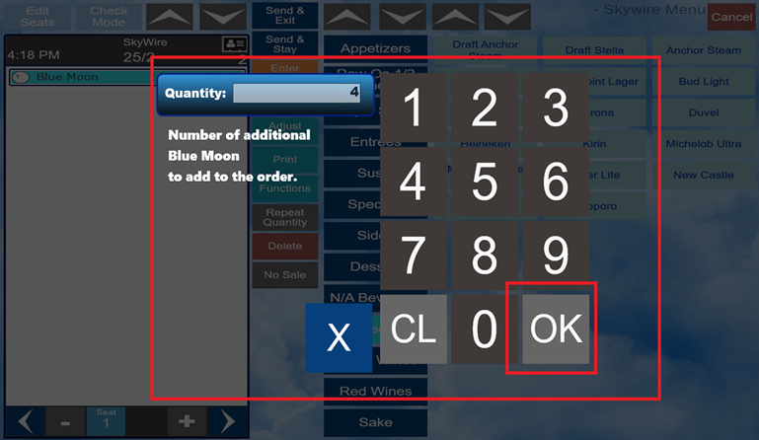

Adjusting and Splitting Orders

Splitting a Check

- To split a check, select “Split Check.”
- Note: This function is only available in Check Mode.

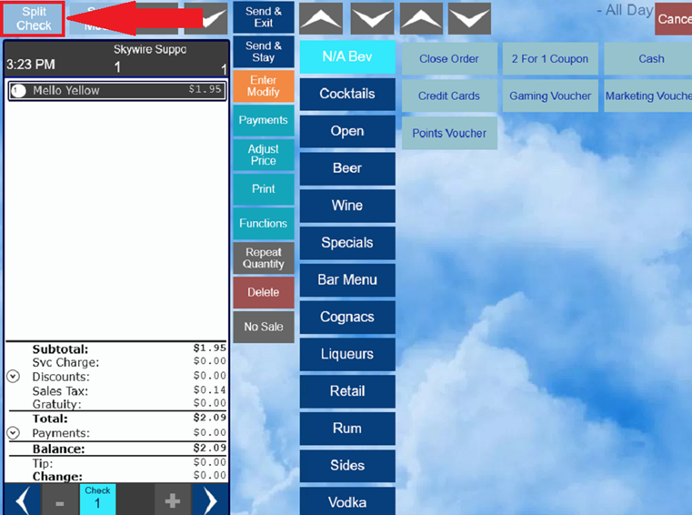

- Select the item(s) to be split and relocate them to a different check (s).
- Select “Exit” when complete.

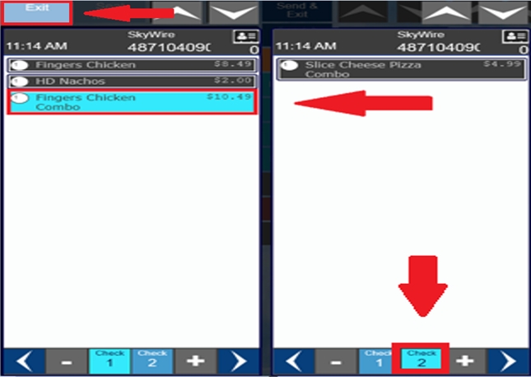

Splitting Checks by Seats

- Select “Function.”
- Select “Split Check by Seat.”

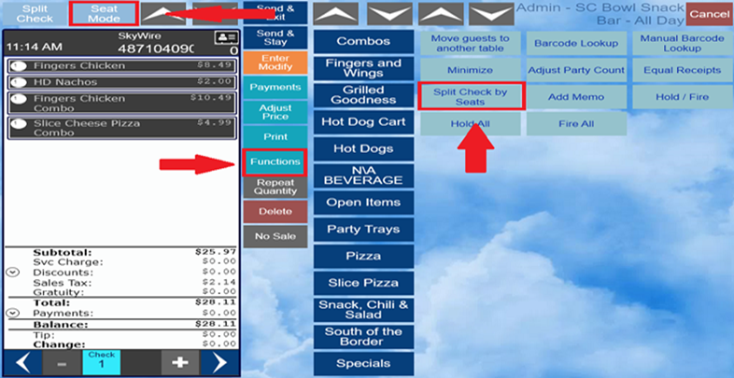

Equal Receipts

- To split amount of the check evenly, select “Functions.”
- Select “Equal Receipts.”

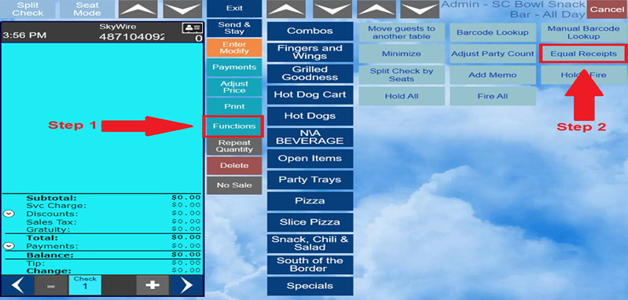
- Select the number of splits.

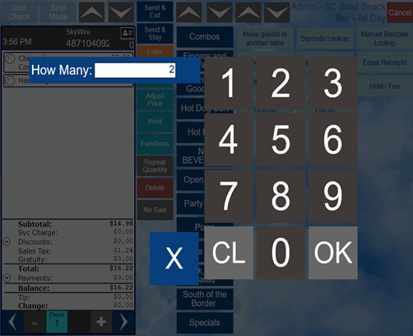

- Select “Itemized” or “Split” receipt to print.

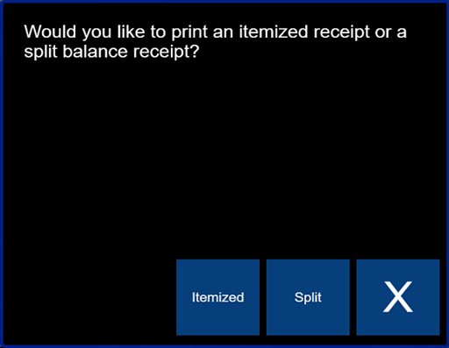

Transferring Orders

- Select “Transfer Orders” to receive a check from another user.

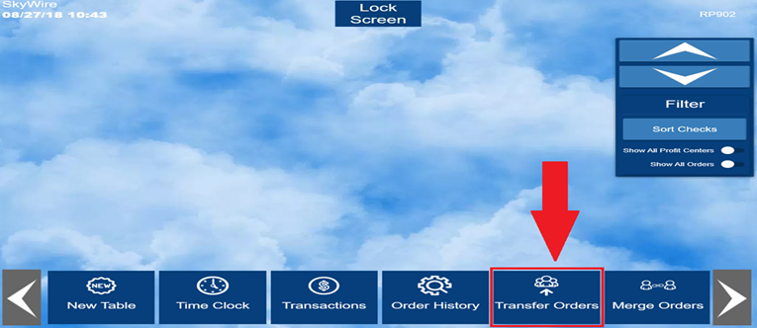

- First, scroll through the users on the left to find the user who’s check you are transferring to yourself.
- Select the check, then select the arrow in the middle (will appear once a check is selected) to add the check to the transfer.

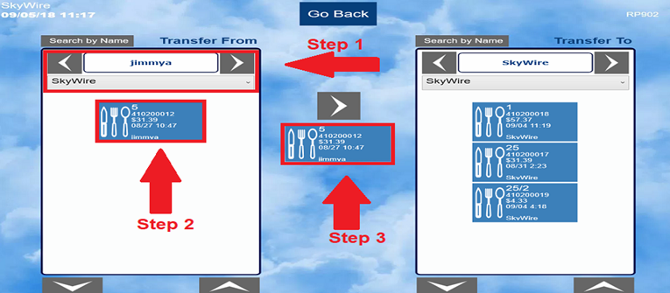

Merge Orders

- Select “Merge Orders” to combine orders together.

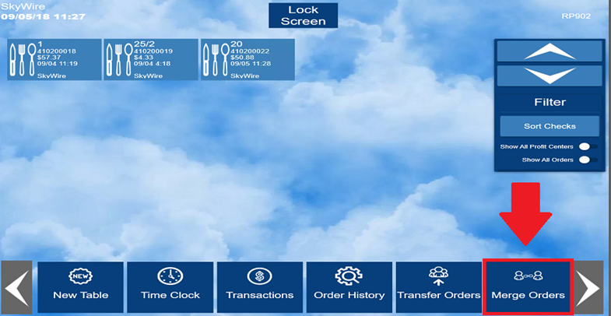

- Scroll through the users on the left to find the order if the order belongs to another user.
- Select checks to be merged.
- Select “Merge.”

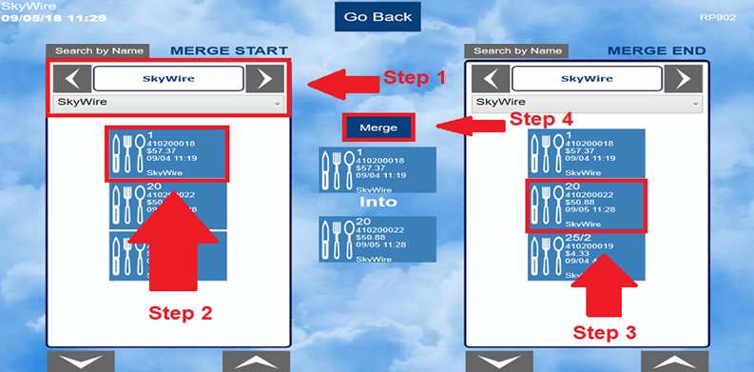

Closing Orders

Payments / Tenders

- Select “Payment” to tender an order.

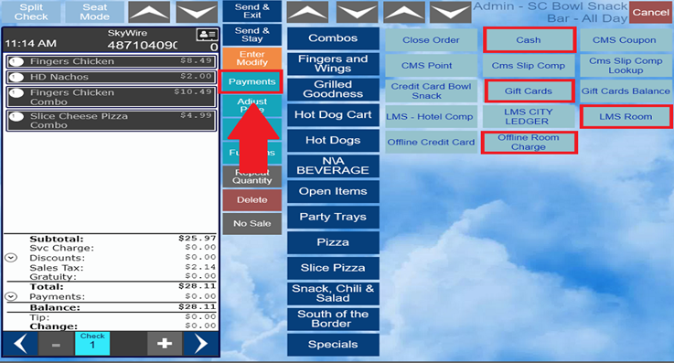

- Some tenders will prompt for amount, some may not. For example, “Fast Cash” might be configured to close the order automatically.
- Select “OK” if you want to accept the amount given, or you can enter a specific amount.
- Tenders that allow tips will prompt for a tip amount when the order is closed. After all tenders are applied to the check, select “Close Order” to close the check and apply tips.

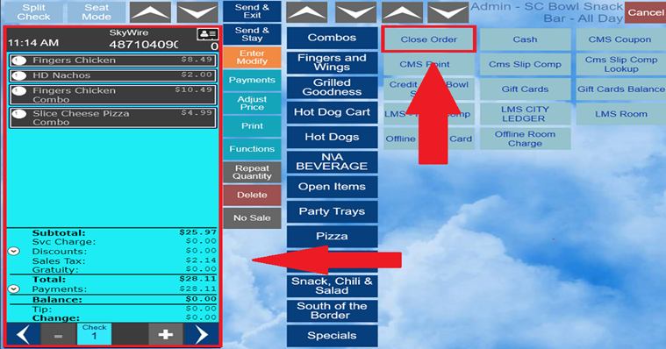

Split Tenders & Multiple Tenders

- Multiple tenders can be applied to a check by partially tendering the check to one tender, and then applying another tender.
- Select “Payments,” then select tender type.
- By default, the payment will prompt to tender the entire amount of the check. To apply a partial payment, enter the partial amount.
- The remaining balance can now be paid with a different type of tender. The order will stay on the screen until fully tendered.

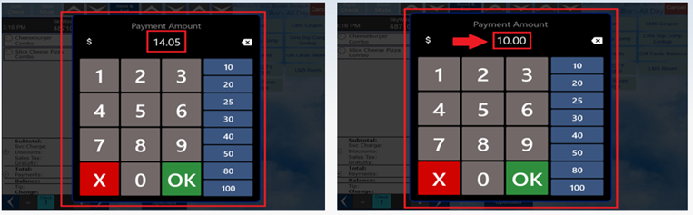

How to Reauthorize a Payment

- Navigate to the check to re-authorize.
- Select “Check Mode.”

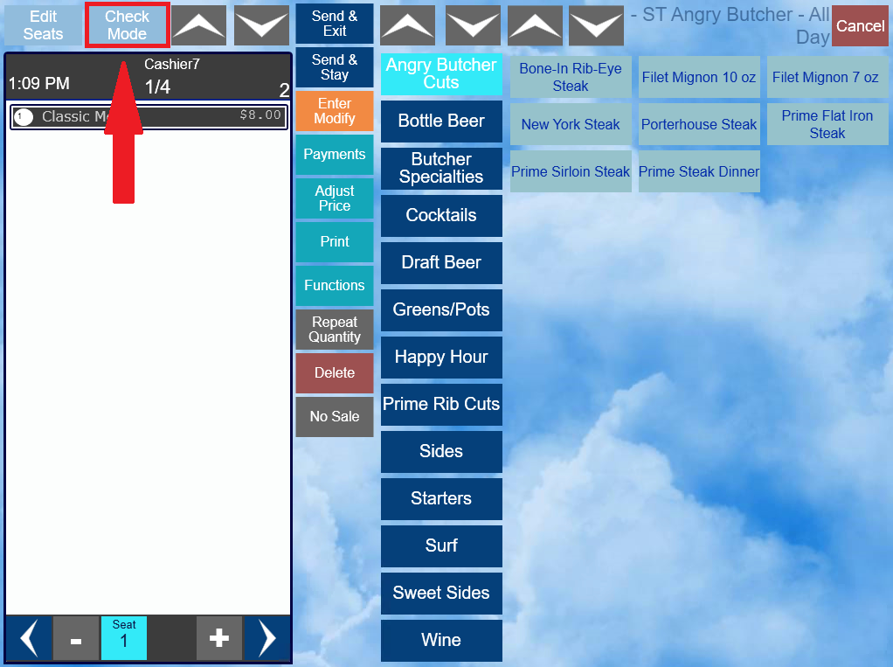
- Select “Payments.”

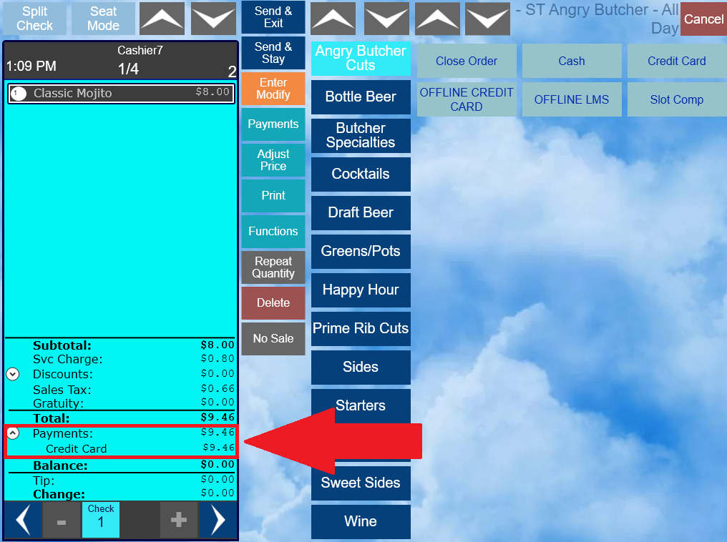

- Select the payment to reauthorize.
- Select “Reauth.”

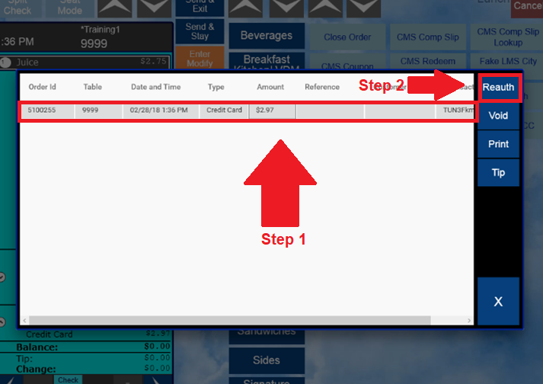
- The Payment Amount prompt will show the new total. This amount can be changed to any value that is equal to or less than the balance of the check.
- Select “OK.”

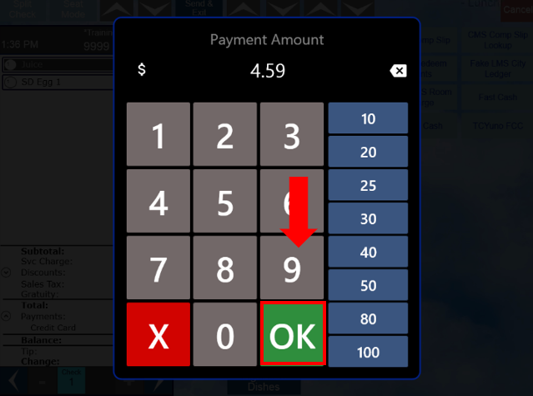

How to Print an Authorization Draft

- Navigate to the check with the authorization draft to print.
- Select “Check Mode.”

- Select “Payments.”

- Select the payment to print.
- Select “Print.”

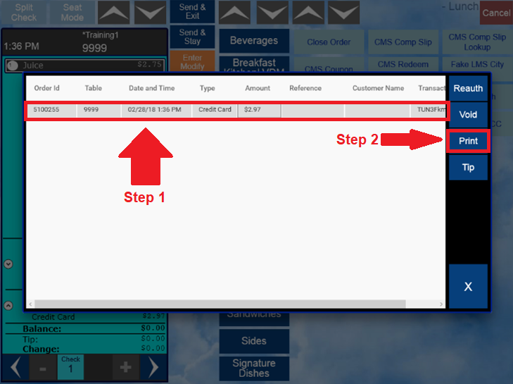

How to Adjust a Tip

- Navigate to “Order History.”

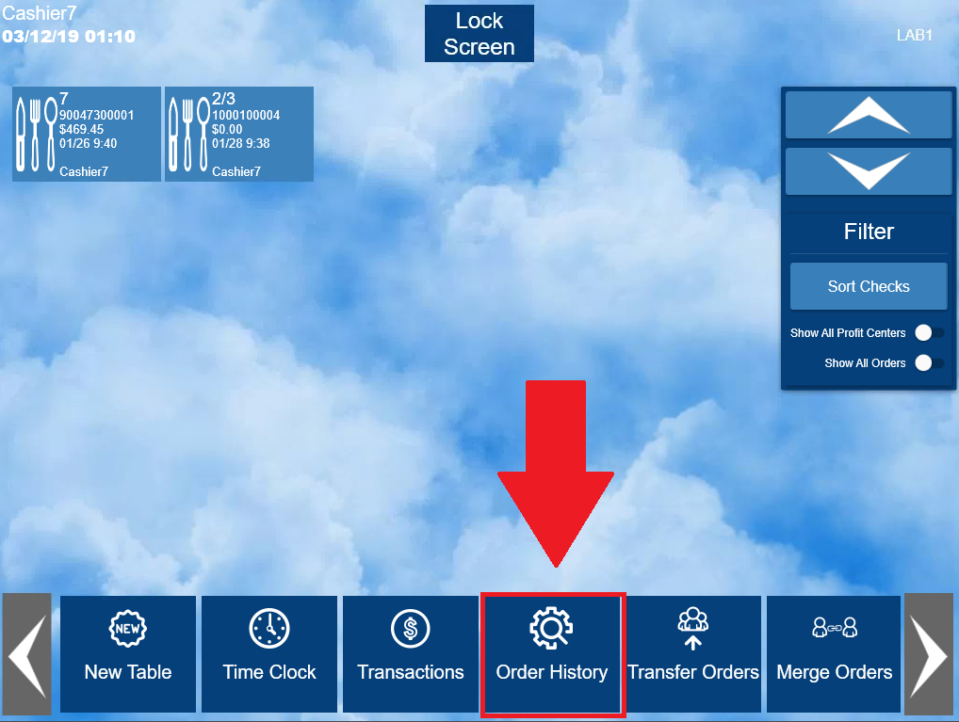

- Navigate to the order that needs to be adjusted.
- Select “Show All Orders” if the order was created by another user other than the user signed in.
- Select “View Order.”

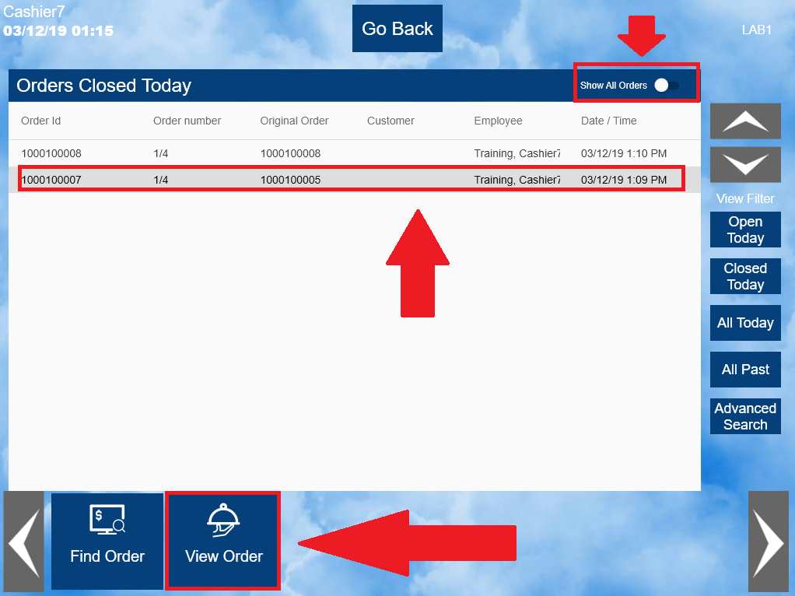
- Confirm the order and select “Reopen Order.”

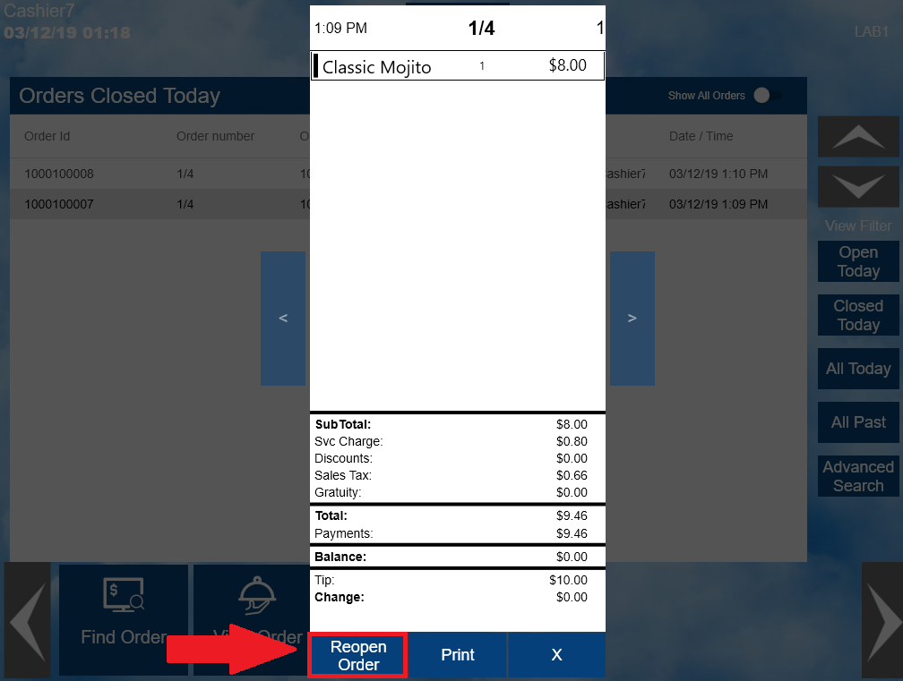

- Select “Check Mode.”

- Select “Payments.”

- Select the transaction with the tip that needs to be adjusted and select “Tip.”

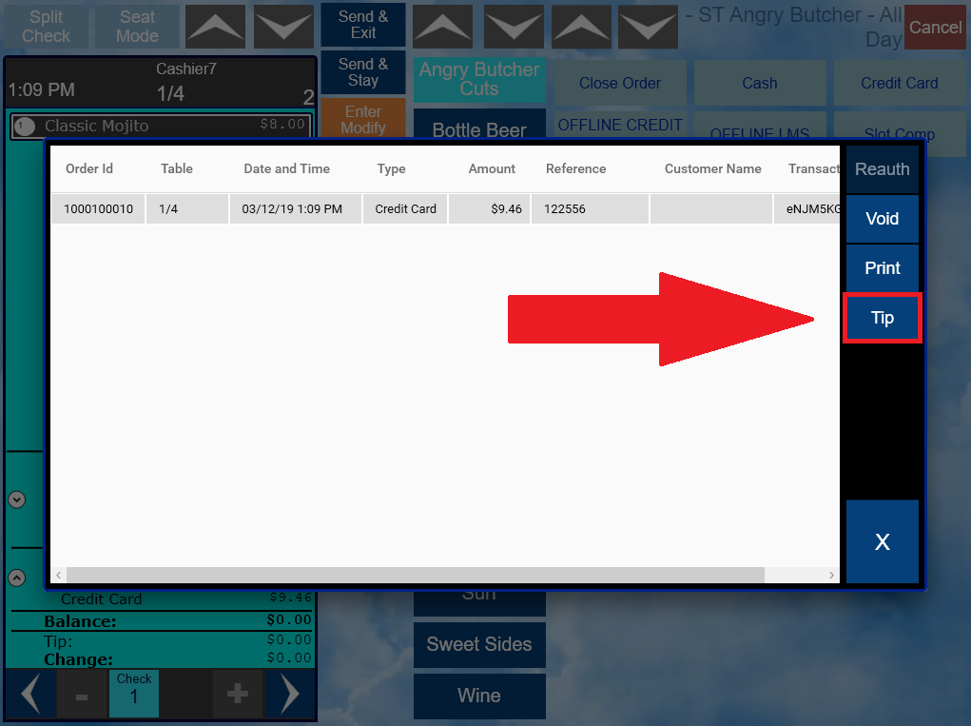
- Enter the correct tip amount and select “OK.”

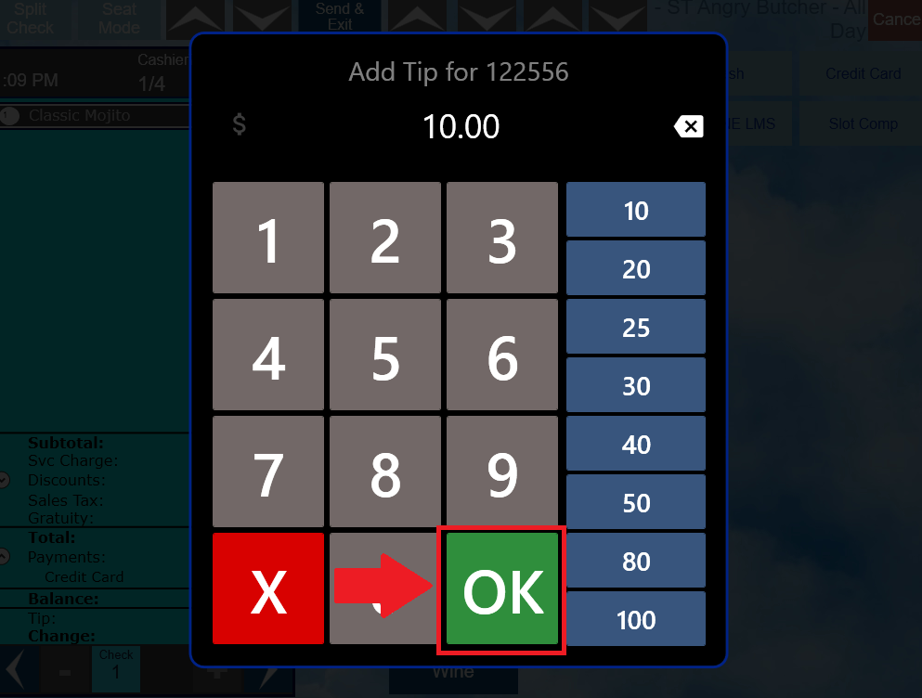

How to Void a Payment

- Navigate to “Order History.”

- Navigate to the order that has the payment that needs to be voided.
- Select “Show All Orders” if the order was created by another user other than the user signed in.
- Select “View Order.”

- Confirm the order and select “Reopen Order.”

- Select “Check Mode.”

- Select “Payments.”

- Select the transaction with the payment that needs to be voided.
- Select “Void.”

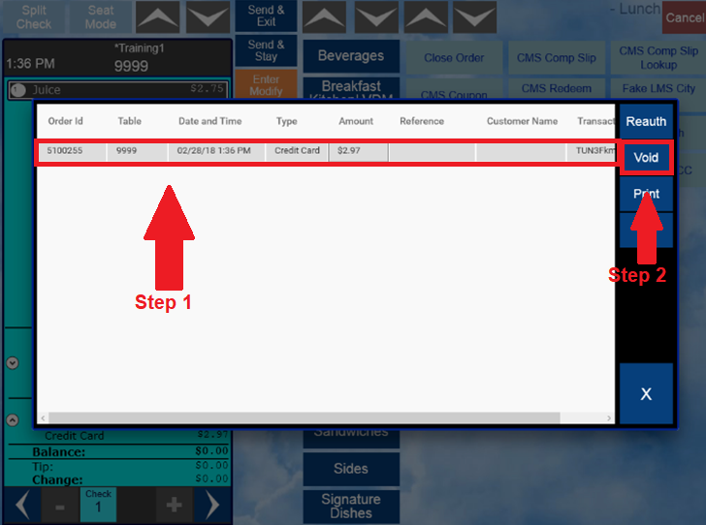

Adjust Price – Discounts, Voids, and Comps

- Adjust Price allows you to perform multiple adjustments for discounting, voiding, and comping.
- To use any of these functions, select “Adjust Price.”
- If adjusting price to one item, select the item to be adjusted.
- Choose the correct price adjusting option.
- If / when prompted for a selection, make the appropriate choice based on the circumstance.

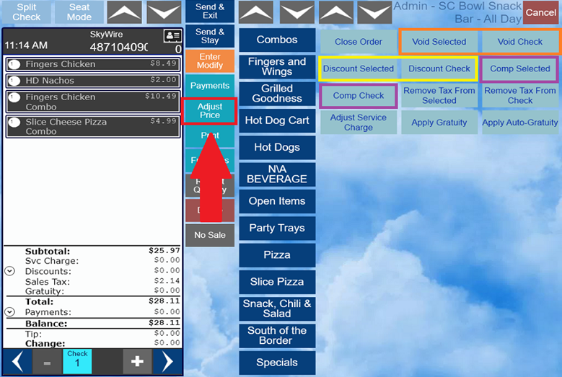

- Note: Not all users will have access to Void or Comp items and checks. Reach out to management if the prompt below is received.

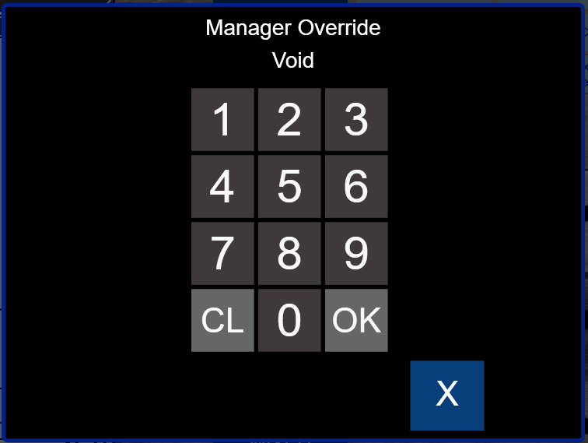

Tax Free Selected / Tax Free Check

- To remove tax from an item or the entire check, select “Adjust Price.”
- Select “Remove Tax from Selected” or “Remove Tax from Check.”
- If removing the tax from an item, select the item first.

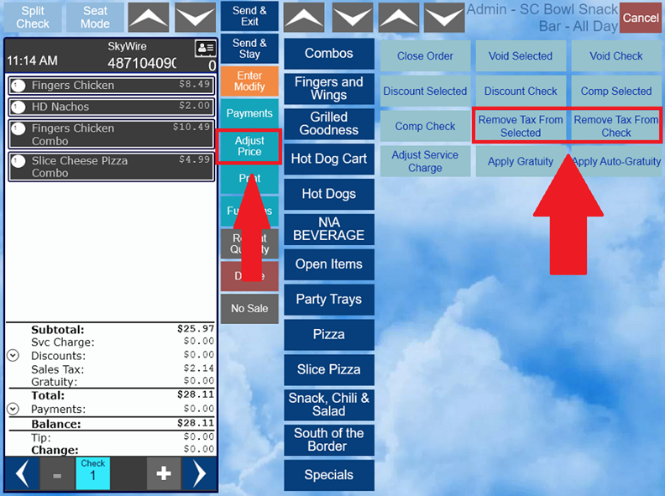

Order Functions

- Select “Function” to access the following:
- Move guest to another table
- Adjust Party Count
- Equal Receipts
- Split Check by Seats
- Add Memo
- Hold / Fire

Modify Table Number

- This function allows you to change the table number of a check.
- Select “Functions.”
- Select “Move guest to another table.”

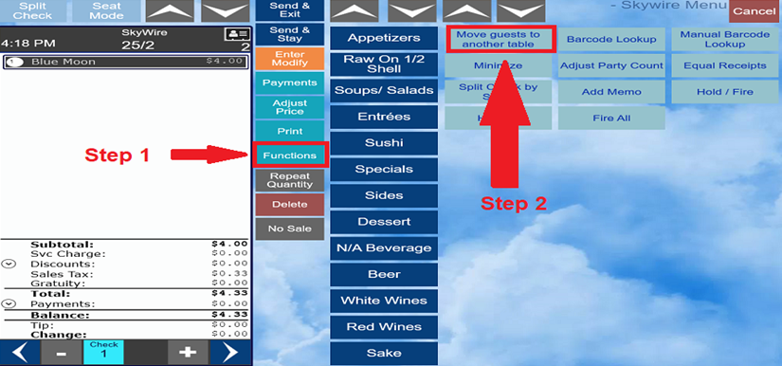

- Enter the new table number.
- Select “OK.”

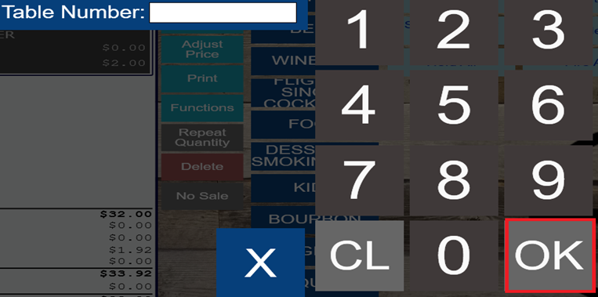

Adjust Party Count

- The party / guest count can be modified at any time.
- Select “Function.”
- Select “Adjust Party Count.”

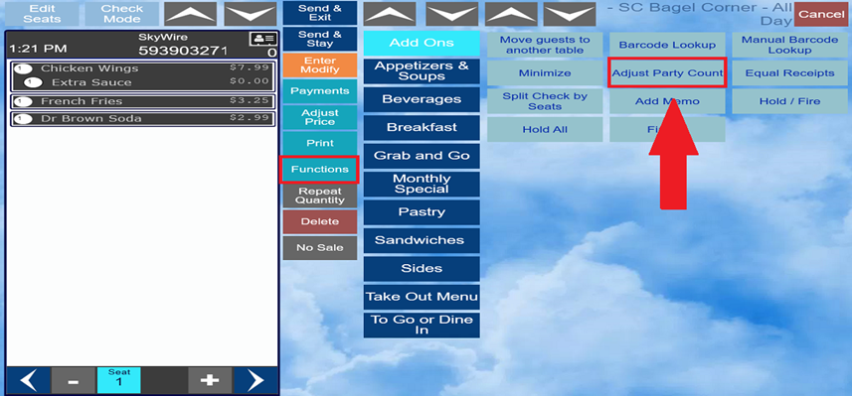

- Enter new guest / party count.
- Select “OK.”

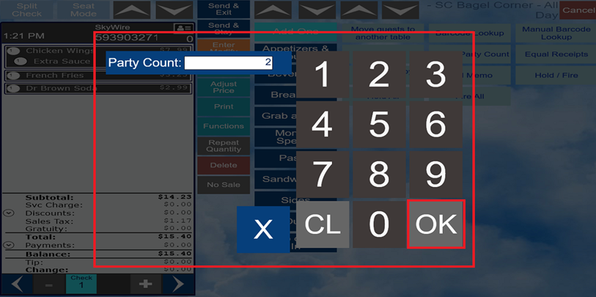

Naming an Order

- To add a reference to the order, select “Functions.”
- Select “Add Memo.”

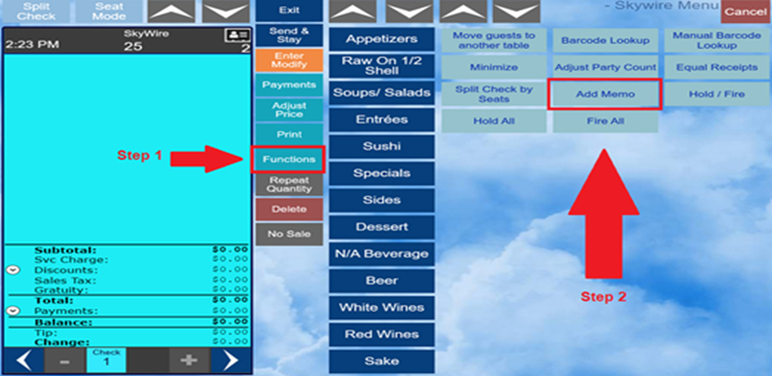

- Enter a name for the order.

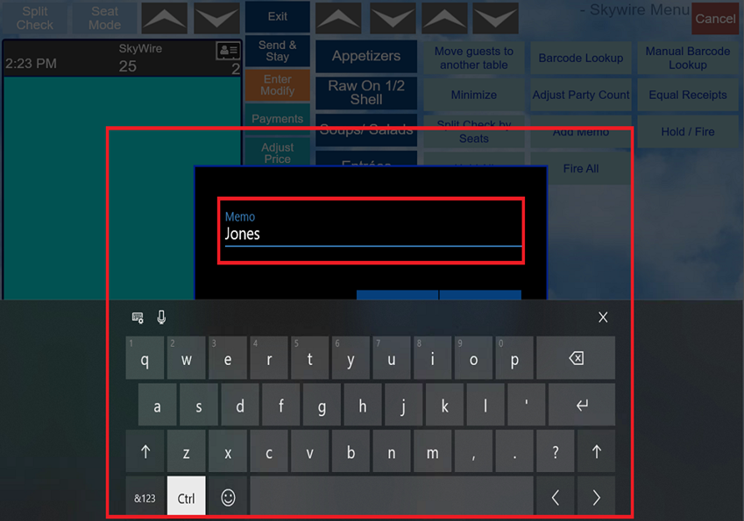
- Select “Confirm.”
- Note: The reference will appear on the screen by the order/table number and print on the check.

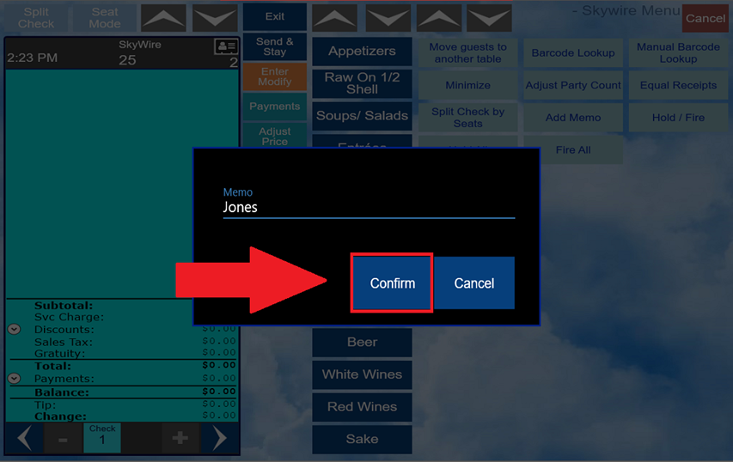

Hold / Fire Functions

- By default, products that are configured to print remotely are sent to the kitchen or the bar after selecting “Send & Stay” or “Send & Exit.”
- Products can be held and fired by using the “Hold / Fire” buttons which is accessible from the functions tab.

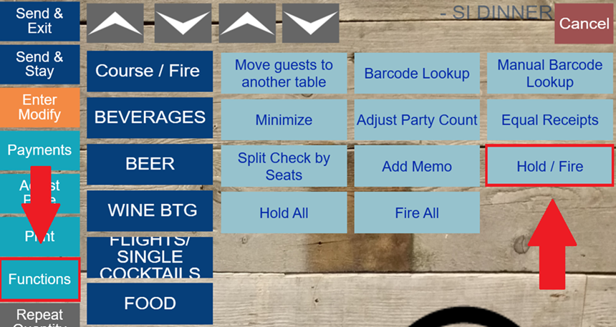

How to Hold an Item

- Select “Function.”
- Select the item or items to be held.
- The modifiers attached to the item will be held as well.
- Items selected will appear in blue.
- Select the “Hold / Fire” button to activate the hold function. The item or items held will appear in pink.

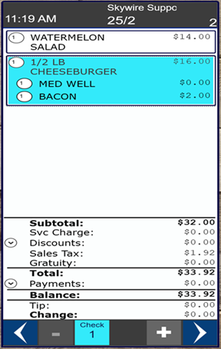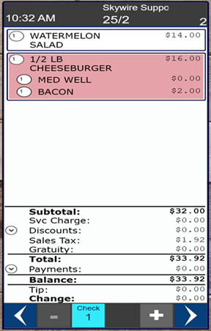

- Orders with held items will show in pink at the main screen.

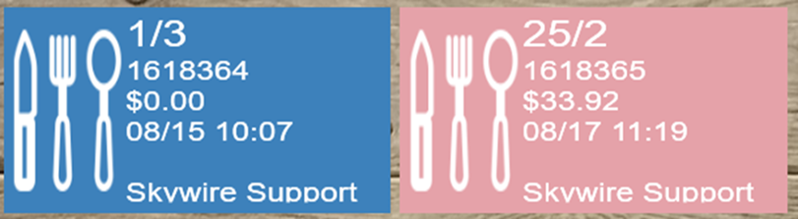

How to Fire Items

- Select “Function.”
- Select the item or items to be fired.
- The modifiers attached to the item will be fired as well.
- Items selected will appear in blue.
- Select the “Hold / Fire” button to activate the fire function.
- The item or items will appear in white.
- Select “Send & Exit” or “Send & Stay” to save the check and fire items.

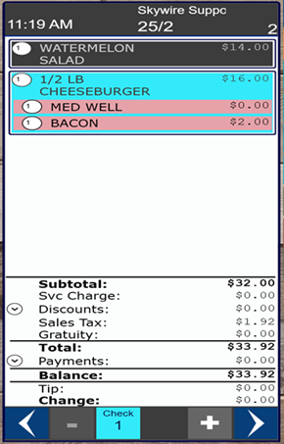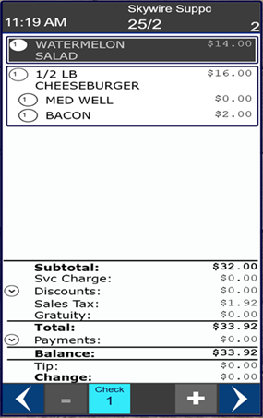

How to Hold or Fire All Items

- Select “Function.”
- Select “Hold All” or “Fire All” to hold or fire all items.
- No items need to be selected prior to activating this function.

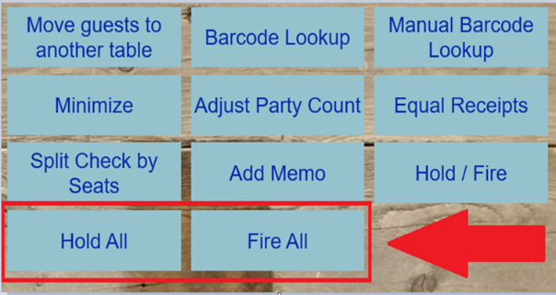

Barcode Lookup

- Use this function to find a barcode item.
- Select “Barcode Lookup” to look up an item with a bar code scanner.

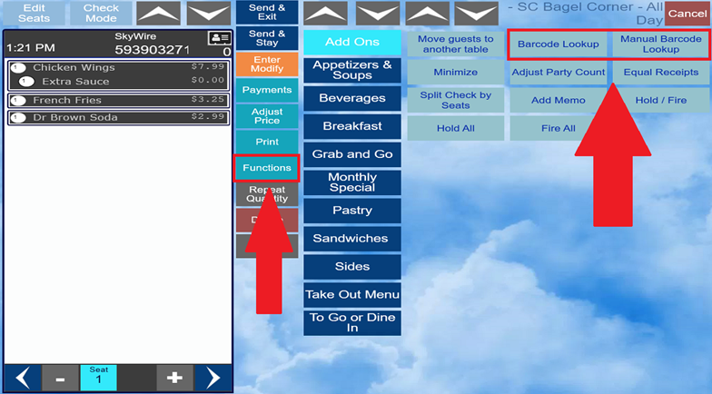

- Select “Manual Barcode Lookup” to look up an item by entering the number of the barcode manually.

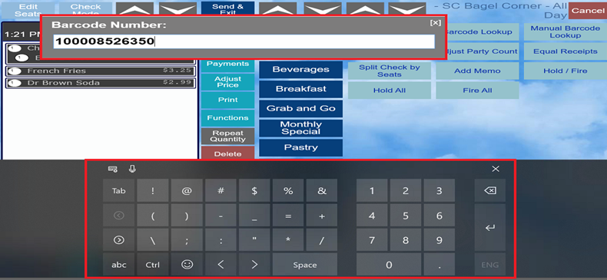

Other Functions

Time Clock Functions
Here you will find the following functions:

- End Shift
- Start Break
- Print Current Report
- Previous Shift Reports
- Tips
- Claim or Release Cash Drawers
- Open Drawer
- Pay Cash In / Pay Cash Out
- Enroll Print
- Assign Mag Card

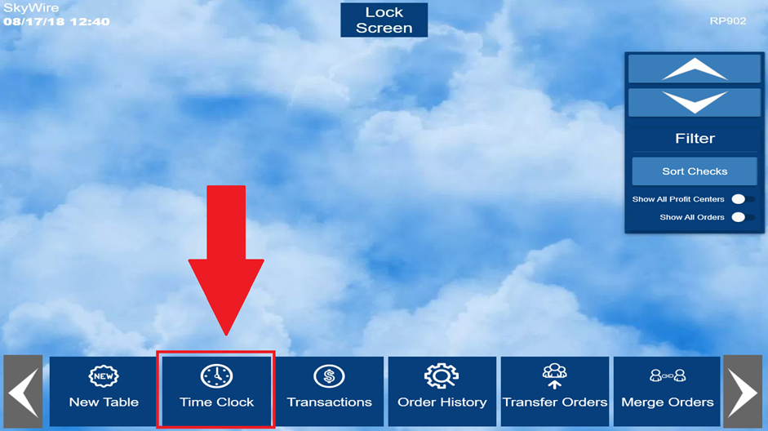

Start Break / End Break

- To disable POS access during breaks without ending shift, select “ Start Break.”

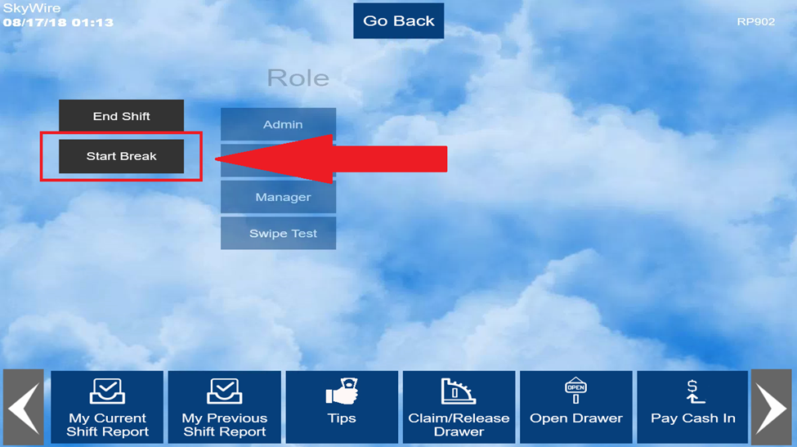
- Select “End Break” once returned to access the POS terminal.

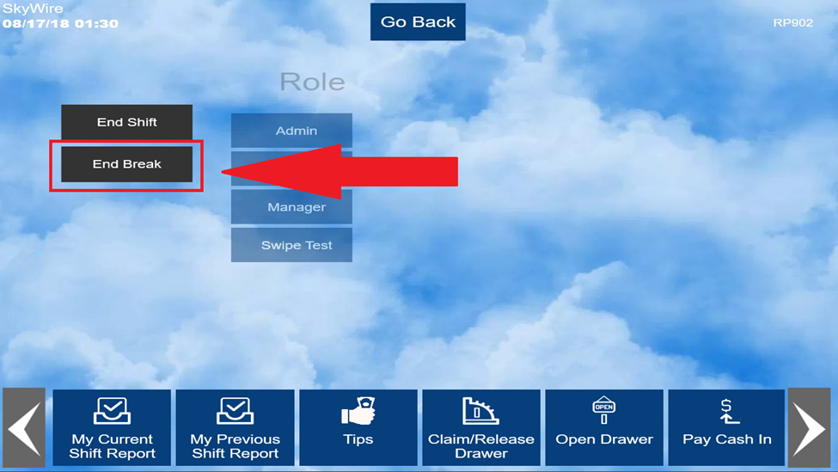

Print Current and Previous Shift Reports

- A shift report will print automatically after ending your shift. A shift report may be reprinted at any time.
- To print a shift report for the current period, select “My Current Shift Report.”
- To print a shift report for the previous period, select “My Previous Shift Report.”

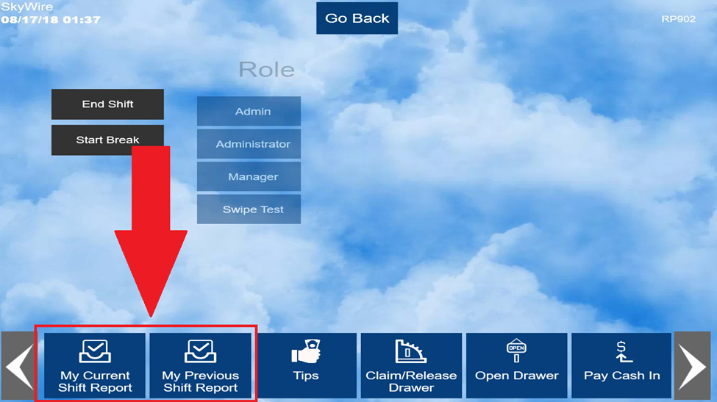

- Choose the number of reports to print.

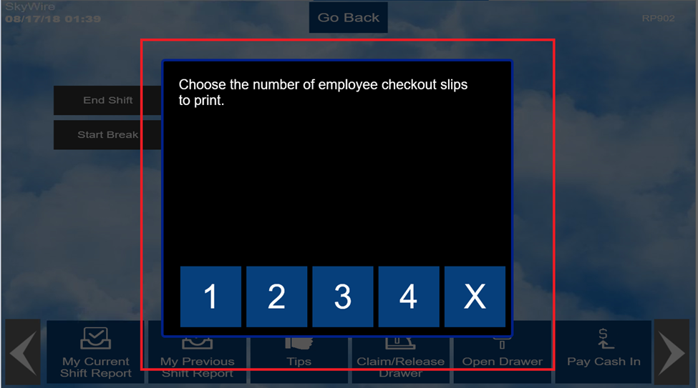
Shift Report Includes:

- General information outlining the specifications for the shift report. Name, outlet, shift times, etc.…
- “Sales by Revenue Type” breaks down sales by revenue category (E.g. food, beer, wine). Useful for tipping out support staff.
- “Taxes” portion breaks down exclusive and inclusive taxes.
- “Payment” is where you find all the tenders applied during the shift.
- “Tips” are broken down by tender.
- “Paid in / Paid Out” shows all Non-POS transactions.

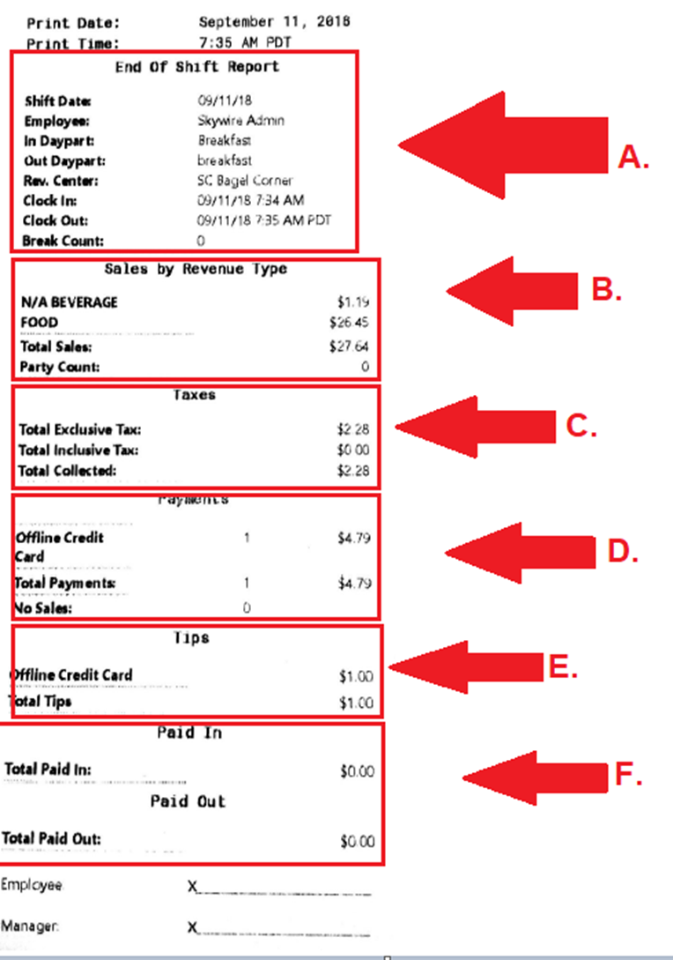

Pay Cash In / Pay Cash Out

These functions are for Non-POS Transactions.
- Select “Pay Cash In” to collect cash for the house.
- Select “Pay Cash Out” to pay out cash from the house.

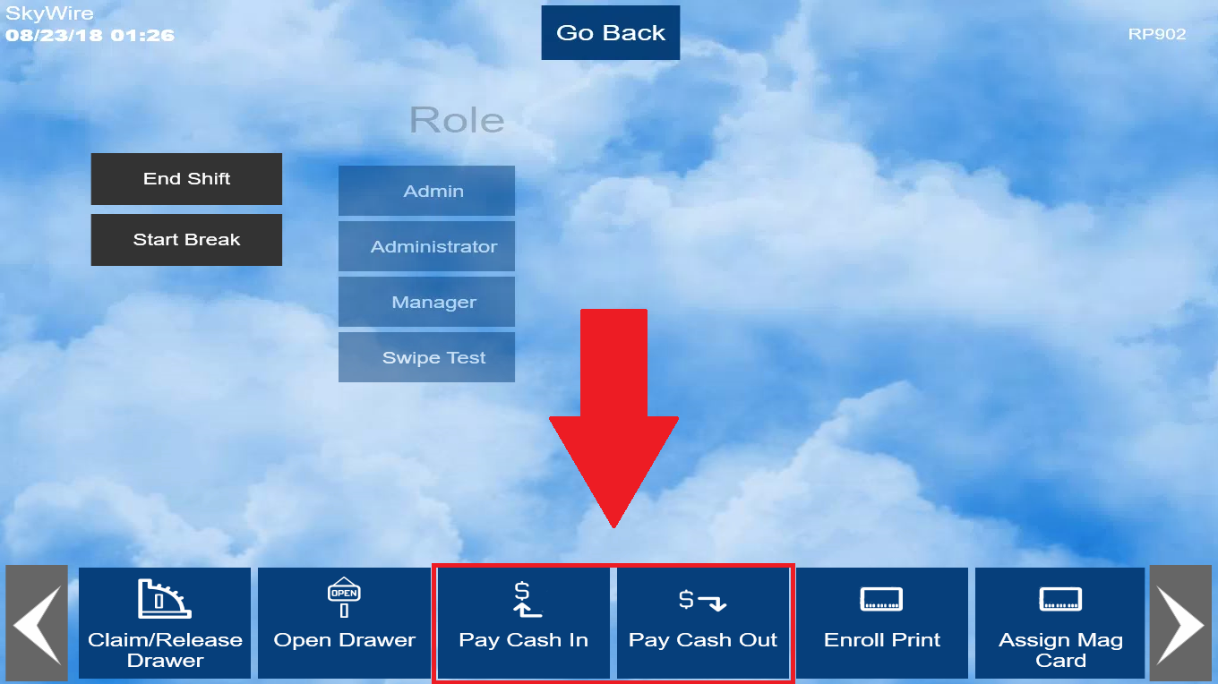

- Select an amount to be Paid In / Out.

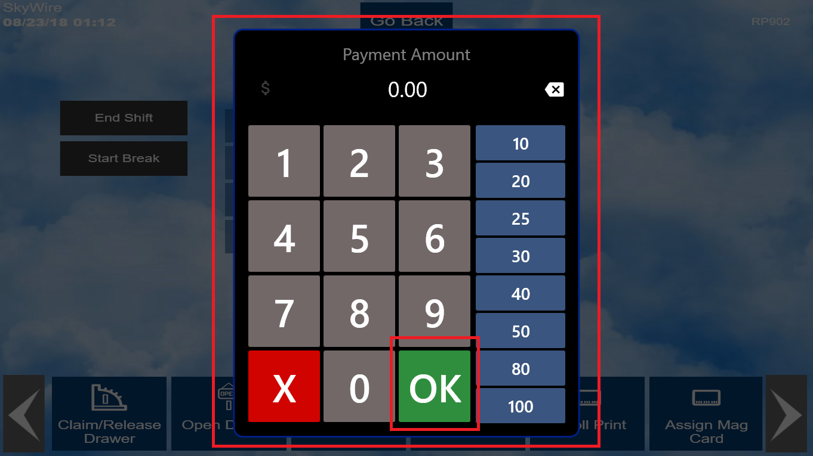

- Choose Paid In / Out reason.
- Select “Confirm.”

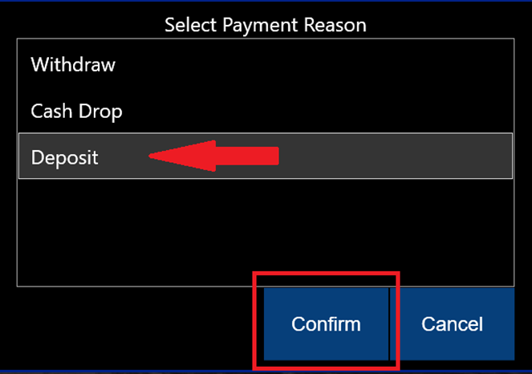

- Select “OK.”

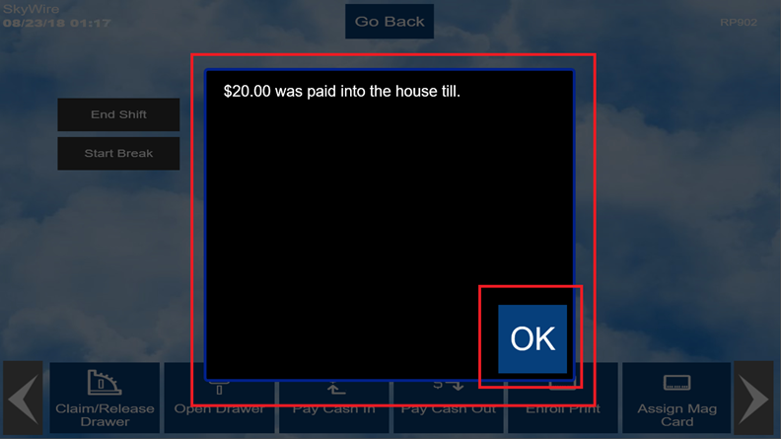

Enroll Print

For terminals with integrated fingerprint pads only.
- Select “Enroll Print.”

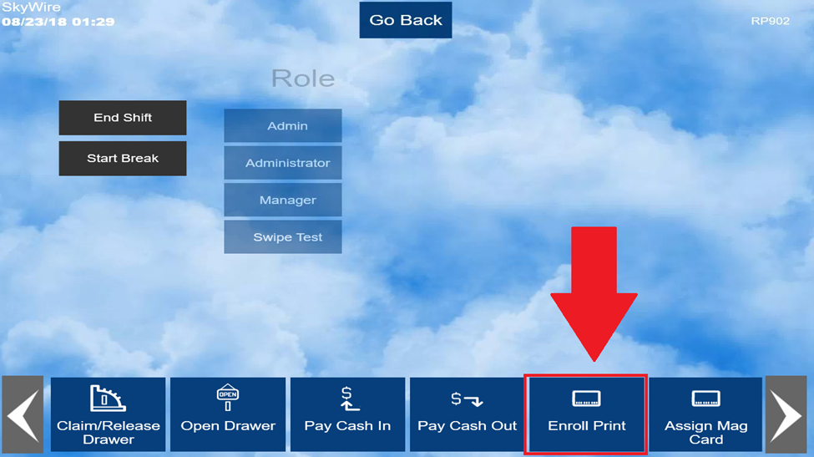

- Select employee assigning fingerprint.

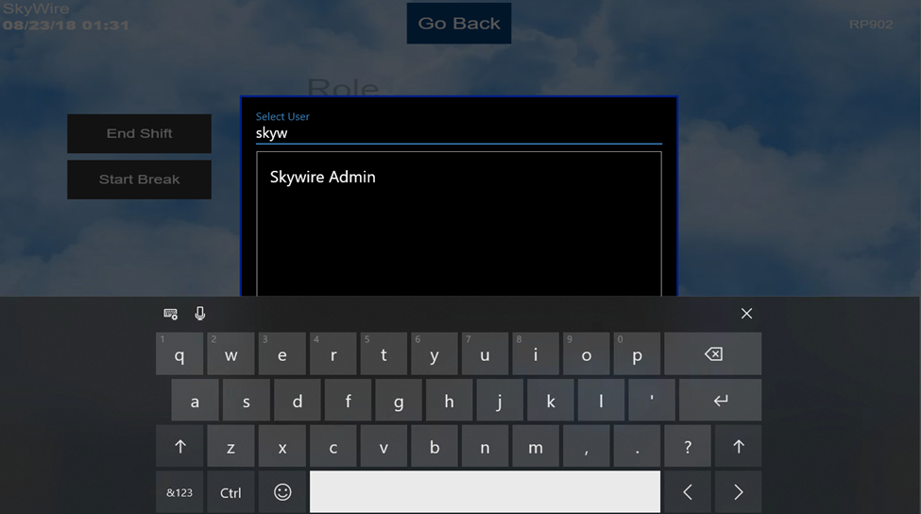
- Place desired fingerprint on fingerprint pad. This step will be repeated until terminal shows 100%.

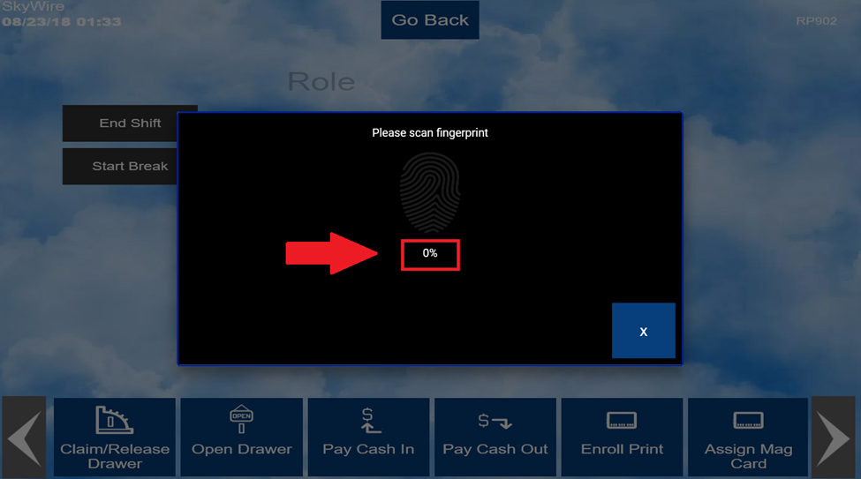

- Place the employee’s finger on the finger pad until 25% is completed.
- Remove the finger from the reader.
- Continue placing the finger on and off the pad until 100%.
- Note: The scans are in 25% increments.

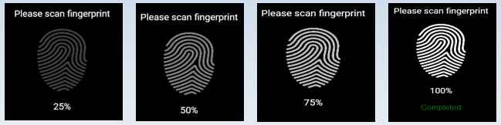

Assign Mag Card

- To assign an employee swipe card, select “Assign Mag Card.”

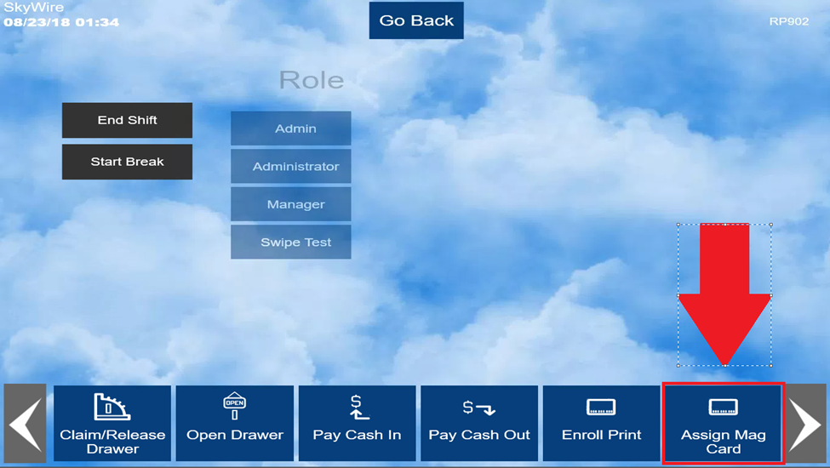

- Select the employee assigning swipe card.

- Swipe employee’s card and confirm.

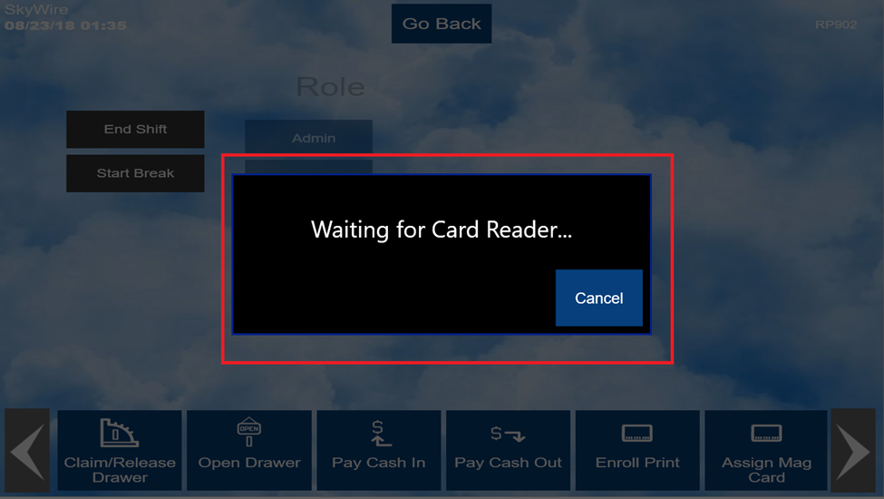

Transactions

Transactions can be used to find checks that have been tendered. Once found, you can re-print or reopen the check.

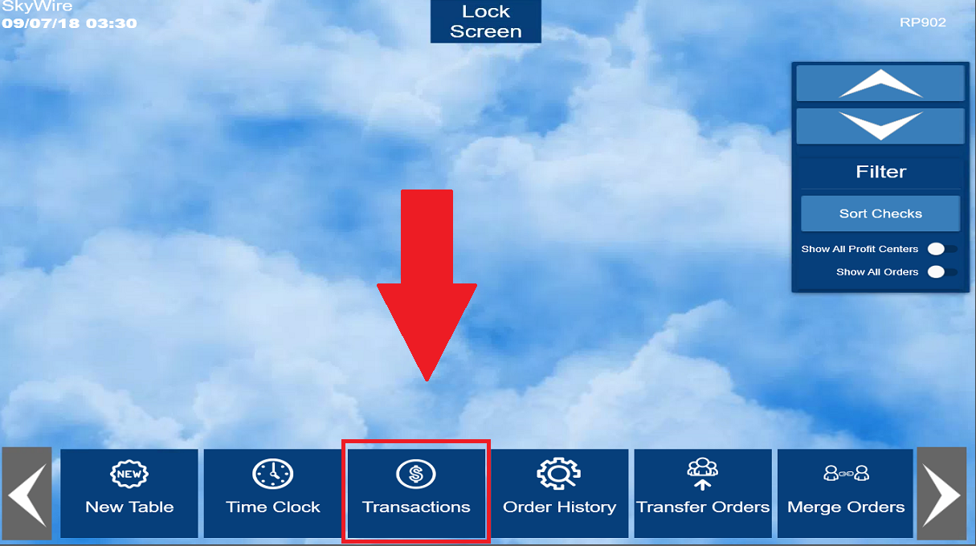
- To find a transaction, select “Find Transaction” and enter the transaction number.
- You can also use “View Filter” to navigate through transactions if transaction number is unknown.

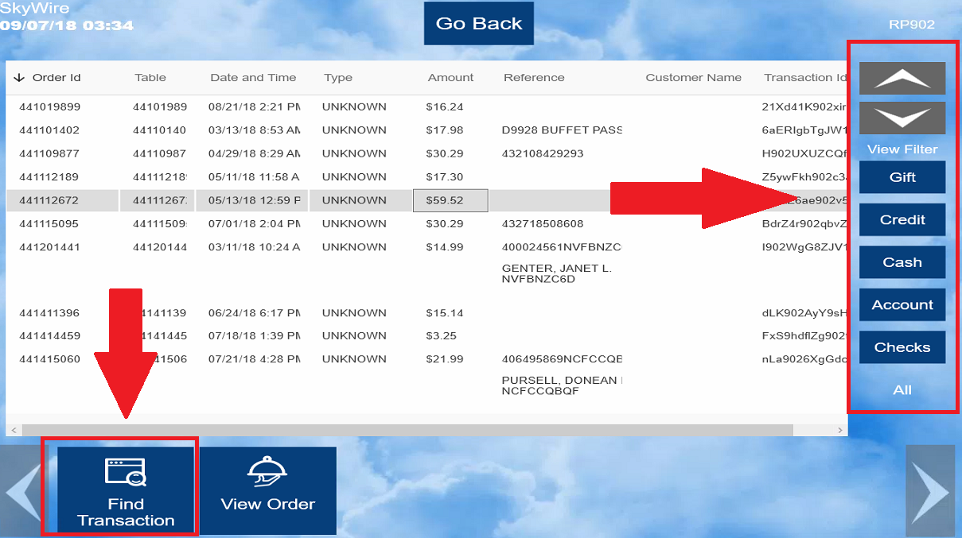

- Select the check and then select, “View Order.”
- Here you have the option to “Reopen Order” or “Print.”
- Selecting reopen will refund the order and keep the check open to adjust.

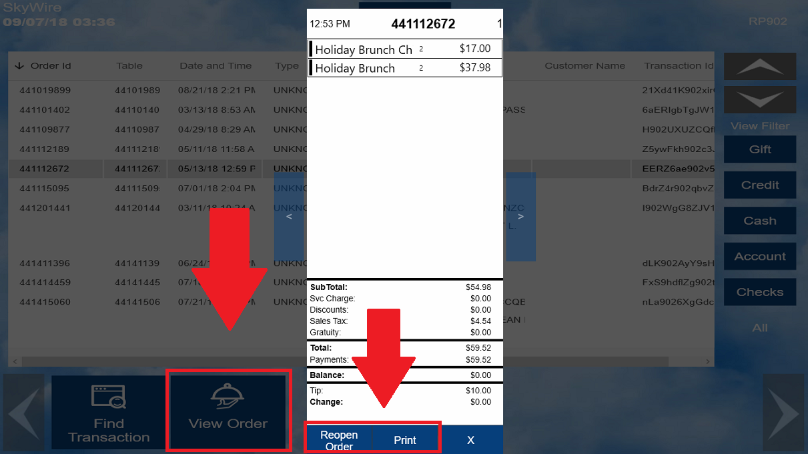

Order History

All current and previous orders can be accessed from Order History.

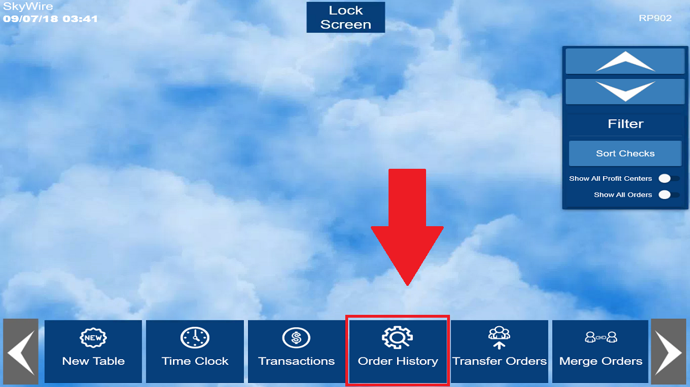

- To find an order, select “Find Order” and enter the order number.
- You can also use “View Filter” to navigate through orders if the order number is unknown.

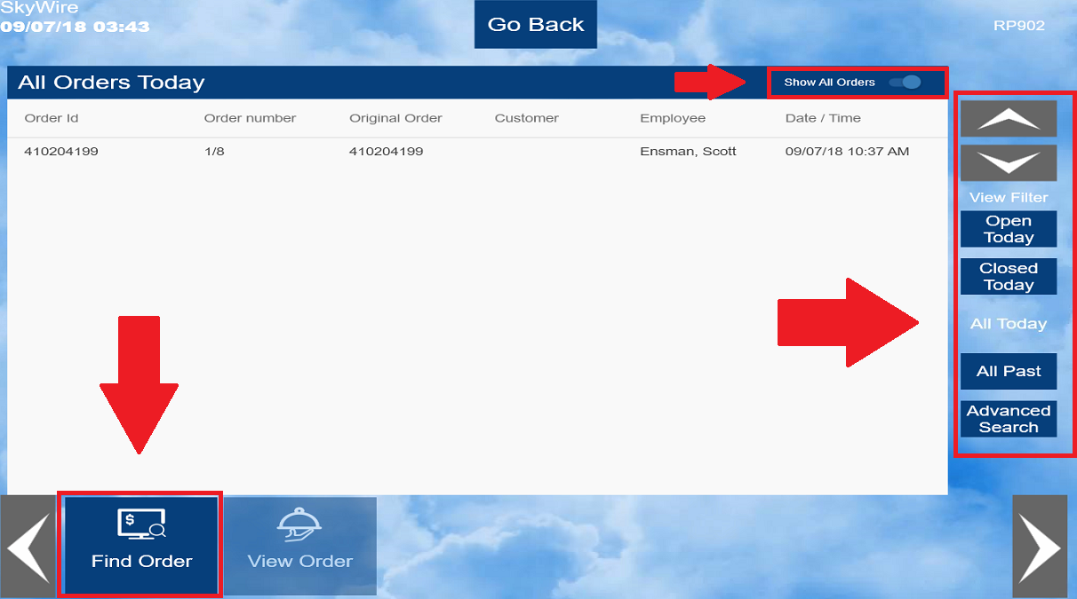
- Select the check and then select, “View Order.”
- Here you have the option to “Reopen Order” or “Print” if the order was tendered. If the order is open, selecting “View Order” will take you to the open order.
- Selecting reopen will refund the order and keep the check open to adjust.

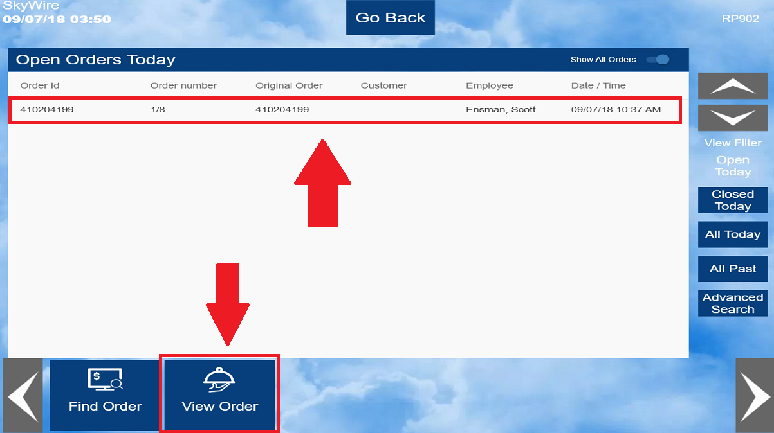

Refund Order

- To Refund an order, select "Refund Order.”

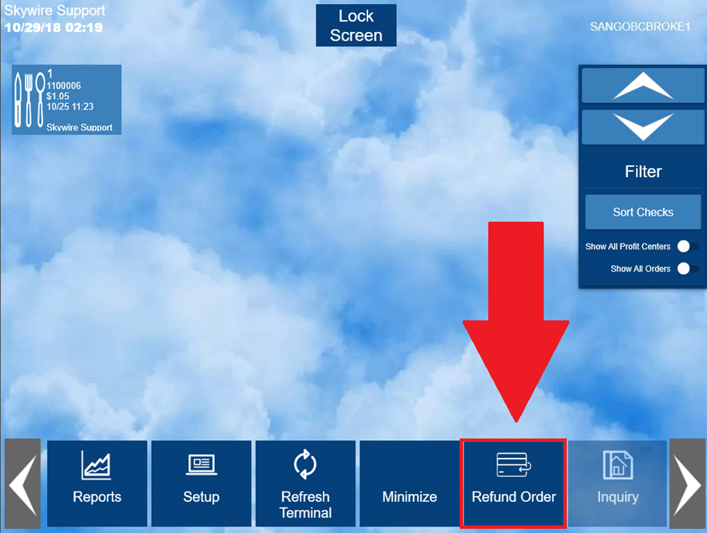
- Select a Refund reason.
- Select "Confirm.”

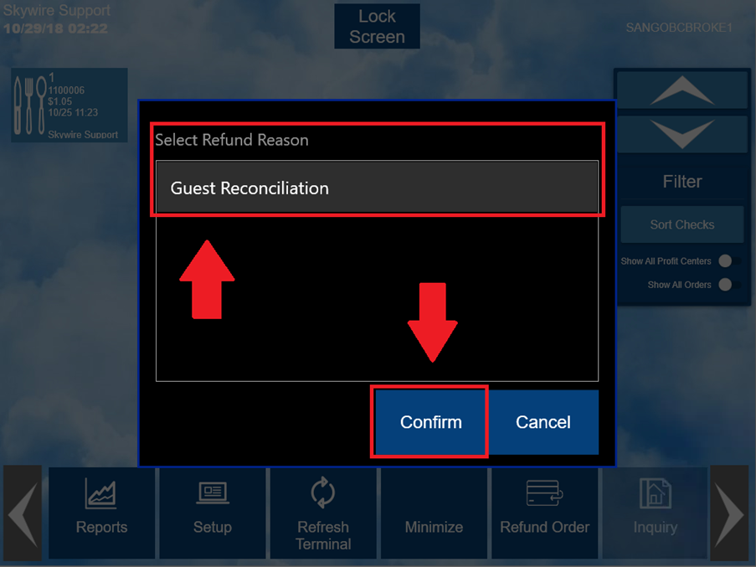

- Re-ring the order to be refunded.
- Select "Payment.”
- Apply the form of payment to refund.

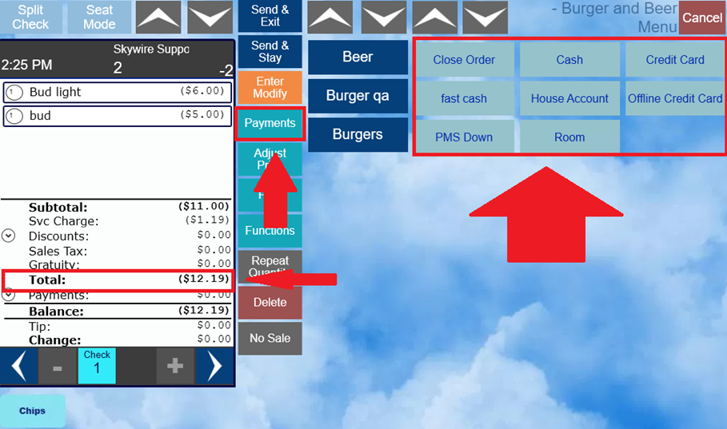

Tip Functions

- To use the following tip functions, select “Tips” located on the Time Clock Screen.

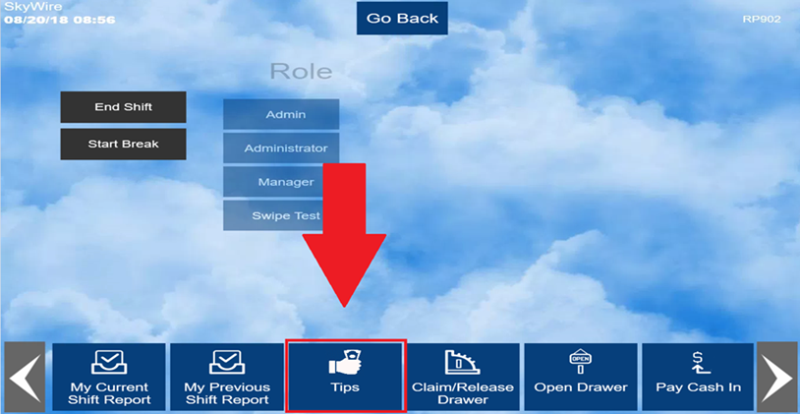

- Tip functions include:
  - Accept Tips
  - Payout Tips
  - Transfer Tips
  - Tips for Shift

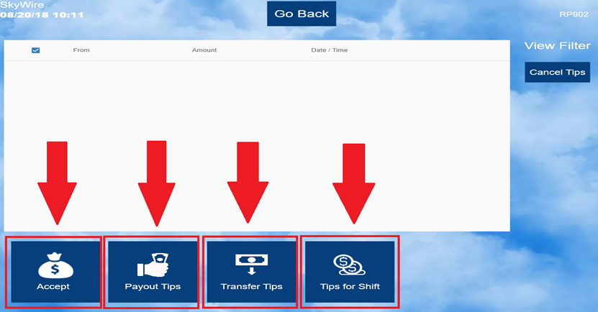

Accept Tips

- To accept tips transferred from other employees, select “Accept.”
- Select “Cancel Tips” to reject transferred tips.
- If tips are not accepted they will be returned to the original owner.

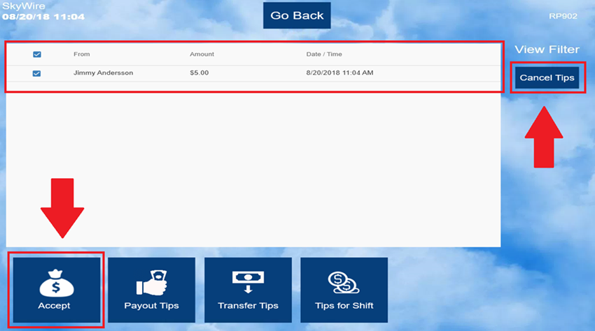

Payout Tips

- Select “Payout Tips.”

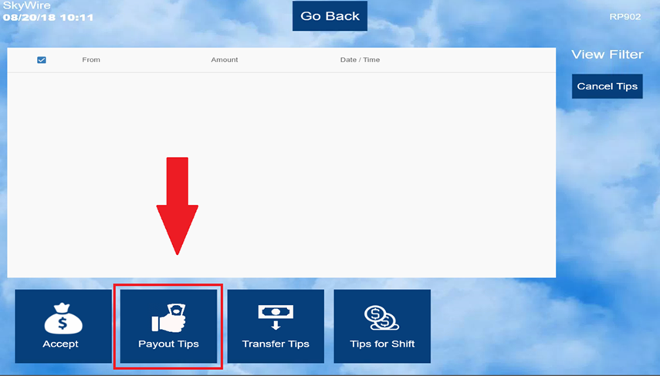
- Enter the employee’s “Front of House Password” or swipe the mag card of whose tips are being paid out.
- If you are tipping out yourself, enter your “Front of House Password.”
- Select "OK" to have the tips paid out.

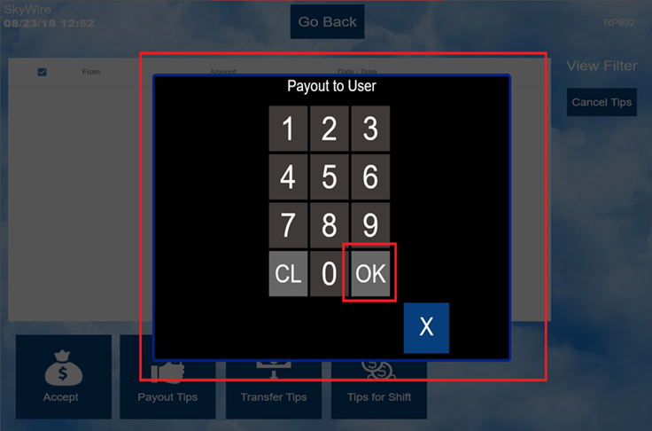

- Confirm the payout amount and user.

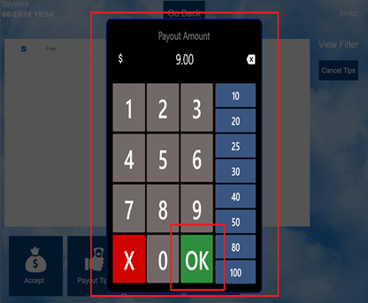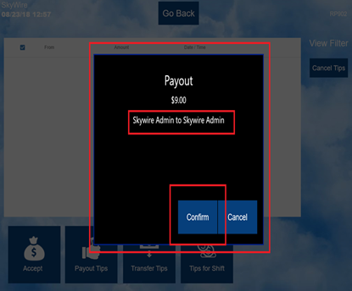

Transfer Tips

- Select “Transfer Tips” to transfer tips to another employee.

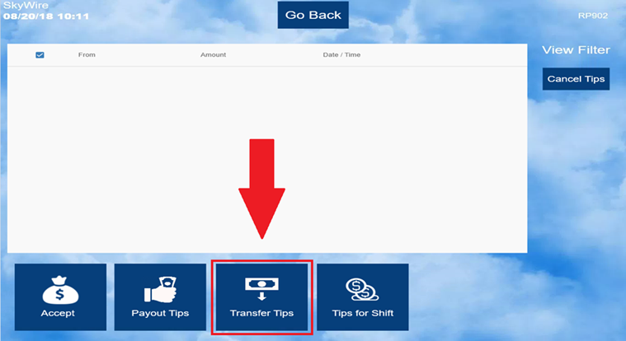

- Type in a few letters of the employee’s name that tips are being transferred to.
- Select the employees name and then “Confirm” to transfer tips.

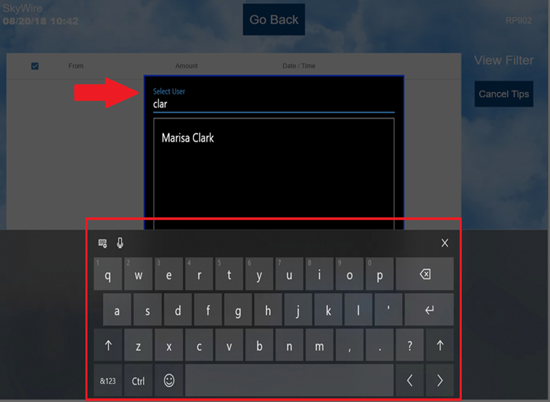
- To transfer a dollar amount, enter the transfer amount.
- To transfer a percentage, select the $. It will change to %. Enter the percentage amount to transfer.
- Select “OK.”

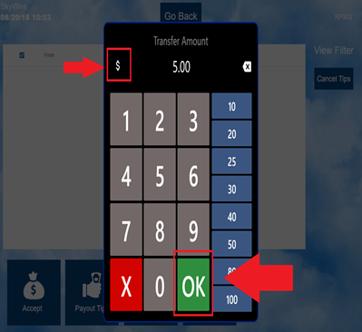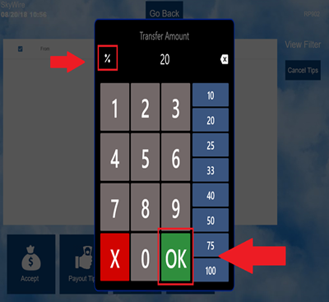

- Select “Confirm.”

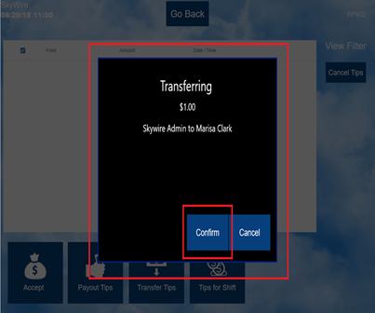

Tips for Shift

- To view and print tips accumulated for the current shift, select “Tips for Shift.”

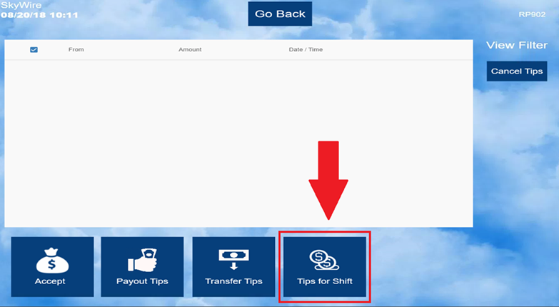

- Select “Print” for a tip chit or “X” to cancel.

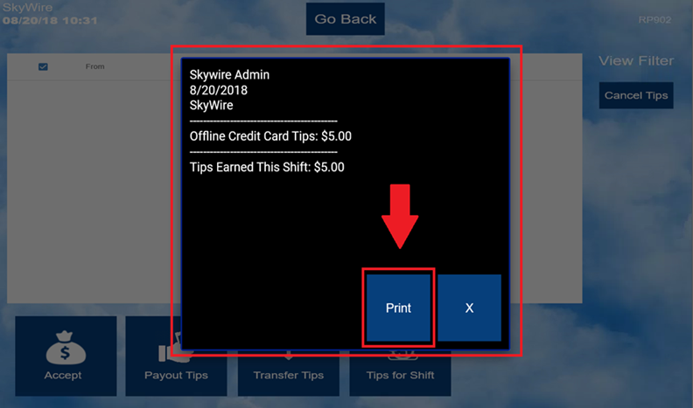

Terminal Reports

- Select the arrow on the right to access terminal reports.

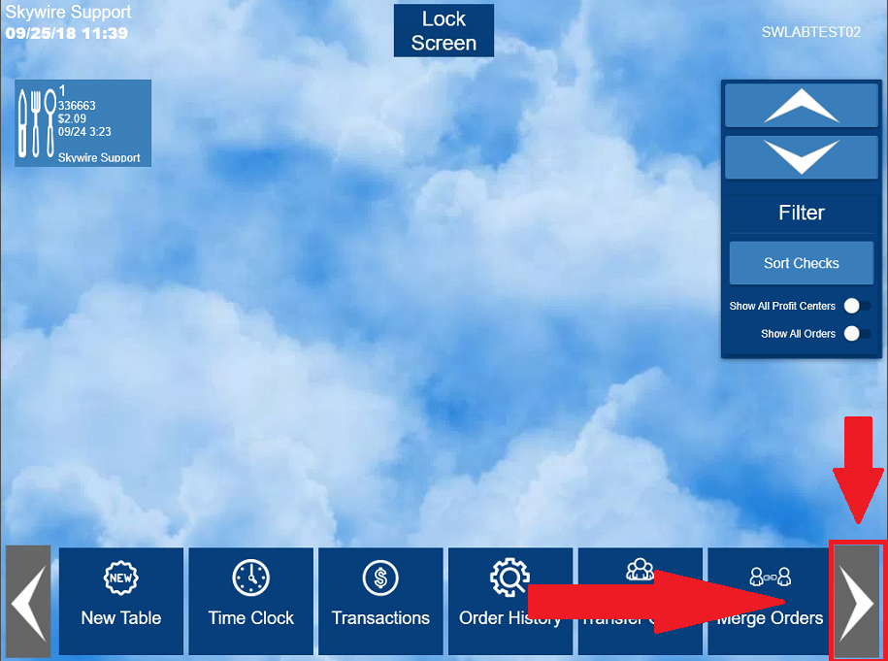

- Select Reports.

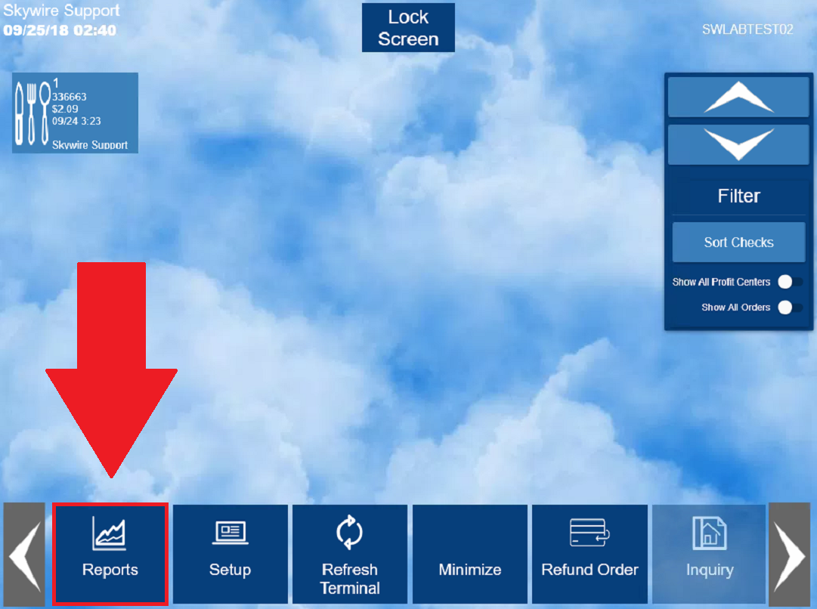
- Select the desired report.
- Select the desired reporting specifications.

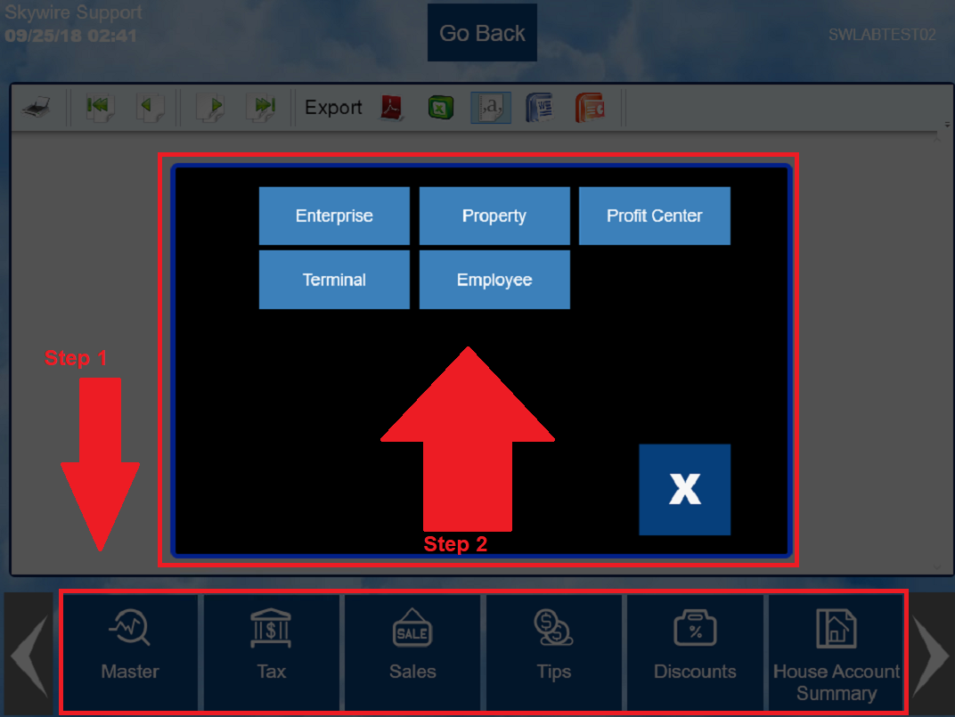

- Add the available report specifications to the selected portion of the screen.
- Select "OK.”

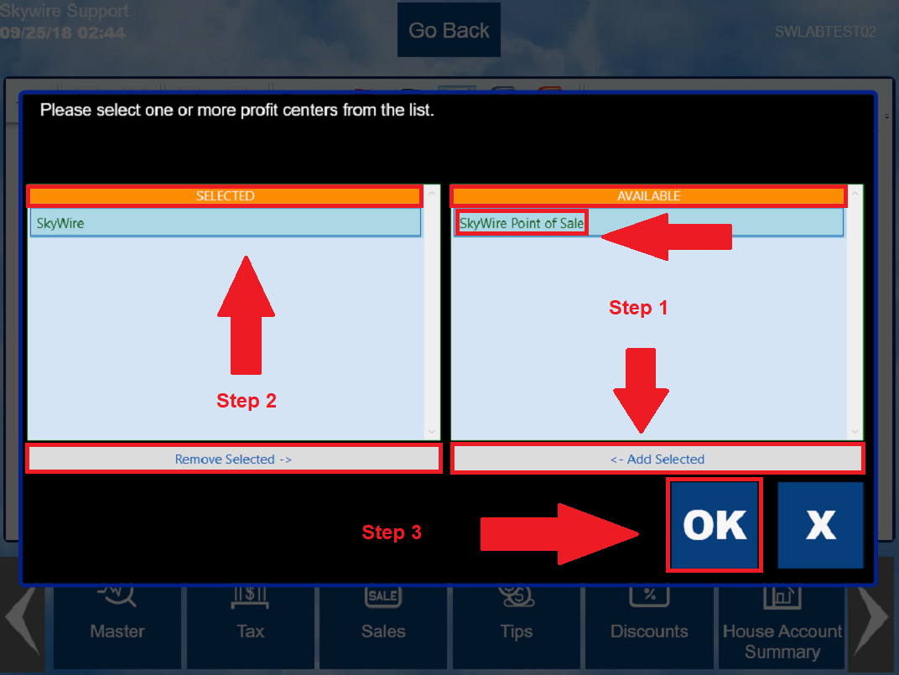
- Use the arrows on the top of the screen or use the scroll bar on the right to navigate through the report.

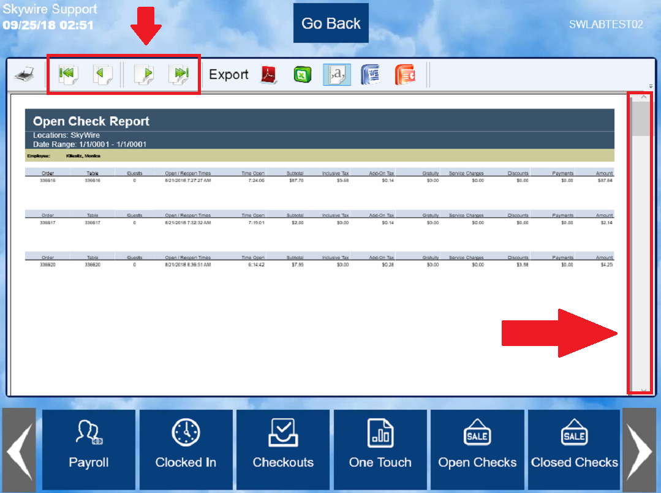

- Select the printer icon on the top left-hand side of the screen to print the report.
- To export the report, select one of the export options on the top of the screen.
  - The export can be saved or emailed.

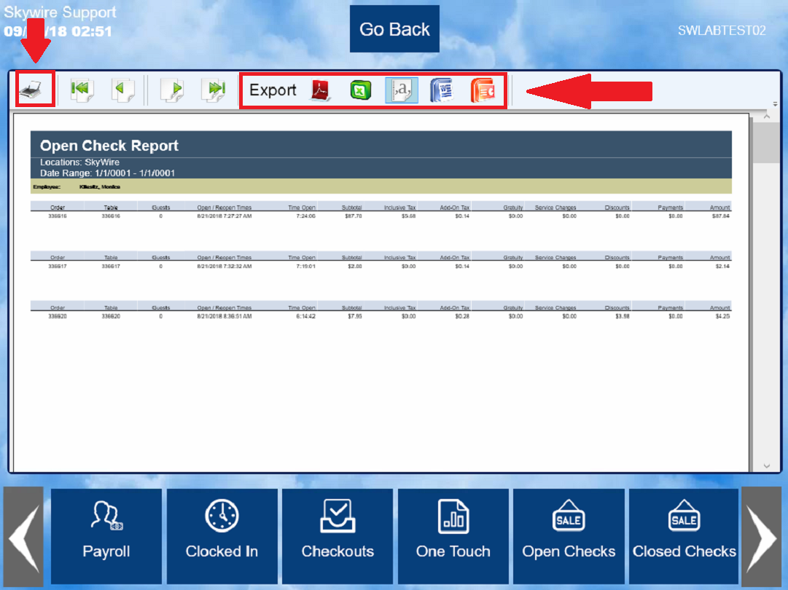

Setup Settings

- Select the arrow on the right to access the setup functions.

- Select “Setup.”

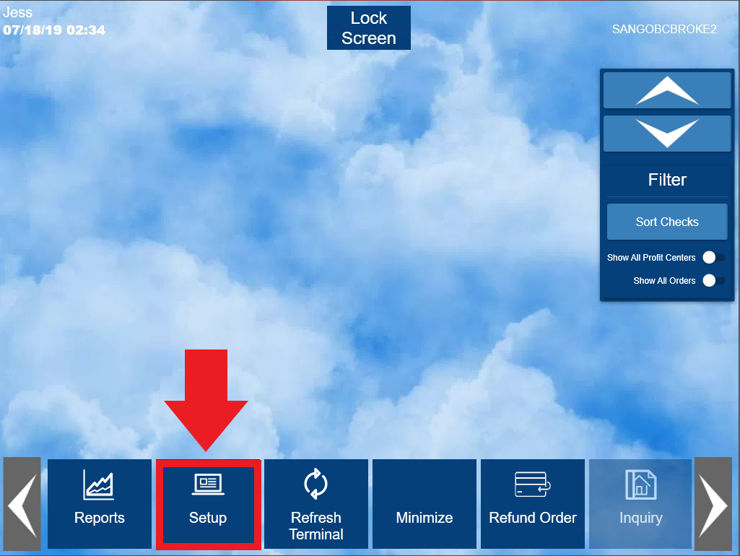
- Enter WebConfig credentials to access “Setup” settings.

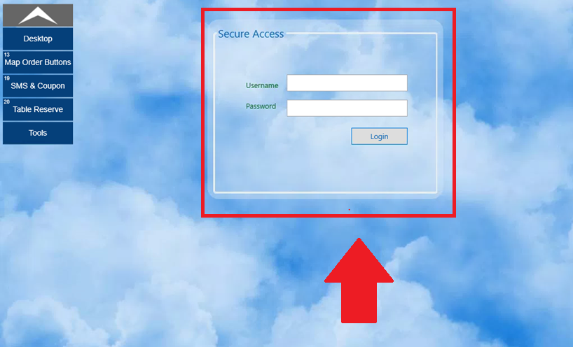

- Select “Desktop” to exit.

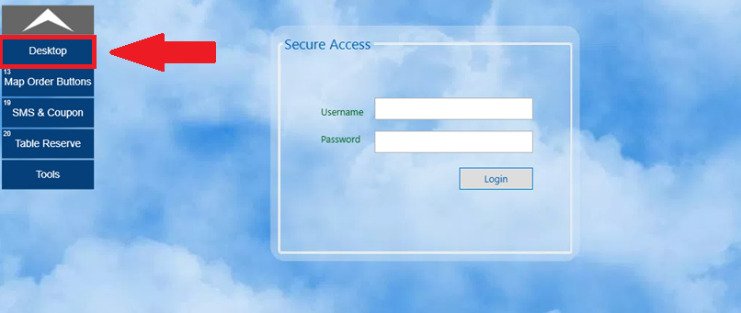

Map Order Buttons

This feature is used to assign functions to the order screen’s quick service buttons. From here, the user can select and change button position, style and text, as well as preview the button map order before making final changes.

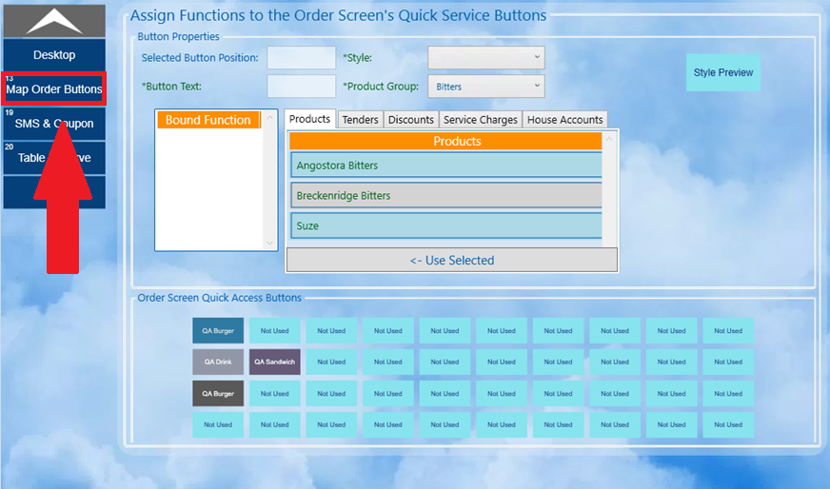

SMS & Coupon

This feature can be used to configure SMS text messages and add recipients for SMS & Text services. To make changes, click the “Edit Form” button and enter the recipient’s information in the required fields. When finished, click “Save Data” to save the new recipient’s information.

- Select “Edit.”

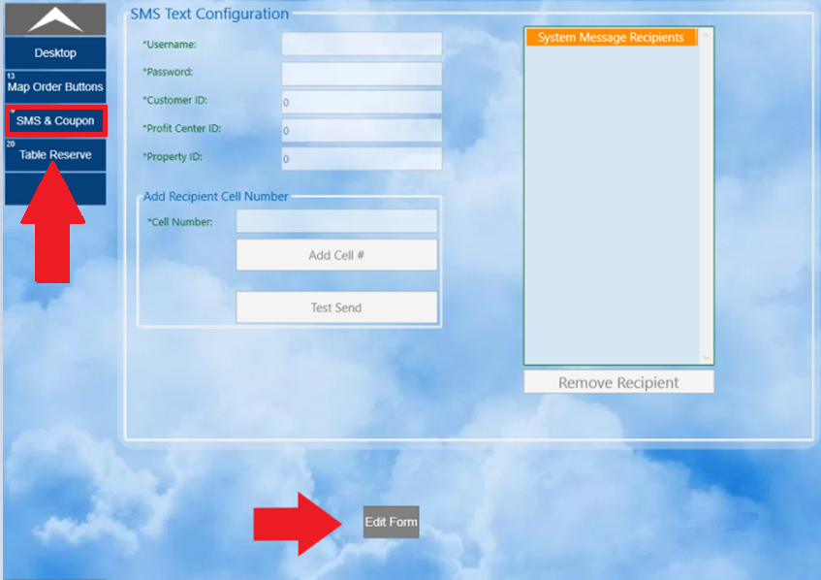

- Select “Save Data” to save configurations. Select “Exit Edit” to discard changes.

Table Reserve

Table Reserve is an optional add-on interface used as an in-house reservation system. To configure Table Reservation, click the “Edit Form” button near the bottom of the screen. Next, check the “Enable Table reservation Box” and enter the necessary information in the fields below. After entering the necessary information, click the “test settings’ button to ensure the interface is configured correctly.

- Select “Edit Form.”

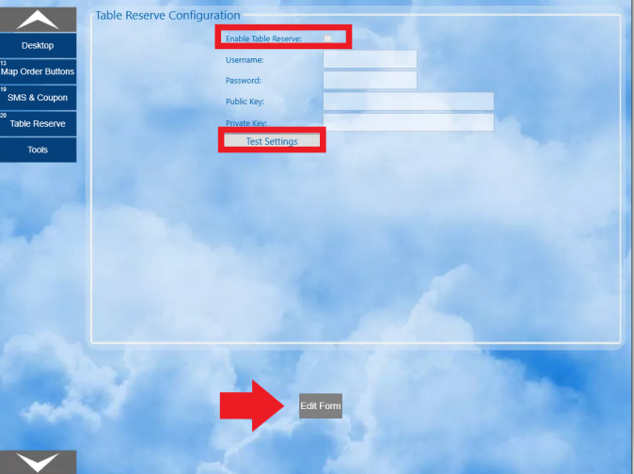

- Select “Save Data” to save configurations. Select “Exit Edit” to discard changes.

Tools

The tools option has several different functions within it. These functions allow the user to shut down the POS software, shutdown the terminal, restart the POS software, reboot the terminal, export audit log trails, erase all sales data, and send sales data. The most commonly used function under the tools tab is the “Send sales” button, which sends the sales data for a specified time frame.

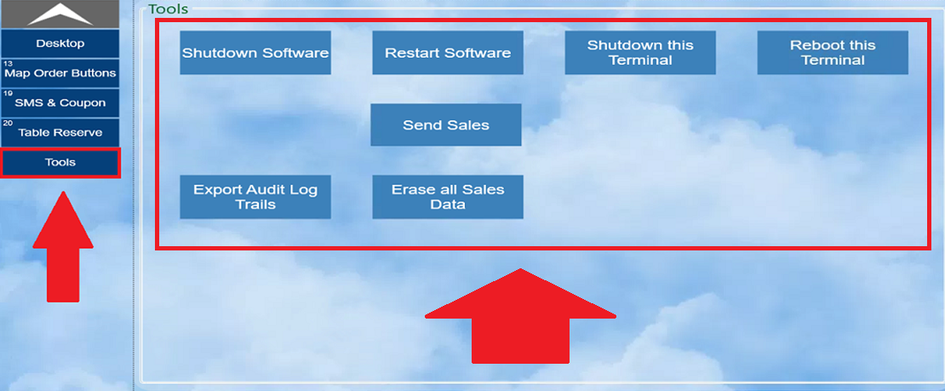

Send Sales

- To send sales data, select the “Send Sales” button.

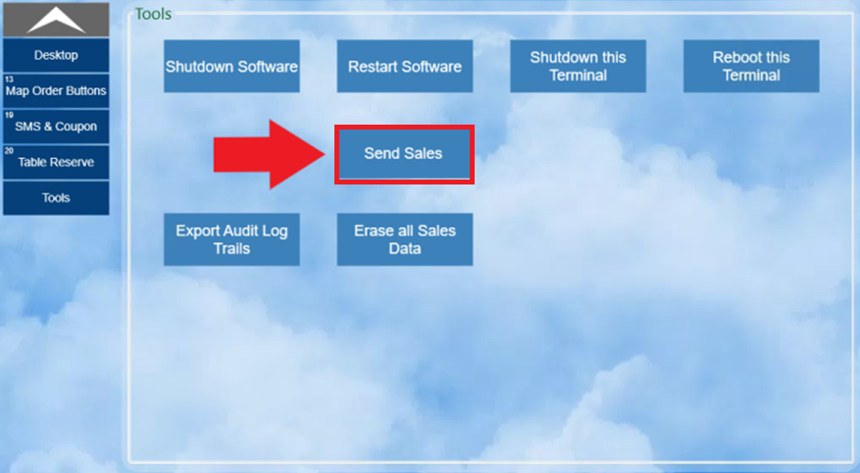
- After selecting “Send Sales”, a window will pop up prompting the user to enter a start date and end date for the sales data being sent. After selecting the dates, hit send and the data will begin sending. You can leave this screen and return to other POS functions while the data is sending.

